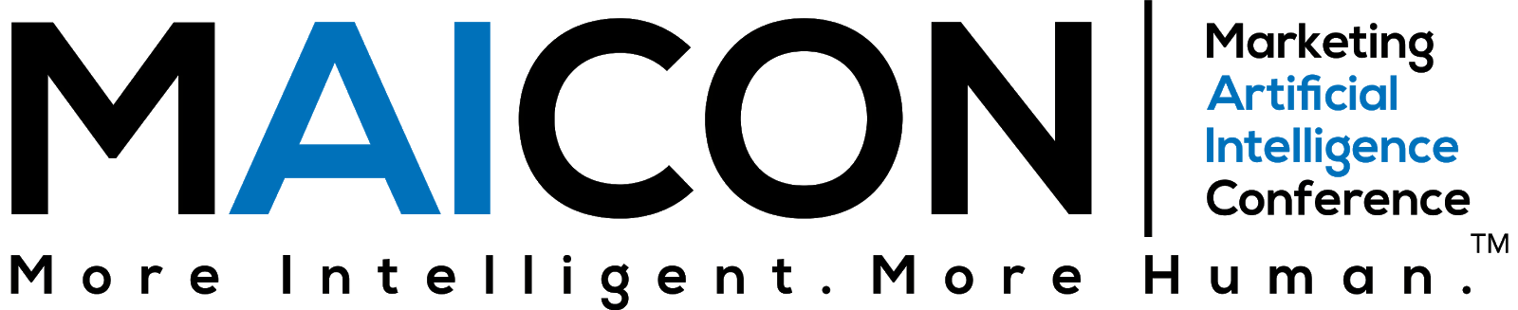

Dear <Insert Manager’s Name>,
I would like your approval to attend the Marketing Artificial Intelligence Conference (MAICON). Held by Marketing AI Institute, MAICON is designed to help marketing leaders truly understand AI, educate their teams, garner executive support, pilot priority AI uses cases, and develop a near-term strategy for successfully scaling AI.
It is a virtual conference taking place September 13 – 14, 2021.
In its inaugural year, MAICON attracted 300+ professionals from 12 counties and 28 states.
Why is this conference worth the investment?
Gartner forecasts global business value derived from AI is projected to reach $3.9 trillion in 2022 through three primary sources of customer experience, cost reduction, and new revenue.
Meanwhile, McKinsey Global Institute projects up to a $6 trillion impact of AI and other analytics on marketing and sales, including the areas of pricing and promotion ($1.9T), customer service management ($1.0T), next product to buy/individualized offering ($1.0T), customer acquisition/lead generation ($0.7T), marketing budget allocation ($0.6T), churn reduction ($0.38T), and channel management ($0.32T).
MAICON takes attendees beyond the splashy headlines and industry jargon to explore the business and practice of AI through keynotes and breakout sessions. I’ll learn what’s possible now, and in the near future, through the eyes of the marketers, analysts, and AI experts who are leading the way.
Here are a few other benefits of attending:
- To network with a community of forward-thinking marketers who are pushing the limits on what’s possible through AI.
- To learn about AI-powered marketing technologies that could help us do our marketing smarter.
- To gain access to the resources, contacts, and tools needed to implement marketing AI solutions in our organization.
- To learn from marketing practitioners who are piloting and scaling marketing AI solutions in their organizations.
- To be proactive in advancing our knowledge and capabilities in marketing AI before our competitors beat us to it.
Following MAICON, I will share key takeaways and immediate action items that our team can use to develop a strategic approach to AI. This includes best practices on how to solve problems, identify use cases and integrate AI within our organization, as means to help us do our jobs more efficiency, reduce costs and generate new revenue streams.
Below is an approximate cost of attending for your consideration.
Conference: $xxx (update to current ticket price)
Total: $xxx
Thank you for your prompt consideration of this request.
All the best,

