PR Template for Step Up for Business Programme – so we can help you with your launch and keep promoting you with the press and on social media.

Name of business
Owner/founder of business (full name)
Contact number
Facebook
Twitter Handle
Instagram
Linked In

Launch date of business

Brief description of business
(who are your customers and what do you do for them)
Why did you want to or decide to start up this business?

If you’re an established business give a brief overview of company history including high points.

How you have launched and where you are based?
A quote – about your business, and about the support you have received from Good2Great on your ‘Start Up journey’

Picture | Can you email us a high res (ie original size if taken on a phone) picture of yourself – fairly close up – and better still holding props associated with your business quite close to your face – please email sally@good-2-great.co.uk  Here are some good examples….  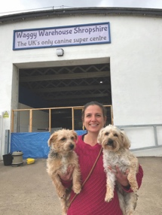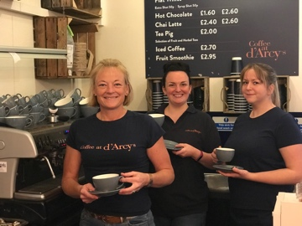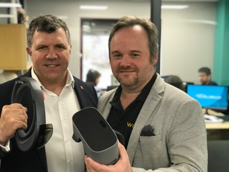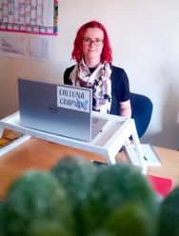

For later down the line: Do you have a product or a service which would be of interest to the local business community?
If so, would you be interested in being interviewed on Saturday Strategy? | (possible subject)
Would you be interested in presenting to the Growth Club

