Team Accountability Assessment
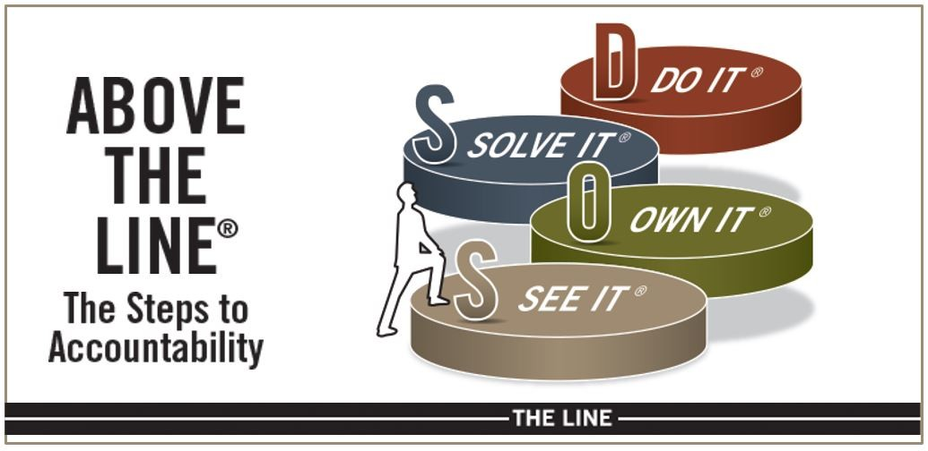
Sixteen Best Practices

SEE IT
Obtaining the Perspectives of Others:
_________ (Grade)
- How well do we gather others’ perspectives?
- Do we apply this to every level in our organization, as well as to people outside our organization, such as suppliers, customers, and even competitors?
Communicating Openly and Candidly:
_________ (Grade)
- Do we cover every important topic—especially the ones that make us feel uncomfortable—during a meeting rather than in the hallway after the meeting?
- Do We encourage honest discussion and debate?

Asking for and Offering Feedback:
_________ (Grade)
- Do we make feedback a daily habit?
- Do we give and receive feedback in a positive, appreciative way?
Hearing the Hard Things:
_________ (Grade)
- Do we welcome the truth about a situation without fear of defeat or retribution?
- Do we acknowledge the realities that are getting in the way of achieving Key Results?

OWN IT
Demonstrating Personal Investment:
_________ (Grade)
- Do we keep people involved in what’s happening throughout our organization, or do we allow people to say, “It’s not my job”?
- Do we seek agreement that getting Key Results is everyone’s job?
Learning from Both Success and Failure:
_________ (Grade)
- Do we encourage people to risk failure and learn from mistakes and setbacks?
- Do we learn from our success and reward people accordingly?
Aligning Work with the Key Results:
_________ (Grade)
- Does everyone see how their work connects to Key Results?
- Do people align their work priorities with those Key Results?
Acting on Feedback:
_________ (Grade)
- Do we communicate our willingness to act on the feedback we receive?
- Do we expect others to act on the feedback we give?

SOLVE IT

Asking Constantly “What Else Can I Do?”
: _________ (Grade)
- Do we stress “else” (different) rather than “more”?
- Do we emphasize the need for the need for creative problem solving and innovation?
Collaborating across Functional Boundaries:
_________ (Grade)
- Do we remove obstructing silos?
- Do we foster cross-functional communication and collaboration?

Conquering Obstacles:
_________ (Grade)
- Do we look for ways over or around roadblocks to success?
- Do we welcome bold new ideas for solving problems?
Taking the Necessary Risks:
_________ (Grade)
- Do we take risks in the face of potential failure?
- Do we encourage and reward calculated risk taking?

DO IT
Doing the Things I Say I’ll Do:
_________ (Grade)
- Are people doing what they say they’ll do?
- Do we leave meetings with action lists detailing who will do what by when?
- Do we follow up on those commitments?
Staying Above the Line by Not Blaming Others:
_________ (Grade)
- Do we discourage excuse making and blaming others?
- Do we respectfully call people out for slipping Below the Line?

Identifying the “Who” in “Who Will Do What by When?”:
_________ (Grade)
- Do we define roles before and during a meeting?
- Do people accept new roles when necessary?

Creating and Sustaining an Environment of Trust:
_________ (Grade)
- Do we interact with others in a spirit of humility, honesty, and respect?
- Do we let people know we expect the same from them?

Adopting and perfecting the Sixteen Best Practices will help you create a Culture of Accountability, the best gift you will ever give your organization. It’s worth repeating: Either you manage your culture, or it will manage you.

