HJA Secret Fix
Price Enquiry Sheet

Company Name:…………………………

Contact Name & No:…………………….

Corners |  | 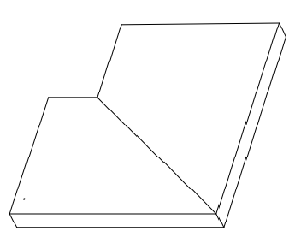  Add sizes to each side (mm)  Add leg lengths each side (mm)  Inside angle: ………….
Qty

Length
Width
Inside Leg
Outside Leg
Straights |  | 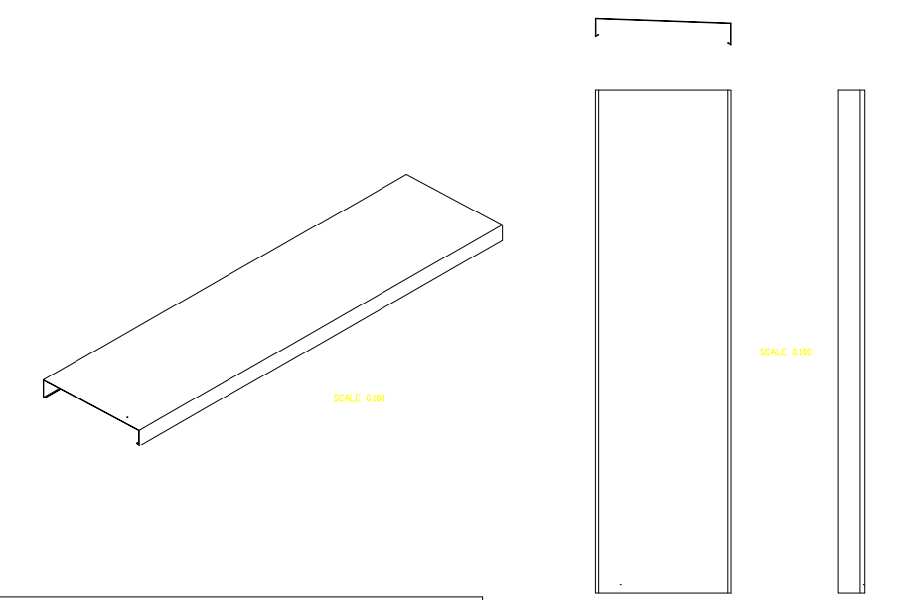
Qty

Length
Width
Inside Leg
Outside Leg
Brackets |  | 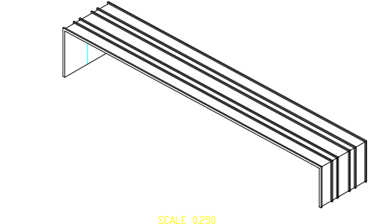
Qty
Stop Ends |  | Loose Or Welded to the Capping Length
Qty

RAL Colour |  | RAL:
Additional Notes

Email: Enquiries@hjafabrications.co.uk
Call: 01905 454790

