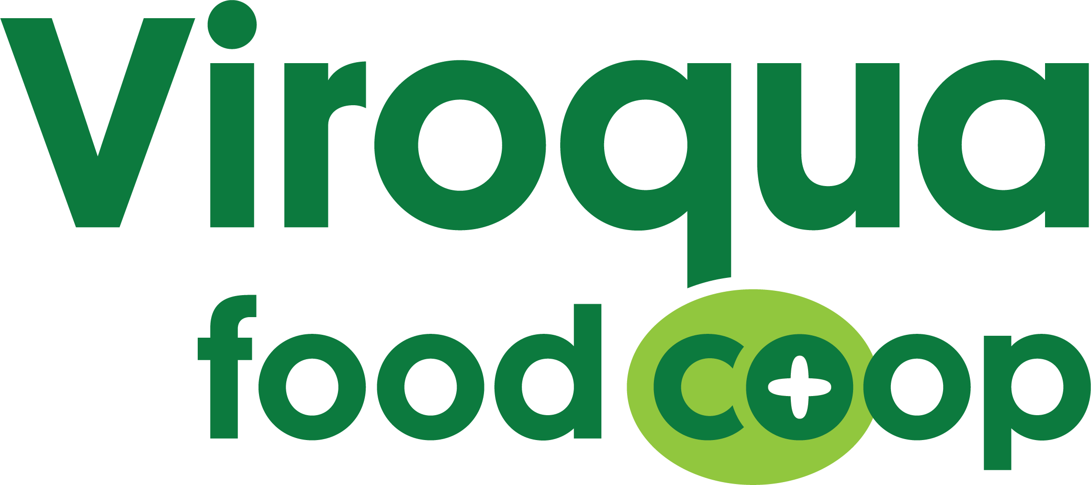
Microlending Initiative

Through the Viroqua Food Co+op (VFC) Microlending Initiative, a business or farm selling food or other products they produce to the VFC or local farmers market is eligible for an interest-free loan of up to $3,500, to be paid back within one year.

The Microlending Initiative was developed in 2012 under the direction of the VFC Board of Directors. The Board was looking at how to make our Co-op more resilient. One path to resilience that they identified was to make sure VFC has many strong, local suppliers. By starting the Microlending Initiative the Board aimed to grow farm and food small businesses and ensure that VFC owners and customers have access to local food and products.

Interest-free loans are opposite of the normal cycle all too many farmers and food producers find themselves in – the cycle of high interest loans, debt, and the inability to reach financial security and true economic viability through their business. VFC’s intention is to share the resources that we have to better enable farmers and food producers to provide us with the food and resources needed to live a healthy life.

Applications are due on January 16, 2021. They are evaluated on the criteria listed on the last page of the applicaiton. The VFC Microlending Committee will select a recipient in late January 2021.

Past VFC Microloan Recipients:
- 2020: Driftless Provisions for $2,855. Financed purchasing a label maker and camera.
- 2018: B&E’s Trees for $3,500. Financed updating their maple syrup bourbon barrel aging building.
- 2017: Deep Rooted for $3,500. Financed building a produce refrigerator.
- 2016: WiscoPop for $3,500. Financed converting their soda/sparkling water line to certified organic and launched two new flavors of sparkling water.
- 2015: Del Sol Chocolate for $2,000. Financed building a cacao mill and winnowing machine.

Questions? Please call or email Bjorn Bergman (bjorn.bergman@viroquafood.coop)

609 N Main St - Viroqua, WI 54665 - 608.637.7511 - www.viroquafood.coop

2021 VFC Microloan Application

General Business Information:

Farm/Business Name:

Applicant Name:

Applicant Address:

City: State: ZIP:

Phone Number: Email:

Website:

Farm/Business Location:

Farm/Business Description & Mission:

Microloan Request:

- Amount Microloan Requesting (up to $3,500):

- Project Description: Please describe your project. How will this microloan help strengthen your farm/business? Feel free to attach additional page(s) if necessary.

- Project Budget: With as much detail as possible, please tell us how you will use the microloan. Feel free to attach additional page(s) if necessary.

- Are you a VFC owner?
If No, what is your relationship with us?

- Gross Income: 2020 Actual: 2021 Projected:

- Net Income: 2020 Actual: 2021 Projected:

- Current Debts:
  - Type: Amount:
  - Type: Amount:
  - Type: Amount:

- Have you completely repaid any loans in the last 10 years?
If yes, can you provide documentation of repayment?

- Your Preferred Repayment Plan:
  - Payment Date(s):
  - Number of Payments:
  - Individual Payment Amount:
*Please note: repayment plan must be approved by VFC Microlending Committee
2021 VFC Microloan Timeline:
- Application Period: December 1, 2020 – January 16, 2021
- Microloan Recipient Chosen by VFC Microlending Committee: late January 2021
- Microloan Applicants contacted about result of review: late January 2021
- 2021 Microlending Recipient made public in Spring 2021 Pea Soup (emailed March 2021)

VFC Microloan Assessment Criteria:
The VFC Microlending Committee considers each of the following criteria to determine if a potential loan would be prudent for the Co-op:
- Project accomplishes at least one of the following for the applicant:
  - Fills a hole in local food supply system by expanding production and/or distribution of a food and/or products.
  - Project purchases equipment to increase efficiency and profitability.
  - Project helps grow their business.
- Mission, values, and practices of the farm/business furthers VFC’s Ends.
- Demonstrated need and plan for implementation of the loan.
- Nature of relationship between VFC and the farm/business.
- Status as an active distributor of product/produce to VFC and/or at the Viroqua Farmers Market.
- Proven track record of effectively managing and paying back loans/investments as demonstrated in application.
- Decent financial position (income would need to support all debts including but not limited to debts to VFC).
- Clear strategy and plan for repayment.

VFC Microloan Guidelines:
- Viroqua Food Co+op limits our Community Investments (including Microloans) in non-federally secured institutions to 5% of our total cash.
- An individual farm or business is eligible for a loan of up to $3,500 every twelve months.
- VFC Microlending Committee shall use the following Loan Assessment Criteria (see above) to review and recommend applicants for loans.
- The VFC Finance Team shall decide whether to approve the Microlending Committee’s recommendation in light of the Co-op’s financial status and compliance with the investments policy of the Co-op and the Microloan Assessment Criteria (see above).
- A Promissory Note between Viroqua Food Co+op (Lender) and the Microloan Recipient (Borrower) shall be drawn up by the VFC Microlending Committee, approved by the VFC Finance Team, and signed by the Borrower and Lender.
- VFC Microlending Committee is responsible for working with the borrower to ensure that the terms of the loan are met.
- Loans are repayable by check or cash payment. Terms will be outlined in the Promissory Note.
- Loans must be repaid within twelve months or as agreed upon by Borrower and Lender.

