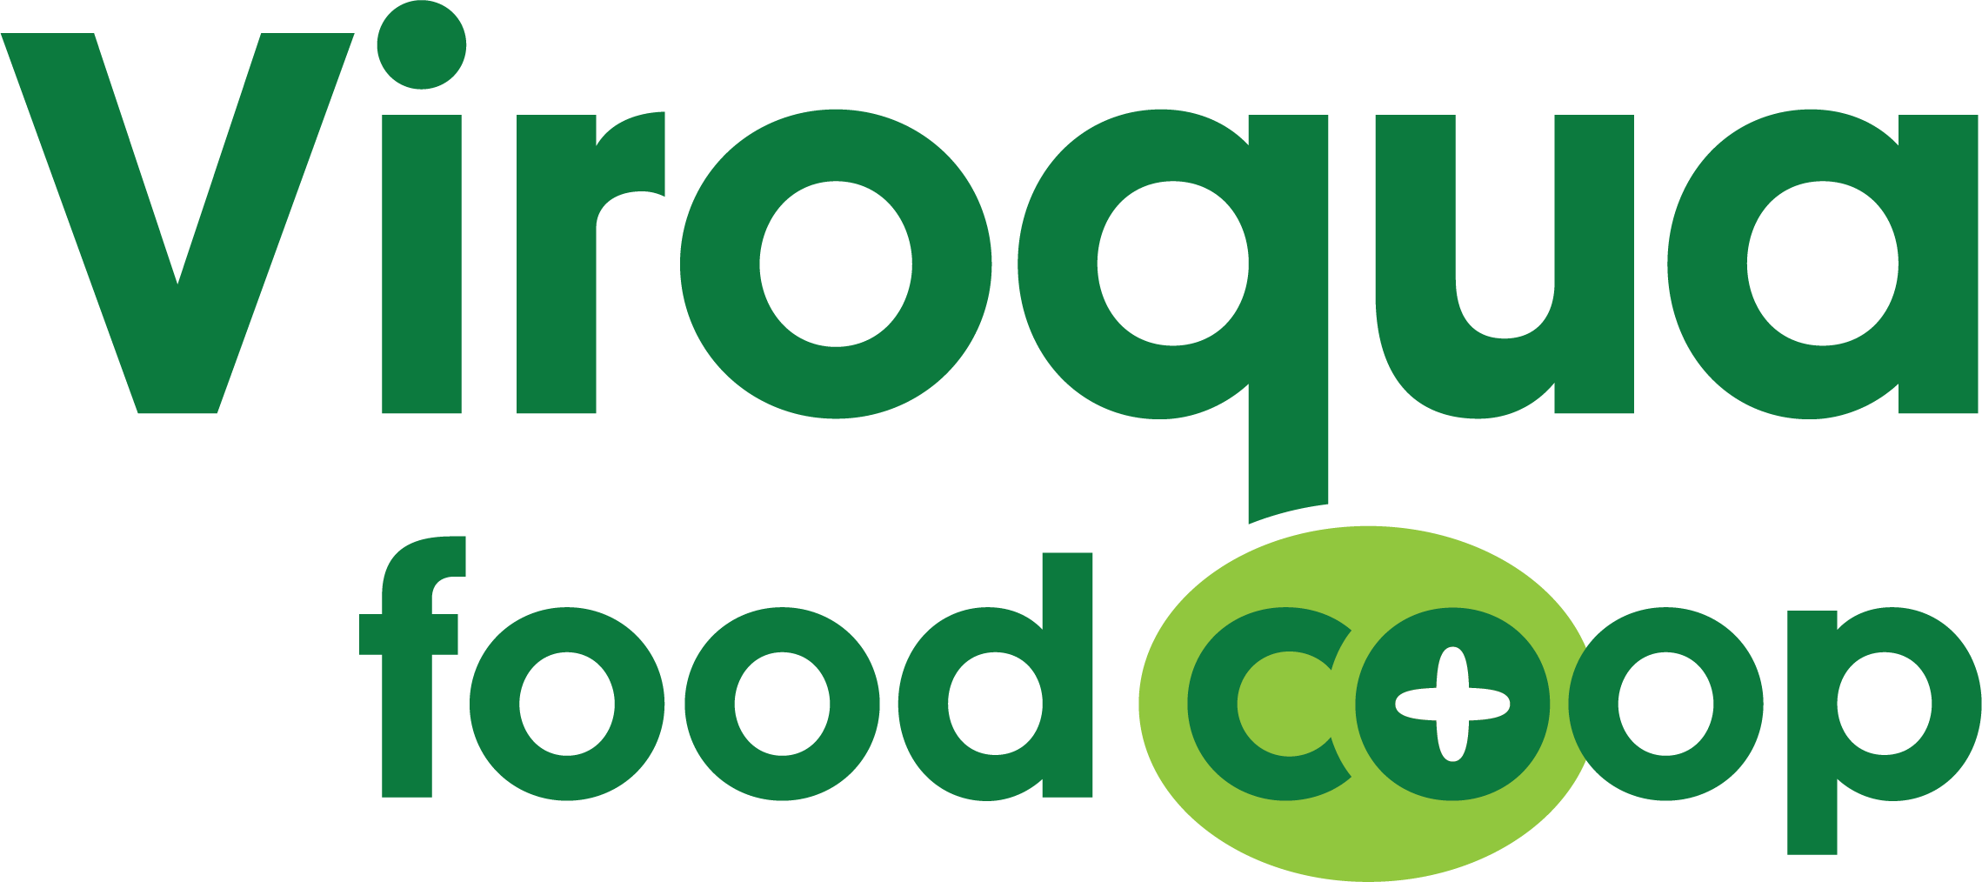

2020 Cooperative Community Fund
Grant Application

The VFC Cooperative Community Fund (CCF) was established in 2016 with the specific goal of providing grant funding to local nonprofit organizations that have a mission that is consistent with Viroqua Food Co+op. VFC’s CCF is an endowment that is administered through Twin Pines Cooperative Foundation (TPCF) (501(c) (3)), which makes donations to the VFC CCF tax deductible. As more money is added to the fund, we accrue more interest and can give out larger grants. In 2020, we have a $600 to grant to local nonprofits.

Local (within 100 miles of VFC) nonprofit organizations are eligible to apply for VFC CCF Grants. Priority is given to grant requests for educational projects, development projects and events that match VFC’s mission and focus on but are not necessarily limited to:

- Food and food systems
- Nutrition
- Health and well-being
- Cooking education
- Sustainable agriculture
- Cooperative education
- Social change

Instructions:
- Applications should be typed or printed.
- Please attach a copy of the Internal Revenue Service determination letter indicating the 501(c)(3) status of your organization.
- Send complete applications to VFC CCF Grant Committee, c/o Viroqua Food Co+op, 609 N Main ST, Viroqua, WI 54665 or outreach@viroquafood.coop
- Applications must be received by October 31, 2020 at 9pm.
- Applications are evaluated on the criteria listed above.
- Grant awardees are announced the first half of November 2020. At that time, all applicants will receive an email indicating the status of their application.

Questions? Please contact Bjorn Bergman - outreach@viroquafood.coop

VFC Cooperative Community Fund Grant Application

Non-Profit Name: ___________________________________________________________

Applicant Name: ___________________________________________________________

Non-Profit Address: ________________________________________________________

City:________________________________ State: ____________ ZIP:________________

Phone Number: (____) _____ - _____________ Email:____________________________

Website:___________________________________________________________________

Non-Profit Description & Mission:

- Amount Requesting (up to $600): ___________________________________________

- Project/Event Description: Please describe your project/event. Feel free to attach additional page(s) if necessary.

- Project/Event Budget: With as much detail as possible, please tell us how you will use the grant. Feel free to attach additional page(s) if necessary.

- Project/Event Effectiveness: How will this grant help accomplish your organizations mission? Briefly describe the intended outcomes of the proposed project/event and possible benefits to people, the organization or the community because of the project/event. What information will be collected to measure the effectiveness of the project/event? How will it be collected?

- Additional Documents: Feel free to attach any relevant information about the organization, such as marketing materials, letters of support, and financial statements relevant to the application.

Required Success Report: non-profits that are awarded VFC CCF grants are required to provide a 12-month follow-up success report summarizing the outcomes of the project/event and evaluation results (see question # 4 above). This report will be used to further promote awareness, recruit other potential grant applicants, as well as raise funds for the VFC’s Cooperative Community Fund.

