Telemedicine Billing Questions
05/1/2020

Are you are waiving cost sharing for physical therapy?
Yes. For the duration of the State of Emergency, cost sharing is waived. The provider will be reimbursed the full, in-person rate for the service.

How do you know whether to use the GT or 95 modifier?
Both modifiers are acceptable when billing 99201-99205 or 99211-99215. Telephonic & Digital codes should NOT be billed with GT & 95 modifiers. See telephonic and digital code list (see below).

Does the place of service 02 need to be on both the claim header and line level?
Place of service 02 is required on every claim line.

Can we bill for pediatric well visits conducted via telemedicine?
Yes. Well visits can be performed via telemedicine for the duration of the State of Emergency. We encourage providers to continue seeing members for well visits. CPT guidelines still apply for the visits, so be sure to select the correct CPT E/M code when billing for the service. As a reminder, well visits do not take cost-sharing, whether performed in person or via telemedicine.

Have you eliminated the age restriction under 24 months of age prohibiting Telemedicine visits?
The age restriction has been eliminated for the duration of the State of Emergency.

How should I bill for telephone only visits?
Physicians may bill E/M’s for telemedicine services if E/M coding guidelines are met for 99201-99215. If E/M coding guidelines are not met, physicians should bill the most appropriate telephonic codes 99441-99443 or digital codes 99421-99423 with POS 02 and NO modifier. When billing 99201-99215 for telemedicine visits, the E&M’s must be billed with modifiers GT or 95 AND POS 02. See telephonic and digital code list (see below).
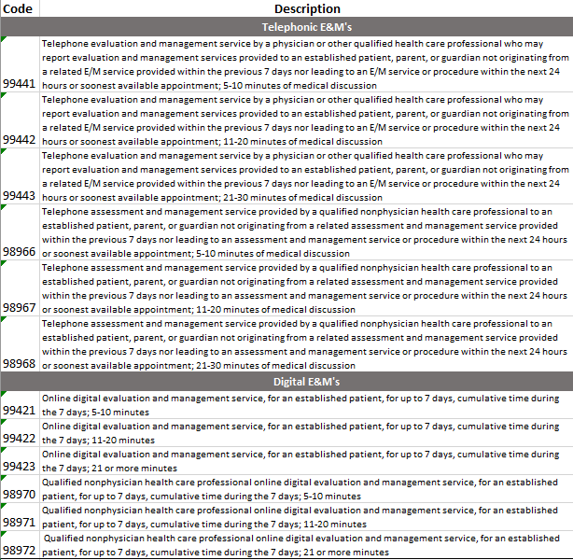

Can we see new patients for consults and be reimbursed?
Yes. Consultations with new patients may be provided via telemedicine, during the State of Emergency. Although physician consultations are covered, AllWays Health Partners requires that new patient E&M’s be billed, as opposed to consult codes. CPT guidelines still apply for the visits, so be sure to select the correct CPT E/M code when billing for the service.

Does place of service (POS) have to be 02 for Telephone calls?
Yes. POS 02 must be billed for telephonic visits.

Is the correct POS “02” (with a zero) or “2” (without a zero)?
POS “02” (with a zero)

How long will it take to pay claims? We're really hurting out here with a drastic decrease in outpatient visits?
There is no change in the time it will take AllWays Health Partners to process claims. It’s important to note that improper code/modifier combinations and the incorrect POS could cause claims to deny:
• All telemedicine claims require POS 02
• 99201-99215 & 99381-99397 must be billed with modifiers GT or 95
• 99441-99443, 98966-98968, 99421-99423 & 98970-98972 should NOT be billed with modifiers

How do you bill for telehealth psych visits? We usually bill with 99213 or 90833.
Bill with the codes you regularly bill with for the service provided, along with POS 02 AND modifiers GT or 95. The services must be clinically appropriate and medically necessary.

Is reimbursement the same for visits delivered via telemedicine vs in-person?
For the duration of the state of emergency, reimbursement for telemedicine vs in-person will be the same as long as billing corresponds with the AllWays Health Partners Telemedicine payment policy.

Is AllWays Health Partners aligning with the Medicare billing rules?
AllWays Health Partners lines of business do not include Medicare products.

If a caregiver was talking to you about the patient medical issues and you go over the care plan, would that be counted as a televisit?
Please refer to your CPT coding manual for guidance on E/M, telephonic and digital coding requirements.

If you perform an E/M via telemedicine and it is then decided that the patient needs to be seen for culture at the office (ex: drop off urine) or needs throat culture, can you just add on procedure codes to visit?
Yes, additional procedure codes can be added, however, certain services may not be separately reimbursable.

