Advanced explanation of benefits FAQ for providers
Updated: 3/15/2022
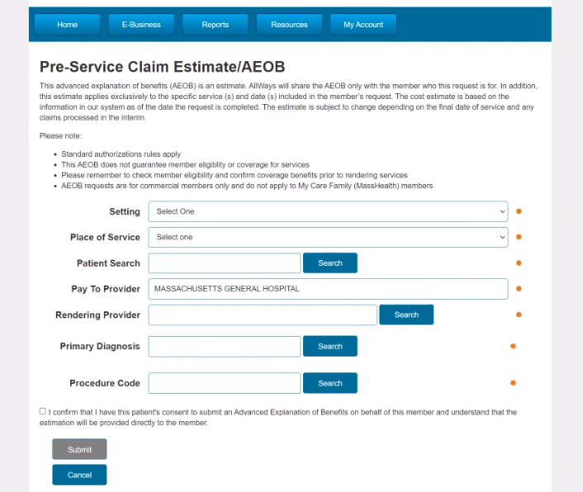
What is the advanced explanation of benefits (AEOB)?
The AEOB is a cost estimate for members to keep them informed about their cost sharing prior to specific scheduled services. A member can request an AEOB after scheduling a service with their provider. Because the final federal rules have not been published, AllWays Health Partners will offer an interim AEOB request process. This is one element of the Federal No Surprises Act. Read more on our blog

Where can I find the form?
You can find our easy-to-use electronic AEOB form on our provider portal under the E-Business tab.

When do I need a revenue code to request a pre-service cost estimate for my patient?
- For professional claims (CMS 1500), no revenue code is required. Please choose SETTING: PROFESSIONAL.
- For facility claims (UB), please be sure to provide the appropriate revenue code

Will I receive a copy of the AEOB?
No, we will provide a copy of the estimate directly to the member who requested it.

What is the turnaround time for AllWays Health Partners to provide my patient with a pre-service cost estimate?
The turnaround time depends on how many days there are between the request and the scheduled date of service:
- For scheduled dates of service less than nine days from when you submit an AEOB request, AllWays will provide pre-service cost estimates no later than one business day from receipt
- For scheduled service dates nine days or more from when you submit the AEOB request, AllWays will provide the pre-service cost estimate no later than three business days from receipt

What are the AllWays Health Partners AEOB disclaimers for providers?
This AEOB request is an estimate and applies exclusively to the specific service(s) codes provided in the request. The estimate is based on the information in our system as of the date the request is completed. The estimate is subject to change depending on the final date of service and any claims processed in the interim.

Please note:
- Standard prior authorization requirements apply
- This AEOB does not guarantee member eligibility or coverage for services
- Remember to check member eligibility and confirm coverage benefits prior to rendering services

What are the AllWays Health Partners AEOB disclaimers for members?
Other plan information is also available on allwayshealthpartners.org.

Please note that the information provided is an estimate based on the information supplied to AllWays Health Partners at the time of the request. It represents best efforts to assist our customers in anticipating cost-sharing prior to services being rendered and/or facilitating a dialogue between patients and providers as to financial responsibilities and treatment options. This estimate does not guarantee coverage and/or pre-approval. The estimated amount may change due to several factors, including but not limited to: changes to your plan design, additional claims received for processing subsequent to this estimate being provided, other services rendered in conjunction with these procedures and changes to a provider’s contract with AllWays Health Partners.

