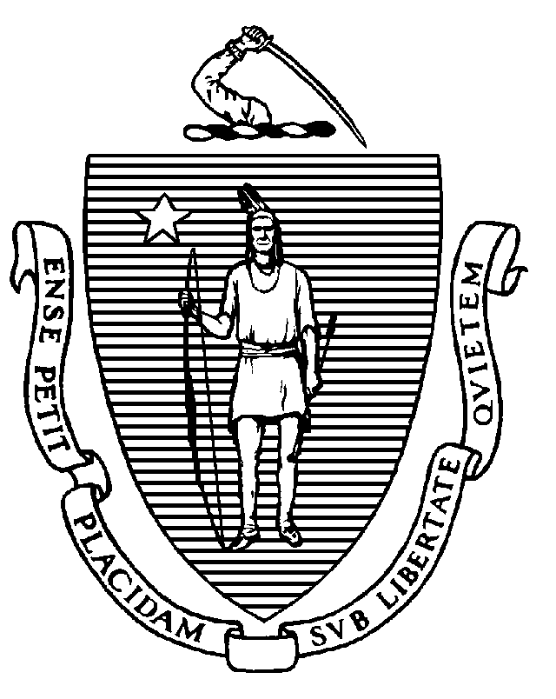
The Commonwealth of Massachusetts
Executive Office of Health and Human Services
Department of Public Health
250 Washington Street, Boston, MA 02108-4619

CHARLES D. BAKER
Governor
KARYN E. POLITO
Lieutenant Governor

MARYLOU SUDDERS
Secretary
MARGRET R. COOKE Acting Commissioner

Tel: 617-624-6000
www.mass.gov/dph

Memorandum

TO: Nursing Home Administrators
FROM: Elizabeth Daake Kelley, MPH, MBA, Director
Bureau of Health Care Safety and Quality
SUBJECT: COVID-19 Personnel Vaccination Requirement
DATE: August 16, 2021

The Massachusetts Department of Public Health (DPH) continues to work with state, federal and local partners to address the Coronavirus Disease 2019 (COVID-19) pandemic. DPH understands the important role that long-term care facilities serve in caring for Massachusetts residents.

The purpose of this guidance is to inform nursing homes about how to ensure all personnel are fully vaccinated, report vaccination data for their facility and explain the enforcement action for facilities who do not comply pursuant to the amendments to 105 CMR 150.000, Standards for Long-Term Care Facilities.

Overview:

All nursing homes must ensure that all personnel are fully vaccinated against COVID-19 by October 10, 2021, unless such administration is medically contraindicated, which means administration of COVID-19 vaccine is likely to be detrimental to the individual’s health; provided, that the individual provides supporting documentation, or the individual objects to vaccination on the basis of a sincerely held religious belief and the individual is able to perform their essential job functions with a reasonable accommodation that is not an undue burden on the nursing home. Personnel may not otherwise decline the vaccine. As of October 10, 2021, nursing homes shall ensure that all new personnel are fully vaccinated or qualify for an exemption from the requirement as described herein prior to being hired or otherwise affiliated with the facility. In order to meet this requirement, nursing homes should ensure that all personnel have received at least the first dose of COVID-19 vaccine, if they are receiving a two-dose series by September 1, 2021.

Facility Documentation:

Nursing homes shall require and maintain for each individual proof of current vaccination against COVID-19 or the individual’s declination statement, and a central system to track the vaccination status of all personnel. The proof of current vaccination and central system must be made available to DPH upon request. Individual proof of current vaccination may include but is not limited to:
- Copy of CDC Vaccination Card
- Copy of MA Immunization Information System (MIIS) Vaccination Record
- Copy of vaccination from their electronic health record

Declination statements from personnel must include but are not limited to each individual who declines vaccination due to medical contraindication or a sincerely held religious belief signing a statement certifying he or she received information about the risks and benefits of COVID-19 vaccine.

Reporting:

Nursing homes must use the Centers for Disease Control and Prevention (CDC) National Healthcare Safety Network (NHSN) to report cumulative weekly COVID-19 vaccination for residents and personnel through the Long-Term Care Facility Component. DPH will use data submitted through the weekly COVID-19 vaccination modules to provide consistent reporting and comparable data across facilities. NHSN data can be used to monitor COVID-19 vaccination trends over time, identify facilities with lower resident and/or personnel vaccination rates, and inform planning and implementation decisions regarding vaccine supply and distribution.

Training, data collection forms, and instructions can be found on the following NHSN website under ‘HCP & Resident COVID-19 Vaccination’: https://www.cdc.gov/nhsn/ltc/weekly-covid-vac/index.html

Facilities can access the COVID-19 vaccination modules by logging into NHSN (via Secure Access Management Service) as they would for any of the other NHSN reporting (cdc.gov). On the NHSN Home page, select the ‘COVID-19’option on the left-hand navigation bar. Personnel and resident data should be entered by selecting ‘COVID-19 Vaccination-HCW’ and ‘COVID-19 Vaccination-Residents’ respectively. This reporting is separate from the ‘Daily Entry’ where facilities enter weekly case counts and supply data. For reference, please see the image below:

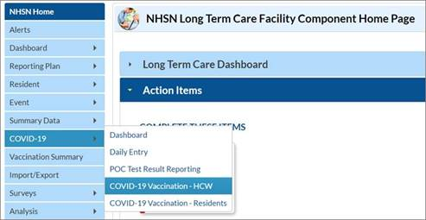

Nursing homes must complete the two vaccination modules each week, no later than Sunday at 11:59 PM, in alignment with the CMS weekly deadline. Beginning Sunday, October 10, 2021, DPH will use submitted information to identify if all personnel are fully vaccinated, unless otherwise exempt, at each facility to assess compliance with the amendments to 105 CMR 150.000.

Enforcement Action:

This guidance serves as notice that if a facility fails to comply with the amendments to 105 CMR 150.000, including the reporting requirements set forth in this or subsequent guidance, it will be subject to the following penalties pursuant to G.L. c. 111, § 73 and 105 CMR 153.024(C):

- DPH will impose a penalty of $50 for a failure to report by October 10, 2021;

- DPH will impose a penalty of $50 per day for each member of the facility’s personnel who is not fully vaccinated against COVID-19.

- If a facility fails to ensure that 75% of personnel or more are vaccinated as of October 10, 2021 then DPH shall have the authority to issue an Admissions Freeze. The Admissions Freeze will not be lifted until facility demonstrates to the Department that the rate of fully vaccinated personnel is 75% or higher.

The Bureau may revise, change, update, or rescind this memorandum at any time.

DPH strongly encourages all health care facilities in Massachusetts to monitor the Centers for Medicare & Medicaid Services (CMS) website and the Centers for Disease Control and Prevention (CDC) website for up-to-date information and resources:
- CMS website: https://www.cms.gov/About-CMS/Agency-Information/Emergency/EPRO/Current-Emergencies/Current-Emergencies-page
- CDC website: https://www.cdc.gov/coronavirus/2019-ncov/hcp/facility-planning-operations.html
  - For reference, since first responders are part of the COVID-19 response, the CDC healthcare personnel exposure guidance may be found here: https://www.cdc.gov/coronavirus/2019-ncov/hcp/guidance-risk-assesment-hcp.html

Additionally, please visit DPH’s website that provides up-to-date information on COVID-19 in Massachusetts: https://www.mass.gov/2019coronavirus.

If a Nursing Home has reason to dispute the penalty, they may request Administrative Review.

