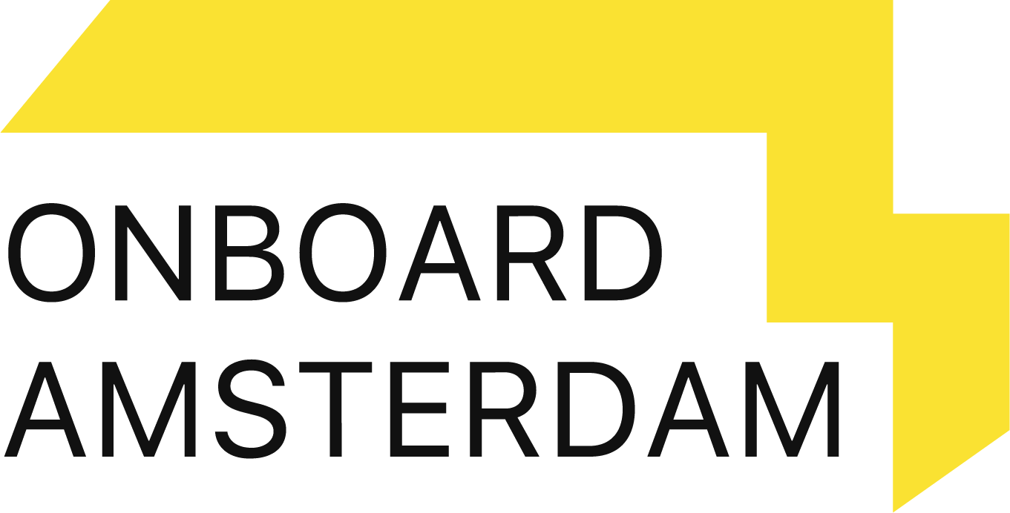

Onboard Award 2021: Become an onboarding legend!

Good onboarding is more important than ever. More and more employees are starting their journey from home or working partly remote. It’s safe to say the new way of working takes a lot of getting used to. Having a structured onboarding process for new recruits plays a vital role in the retention and engagement of your employees. An effective process allows new hires to acquire the necessary knowledge, skills, and behaviors not only for understanding their role, but helps them find their purpose at work.

We want to reward our customers that have perfected their onboarding processes. It’s time for our third edition of the Onboard Award!

Share your onboarding process, hybrid approach, highlights, feedback, internal involvement and measures of success in the six sections below. Give context, share your achievements but also tell us about the onboarding journey itself.

If you have any questions or would like additional information, do not hesitate to contact your Customer Success Manager.

Additional information:
* Please email your entry to marketing@appical.nl before the 15th of October
* We’ll be contacting the finalists on 22nd of October
* Award Ceremony: Thursday the 4th of November at Onboard Amsterdam 2021

General info:

Company name:

Total number of employees:

Total number of new hires in the last 12 months:

Award entry (National (Dutch) or International)?

When did you start your onboarding program?

What is the main reason you created an onboarding program?

How many countries/target groups are in your onboarding program?

Onboard.Award entry

The onboarding process (max 400 words)
Please describe how your onboarding process (pre-and onboarding) is structured. Please include the following:
- A detailed description of the onboarding process that clearly describes each step (timeline with milestones)
- Do you have multiple journeys for different departments or focus areas?
- Are all new hires onboarded in the same way?

Comprehensive hybrid onboarding (max 600 words)
Please tell us about your onboarding program and incorporate the 4C’s of onboarding framework; compliance, clarification, connection and culture:
- How are the basic legal and policy-related rules and regulations translated in your onboarding?
- Explain how the new hire gets all the components they need to thrive at work (set expectations)
- Is your onboarding journey personalized with live contact moments? If so, what are these moments?
- How does the new hire get introduced to the company culture during the onboarding journey?

Creativity & Innovation (max 300 words)
What do you consider to be the most creative or innovative part of your onboarding? Please include the following questions:
- What do you consider to be the creative highlight of your onboarding program?
- What are your short term goals in terms of innovation?
- Could you describe the technological environment; software solutions you use to create an effortless way of working.

Feedback (max 300 words)
Please describe how you collect feedback about the onboarding process. Do you treat onboarding as a living, changing process that ensures you are always able to adapt and improve? Think of the following:
- How often do you currently gather feedback on your onboarding journey and in what way?
- How do you follow up on the feedback you receive?
- Who in the organization is responsible for the follow up of the onboarding process?

Internal involvement (max 300 words)
Please explain how you have created internal involvement in the company’s onboarding journey. Please include the following:
- In which way are internal stakeholders involved in the onboarding process?
- How do you actively motivate managers to participate in the onboarding of a new hire?
- Is there a buddy system integrated?

Measurable results (max 400 words)
What kind of impact do your solutions have on the new hires? How do you measure the success of your onboarding strategy? Please include the following:
- How do you track employee happiness and satisfaction? Could you share some results?
- How do you measure turnover/retention? Could you share some results?

