An Introduction to Copybox

Copybox

Copybox is where we store all the content associated with your listing. Here you can manage the number of images, the description, the categories, how many bullet points, and variations there are for the item.
Loading Data
To use Copybox, you'll first need to upload some products. You can add your products individually by clicking on Add Product, or you can select Upload File and upload a CSV file containing a list of the ASINs/SKUs you want to add. In order to help you keep your catalog organized, Copybox supports uploading custom fields. These columns can be used to subset, sort, or filter your data quickly.
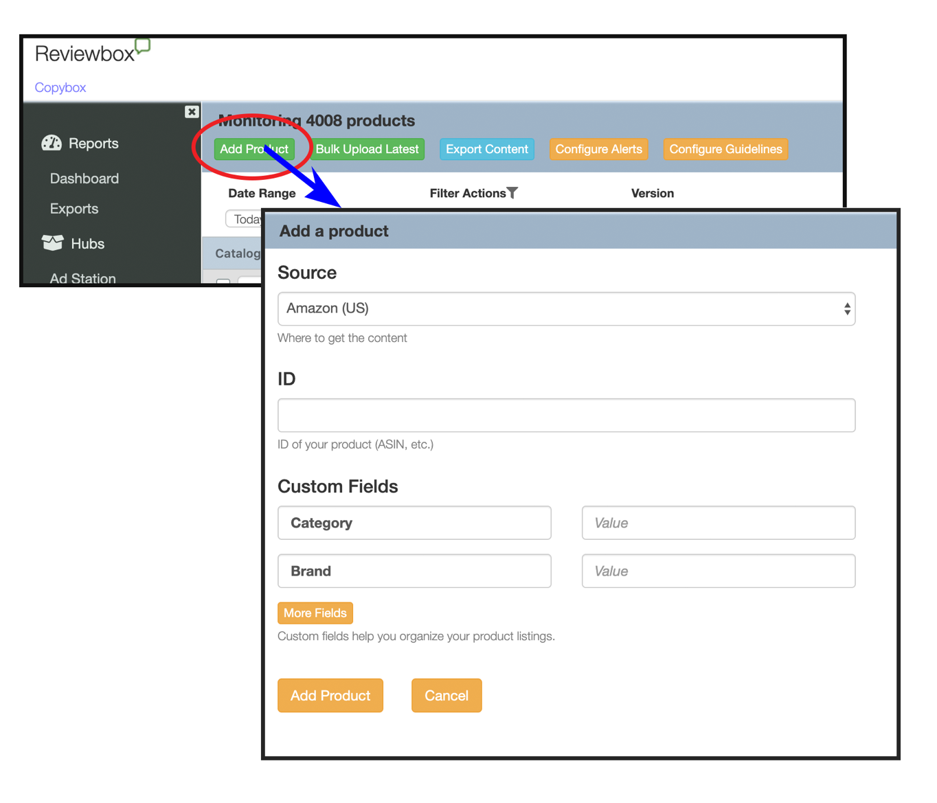
Here is an example of what a CSV file upload should look like. The columns “Category” and “Internal_SKU” are optional. These are columns you can add for your internal use.
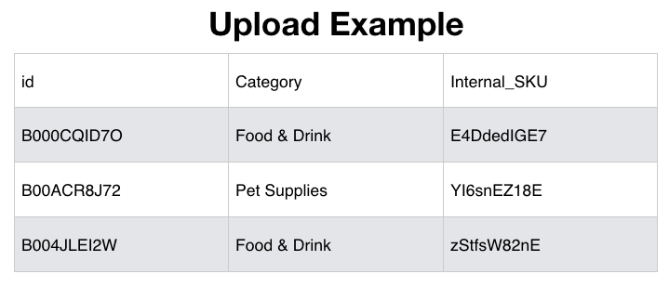
Setting Up Guidelines
There are two main types of guidelines you can set in Copybox. First you can set up some general guidelines. “Configure Guidelines” (located in the toolbar) allows you to set some minimum characters for the title, description, and bullet points. You can also set some minimum number of bullet points and images that you’d like to be associated with each listing. You can also choose to be notified of when your listings differ from those specifications.
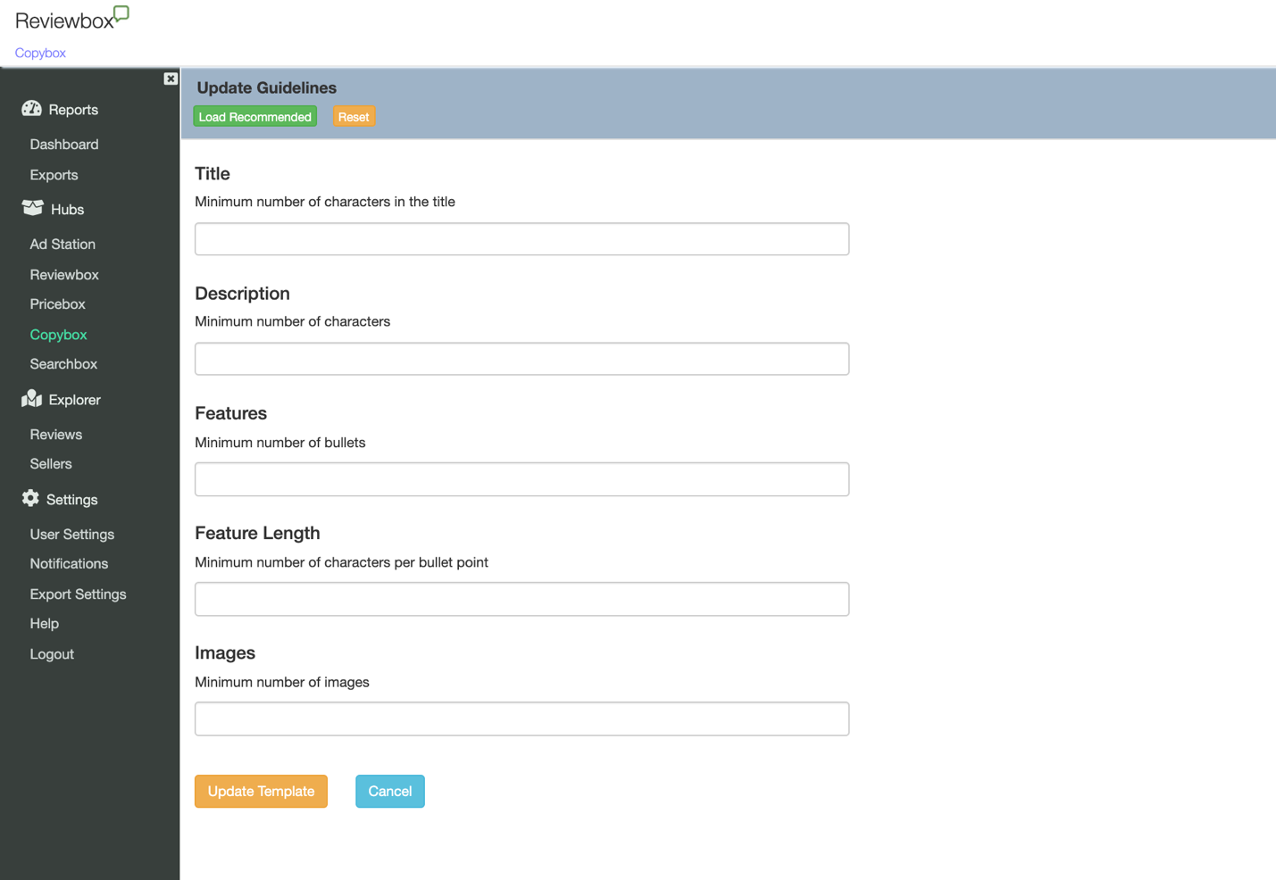
If you’d like to set some more specific guidelines, you can do that by uploading some reference content. (LINK TO REFERNCE TEMPLATE DOC) Reference content can be specific to each and contain exactly how you would like the title, description, and bullet points to read on the product page. To upload a template, go to the drop-down Version menu in the toolbar and select “Official.” Then select the Bulk Upload tab in the toolbar.

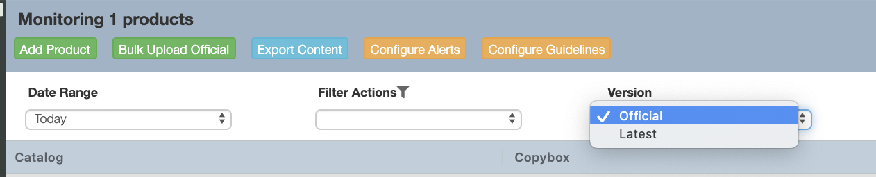

Once you upload a template, we will check your listings against that template and let you know when there are any differences.
Click on the name of the product to see which guidelines are not in compliance and what updates were made to the listing content. Update uploaded content guidelines within the page to keep them current.
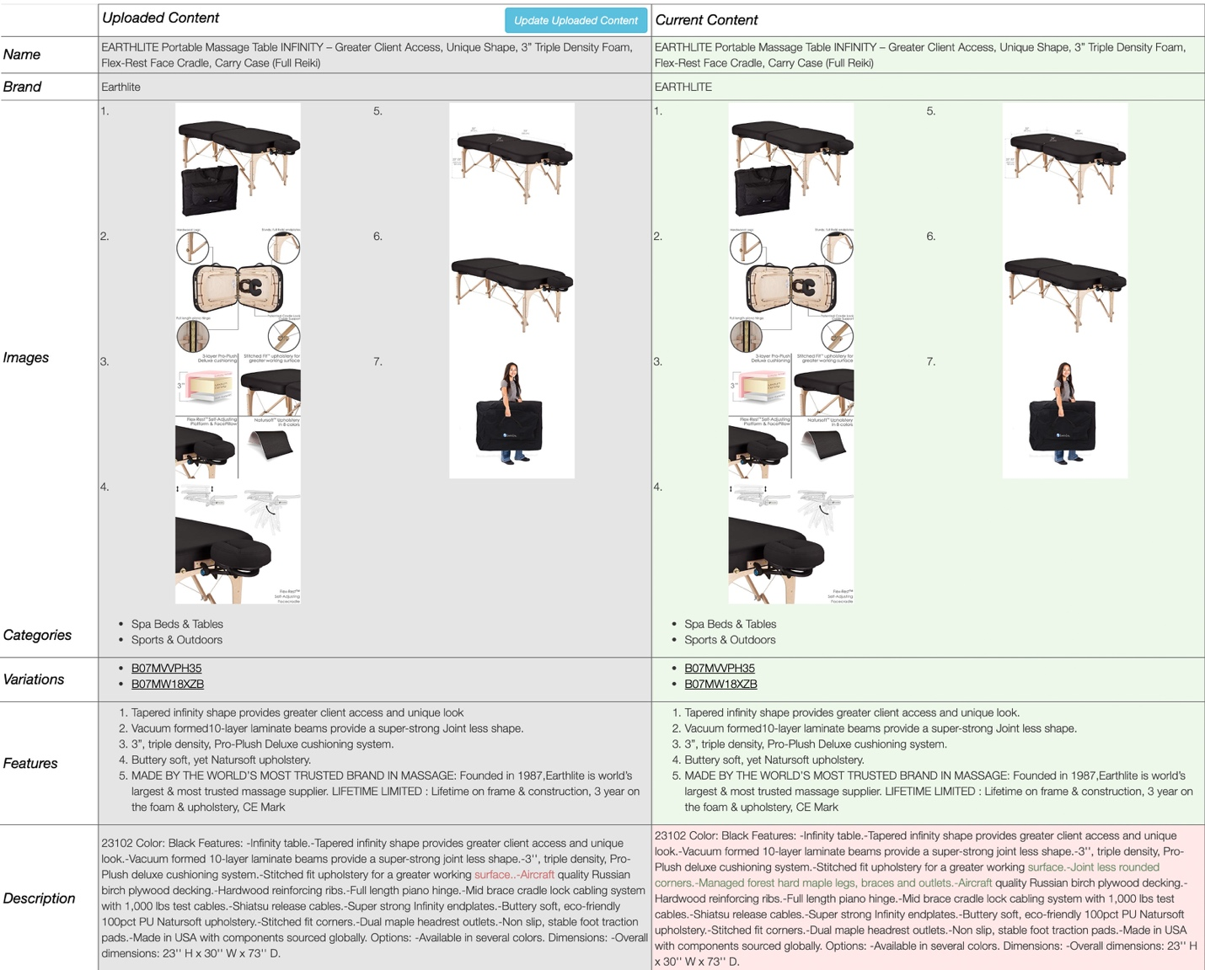

Select Configure Notifications in the toolbar to set up your custom notifications. You can choose who receives notifications, how often, and for what changes.

