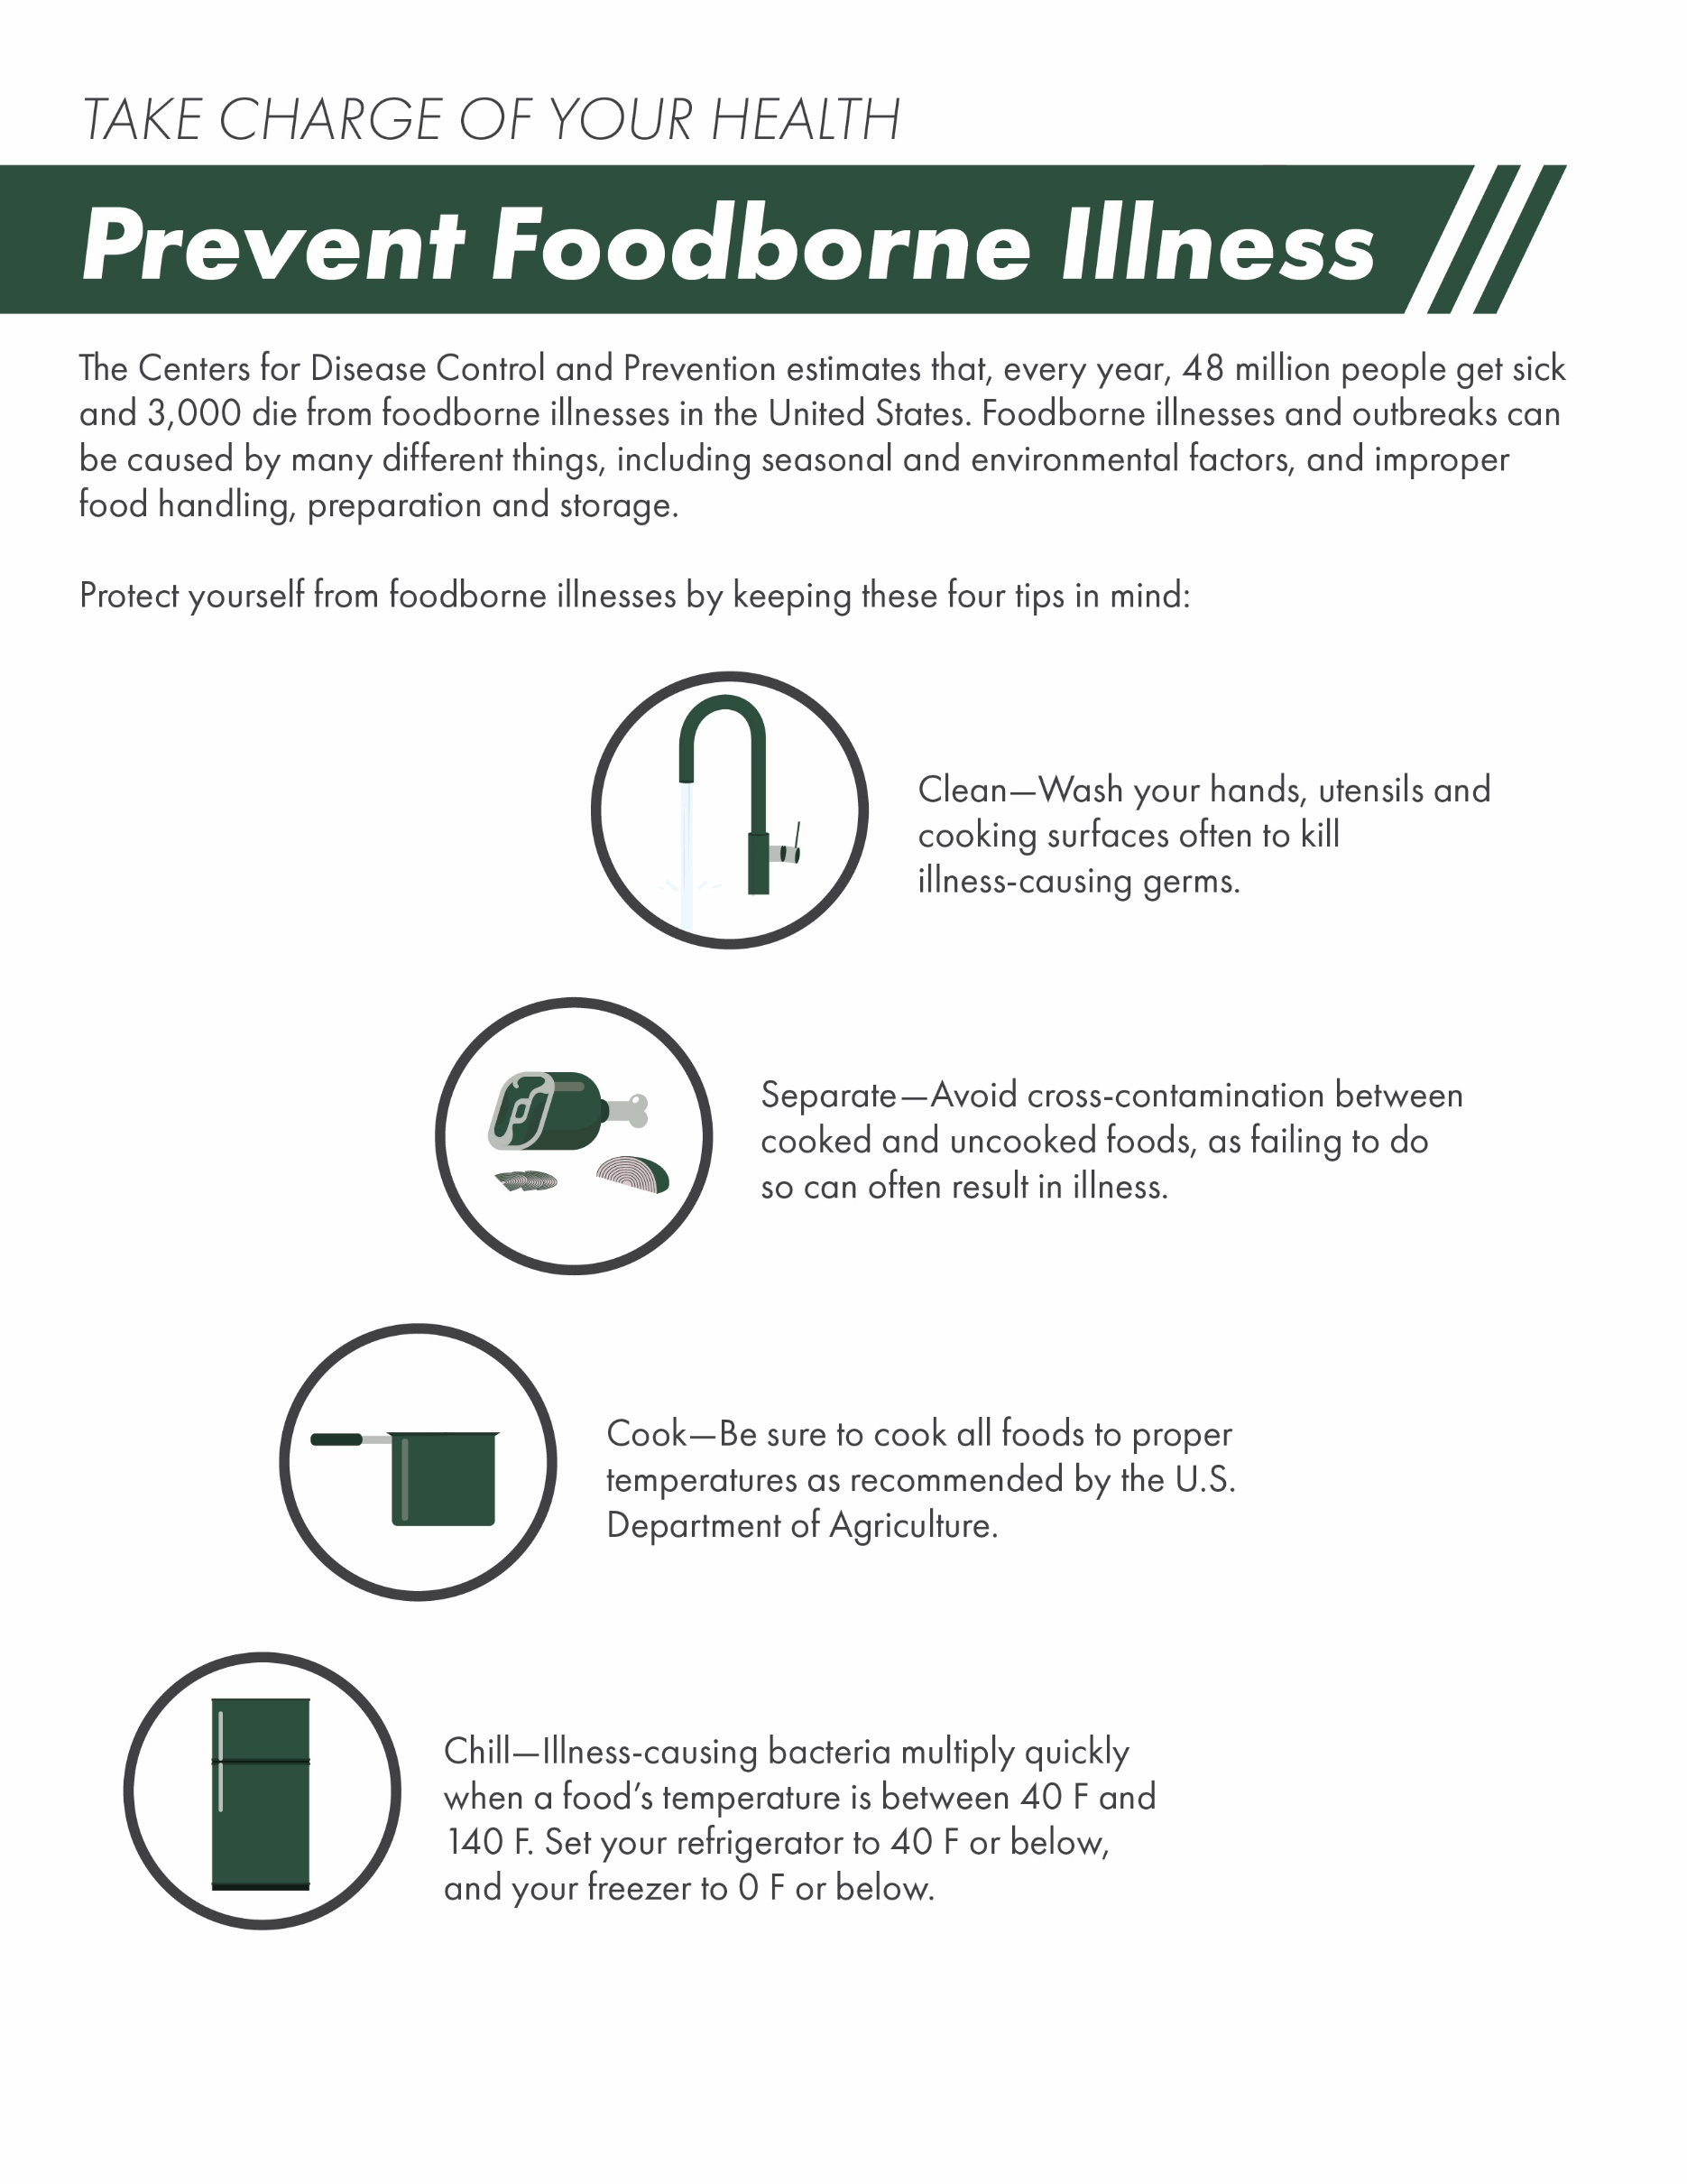

This infographic is intended for informational purposes only and is not intended to be exhaustive, nor should any discussion or opinions be construed as professional advice. Readers should contact a health professional for appropriate advice.

© 2021 Zywave, Inc. All rights reserved.