[Today’s Date]
Your Pharmacy
Logo Goes
Here
[Name of Recipient]
[Address]
[City, St Zip]

Hello [First Name of Recipient],

[Pharmacy Name] just started rolling out our life-changing new service called PakMyMeds™ that will help you simplify your medication routine.

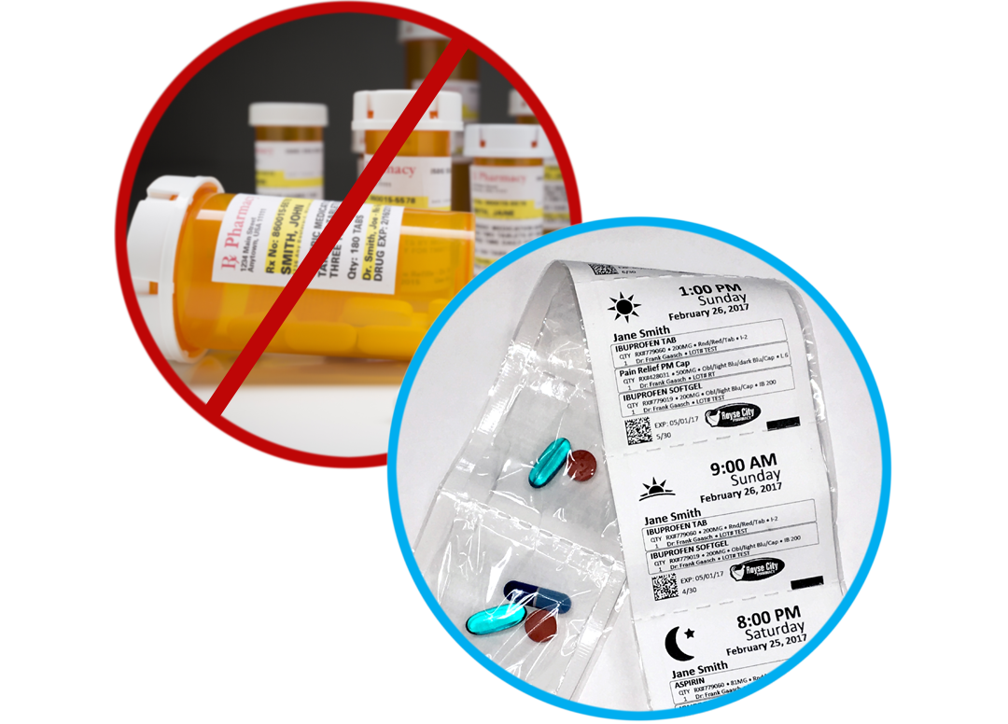
PakMyMeds is a free pouch packaging service that helps people who are on multiple medications to manage their daily doses. We organize and package all your medications for you, removing all the hassle and guesswork. Your medications are sorted for you into convenient pouches marked by dosage, day, date and time.

Get started with this free offering today by contacting the phone or email listed below. Say “goodbye” to pill bottles and “hello” to healthy living.

Thanks for being our valued patient!

Sincerely,

[Pharmacy Name]
[Pharmacy Phone]
[Pharmacy Email]

Enclosures: 1

