[Today’s Date]
Your Pharmacy
Logo Goes
Here
[Name of Recipient]
[Address]
[City, St Zip]

Hello [First Name of Recipient],

Thank you for your interest in PakMyMeds™ medication pouch packaging. PakMyMeds is a free service offered by [Pharmacy Name]. This service helps people on multiple medications manage their daily doses. Our pharmacy will organize and package all your medications for you, removing the hassle and time-consuming organization that pill bottle delivery incurs.

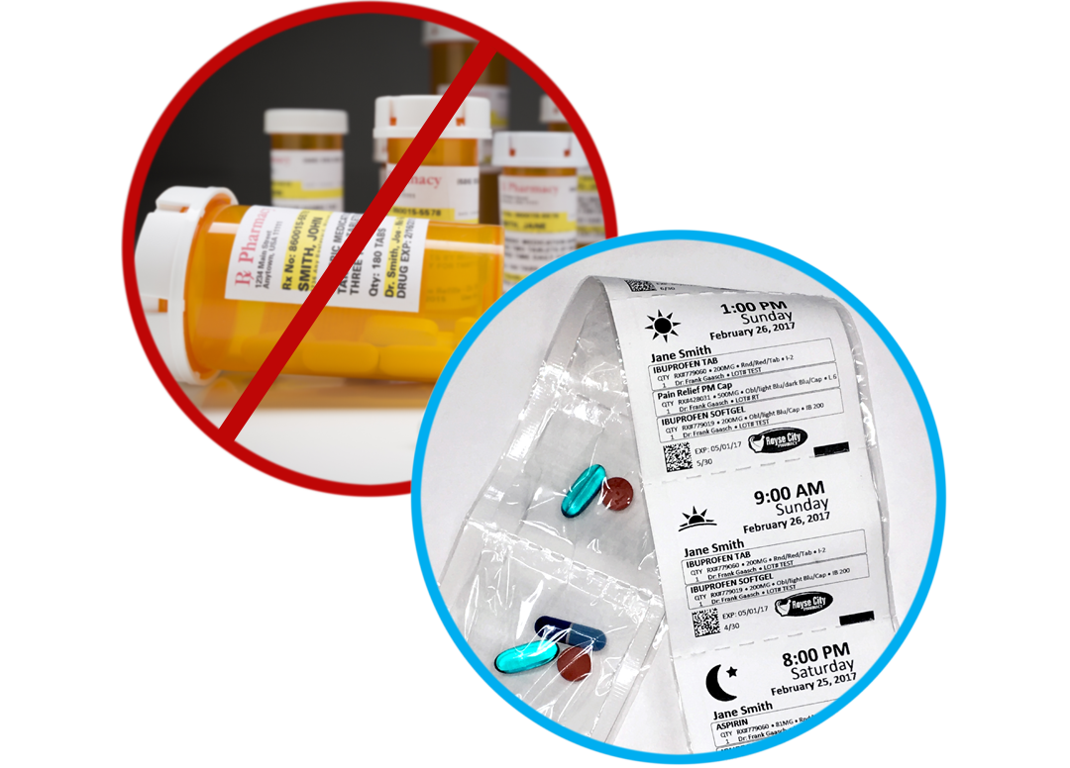
Easily simplify your life by letting us package your medications for you in convenient pouches marked by dosage, day, date and time. All you need to do is contact us at the phone or email listed below. Let us know the name of your doctor and insurance provider and we will transfer your medications for you.

Say “goodbye” to pill bottles and “hello” to healthy living. We look forward to serving you!

Sincerely,

[Pharmacy Name]
[Pharmacy Phone]
[Pharmacy Email]

Enclosures: 1

