Topic 5: Energetics
5.1 | Measuring energy changes
5.1.1 | Heat is a form of energy
5.1.2 | Temperature is a measure of the average kinetic energy of the particles
5.1.3 | Total energy is conserved in chemical reactions
5.1.4 | Chemical reactions that involve transfer of heat between the system and the surroundings are described as endothermic or exothermic
5.1.5 | The enthalpy change (ΔH) for chemical reactions is indicated in kJ mol⁻¹
5.1.6 | ΔH values are usually expressed under standard conditions, given by ΔH° including standard states
5.1.7 | Calculations of the heat change when the temperature of a pure substance is changed using $q=mc∆T$
5.1.8 | A calorimetry experiment for an enthalpy of reaction should be covered and the results evaluated
Heat and Temperature
- Energetics is the study of heat changes in chemical reactions
  - Heat is a form of energy
- Energy can neither be created nor destroyed. Total energy is always conserved and can only be transferred
- Heat energy always flows from a higher temperature object to a lower temperature object
- The Kelvin scale is based on kinetic energy, so 0K means that there is no kinetic movement at all
Definitions
Heat – A measure of the total kinetic energy of particles in a substance
Temperature – A measure of the average kinetic energy of particles in a substance

Enthalpy (H)
- Enthalpy (H): The amount of heat energy contained in a substance
- Enthalpy is stored in the chemical bonds as potential energy
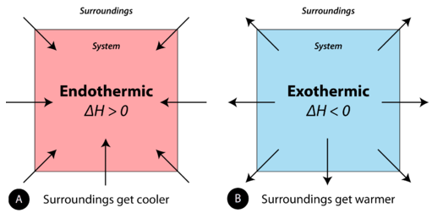
- When substances react, the total enthalpy of a system cannot be measured (due to loss of heat), but it is possible to measure the difference in the enthalpy between the reactants and products
- Enthalpy is denoted as H, however heat change is denoted as ΔH
- The enthalpy change for chemical reactions is denoted kJ mol⁻¹
- The reaction mixture is called the system (the chemical reaction), which gives heat to or takes heat from the surroundings (anything around the system)
- Chemical reactions that involve transfer of heat between system and the surroundings are described as exothermic and endothermic
Exothermic: Heat is Released
- In exothermic reactions heat is released to the surroundings
  - This is because more heat energy is released than what is added
  - So, the overall heat energy is released from the system, causing the surroundings to become hotter
- Exothermic reactions have negative ΔH values, because heat is released (thus enthalpy decreases, -ΔH)
- In an exothermic reaction, the products are more stable than the reactants as they have a lower enthalpy
  - Less heat means more stable
- This means the reaction is downhill in terms of heat energy
- Exothermic reactions release energy (as heat)
- Examples include:
  - Bond forming: Removing heat brings atoms closer together, forming bonds
  - When chemical bonds are formed, heat is released (See 5.3)
  - Gas -> Liquid -> Solid: Heat is removed, thus these are exothermic reactions
  - Rain: The condensation of water vapor into rain releases energy in the form of heat
  - Combustion: The burning of carbon compounds uses oxygen from air, and produces CO₂, H₂O and lots of heat
Endothermic: Heat is Absorbed
- In endothermic reactions heat is absorbed from the surroundings
  - This is because more heat energy is added than what is released
  - So, the overall heat energy is absorbed by the system, causing the surroundings to become cooler.
- Endothermic reactions have positive ΔH values, because heat is absorbed (thus, enthalpy increases +ΔH)
- In an endothermic reaction, the produces are less stable than the reactants as they have a higher enthalpy
  - More heat means less stable
- This means the reaction is uphill in terms of heat energy
- Exothermic reactions require energy (through heat)
- Examples include:
  - Bond breaking: Adding heat separates atoms, breaks bonds (See 5.3)
  - Photosynthesis: Plants absorb heat energy from sunlight to convert CO₂ and water into glucose and oxygen
  - Solid -> Liquid -> Gas: Heat is added, so the reactions are endothermic
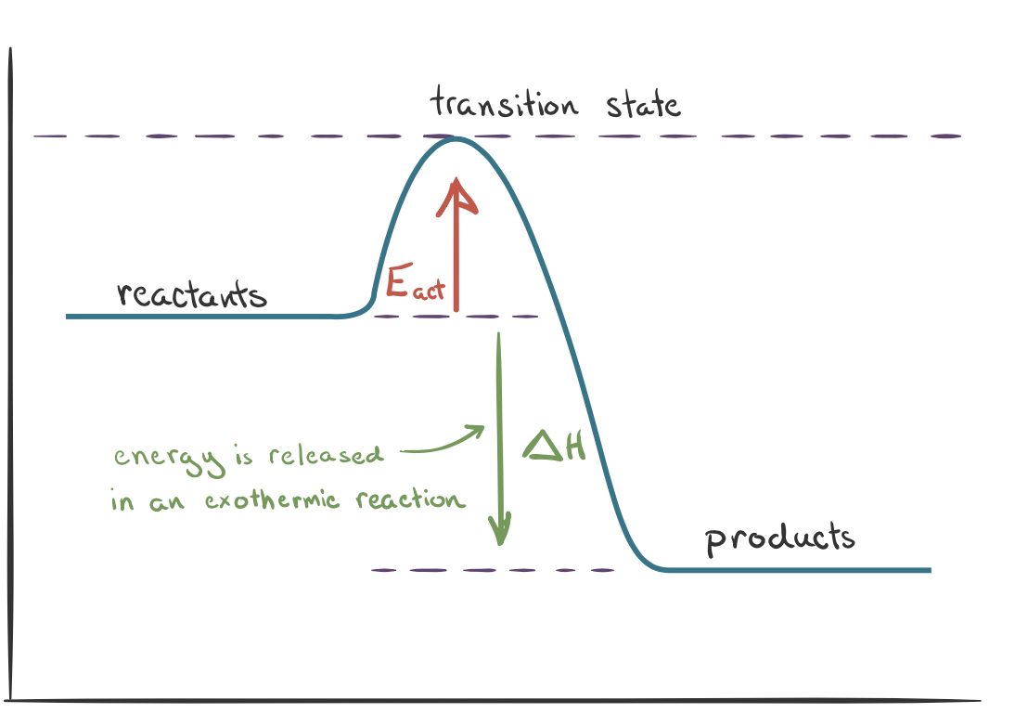
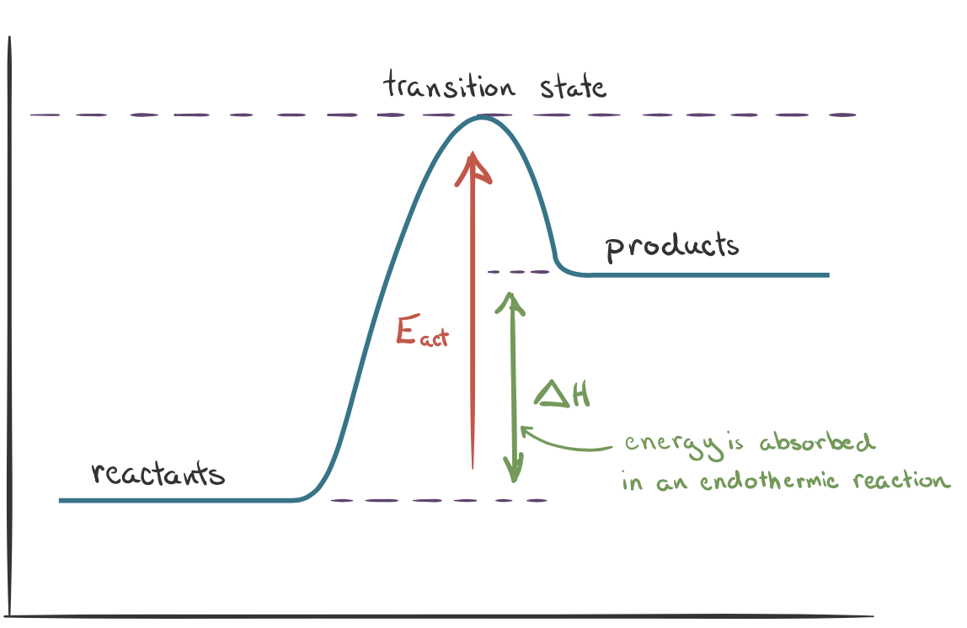
Energy Diagrams: Endothermic and Exothermic Reaction

Enthalpy
Enthalpy

Reaction Pathway
Reaction Pathway

Standard Enthalpy change: $∆H_{x}^{θ}$
- Standard enthalpy change of reaction: The enthalpy change of a reaction carried out under standard with everything in its standard state
- Only $∆H_{ }^{θ}$ can be measured, not $H$
- Standard enthalpy change is measured in kJ mol⁻¹
$∆H_{x}^{θ}$
- $∆H$: Refers to Enthalpy change
A positive value indicates an endothermic reaction while a negative value indicates an exothermic reaction
b) $θ$: Refers to standard conditions where 289K, 101.3 kPa, 1 mol dm⁻³
Standard conditions are necessary as enthalpy changes will have different values depending on the conditions under which they are measured. Therefore, all enthalpy changes are performed under standard conditions
c) $x$: Refers to the type of enthalpy change
Sometimes, bond enthalpies are average values/differ (slightly) from one compound to another so the standard enthalpy will not be the same value in the data booklet

Standard Enthalpy of Formation: $∆H_{f}^{θ}$
- The standard enthalpy change of formation ($∆H_{f}^{θ}$): The energy change when one mole of a compound is formed from its elements in their standard states under standard conditions
- To calculate enthalpy change from formation:
$$∆H_{ }^{θ}=\sum{∆H_{f}^{θ}\left(products\right)-\sum{∆H_{f}^{θ}\left(reactants\right)}}$$
- $∆H_{f}^{θ}$ values are found in the data booklet (remember to include coefficients) (Elements have a $∆H_{f}^{θ}$ value of zero)
Standard Enthalpy of Combustion: $∆H_{comb}^{θ}$
- The standard enthalpy change of combustion (∆H_{c}°): The energy released when one mole of a compound is completely burned in excess oxygen under standard conditions with no change in pressure
- Combustion reactions always produce CO₂ and H₂O
- All combustion reactions are exothermic (always negative) as heat is released during combustion process
- To calculate enthalpy change from combustion:
$$∆H^{θ}=\sum{∆H_{comb}^{θ}\left(reactants\right)-\sum{∆H_{comb}^{θ}\left(products\right)}}$$
Thermochemical equations
- Thermochemical equations give the balanced equation with an enthalpy charge
- State symbols must be shown, as $∆H^{θ}$ depends on the state of the reactants or products
- In order to calculate energy changes for a specific amount of a substance using the thermochemical equation:
Question
Calculate the energy released, in kJ, when 0.500kJ SO₃ reacts with water
$${SO}_{3}+H_{2}O→H_{2}SO_{4} {∆H}^{θ}=-129.6 kJ {mol}^{-1}$$
Step 1: Calculate how many moles of SO₃ there are:
$$n\left(SO_{3}\right)=\frac{1000g}{80.07}=12.49mol$$
Step 2: Compare to thermochemical equation:
1 mol of SO₃ releases 129.6 kJ, therefore 12.5 mol of SO₃ releases $- x$ kJ
Step 3: Use ratios:
$$\frac{1}{12.5}=\frac{-129.6}{x}=-1618 kJ$$
Heat changes calculations
- Heat changes (enthalpy) can be calculated from the temperature changes:
$$q=mc∆T$$
- $q$: heat change
- $m$: mass (Use the mass of water unless specified)
- $c$: specific heat capacity
  - Specific heat capacity (c): The energy required to raise the temperature of 1g of substance by 1K
- $∆T$: Temperature change
  - If the temperature of the compound increased, then the reaction is endothermic and $q$ must be positive
  - If the temperature of the compound decreased, then the reaction is exothermic and $q$ must be negative
For calorimetry experiments take the absolute value of $∆T$ then:
  - If the temperature of the water INCREASED, then the reaction is exothermic and $q$ must be negative
  - If the temperature of the water DECREASED, then the reaction is endothermic and $q$ must be positive
Enthalpy Change
- To calculate enthalpy change ($∆H$), the equation below can be used:
$$∆H=\frac{q (energy, kJ)}{n (mol)}$$
- However, $∆H$ can be either positive or negative. Simply add a positive or negative sign to $Q$ when:
  - The temperature of the substance INCREASED, then the reaction was endothermic and $Q$ is positive
  - The temperature of the substance DECREASED, then the reaction was exothermic and $Q$ is negative
Standard Enthalpy of Neutralization: $∆H_{neut}^{θ}$
- The standard enthalpy change of neutralization (∆H_{neut}°): The enthalpy change when a strong acid and base react together to form one mole of water under standard conditions
- Neutralization reactions are exothermic (always negative) as heat is released
- To calculate enthalpy change from combustion:
- Calculate the number of moles of acid and base using $n=cv$
- Determine the limiting reactant. This will tell you how many moles of water can be produced
- Add the volumes of acid and base together (where 1cm³=1g) to get the mass
- Use $Q=mc∆T$ to calculate enthalpy change
- Use $∆H=\frac{Q}{n}$ where $n$ is number of moles of water produced
Calorimetry
- Calorimetry is the process of measuring the amount of heat released or absorbed during a chemical reaction
- When the reaction occurs, it is either going to give off or take in heat
- The change in heat can be measured by observing the temperature of water, as water can serve as the surroundings
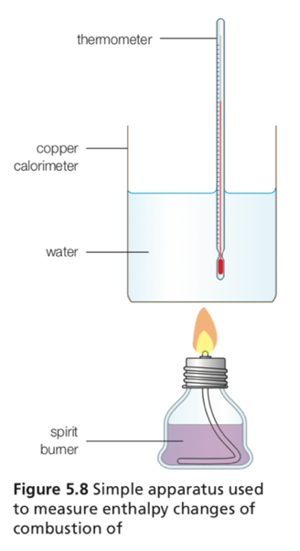
- There are many ways to perform calorimetry, the most common is to use a bomb shell
- Calorimetry is performed many different ways:
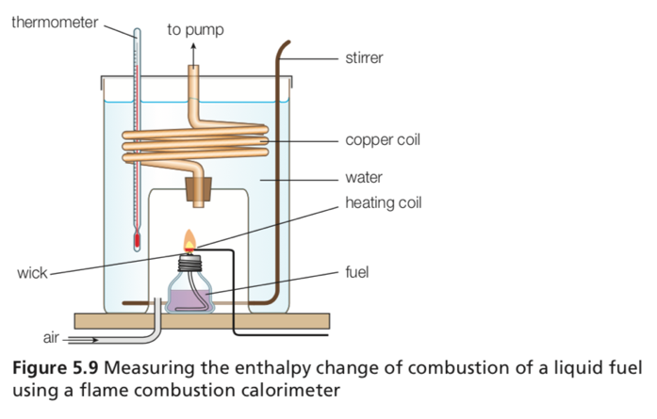
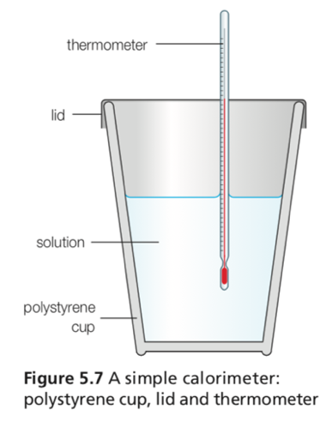

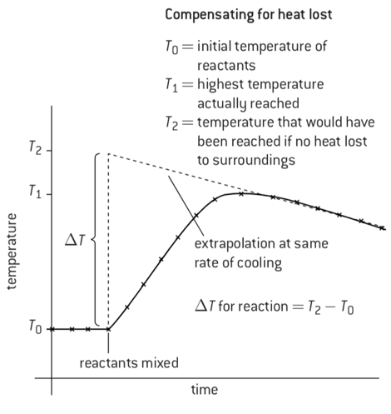
- However, when using calorimetry several assumptions are made
- This is because heat loss and incomplete combustion can lead to systematic errors in experimental results
- These assumptions are:
- That all the heat is transferred to the water
(Some might be transferred to the metal or is still inside the system)
- That all the solution has dissolved
- The mass of the water remained constant
- There was an unlimited oxygen source
- The experiment was under standard conditions
- To compensate for heat lost by the water we can extrapolate the graph recorded
- By extrapolating the graph, the temperature rise that would have taken place had the reaction been instantaneous can be calculated by taking $T_{2}-T_{0}$
5.2 | Hess’s Law
5.2.1 | The enthalpy change for a reaction that is accrued out in a series of steps is equal to the sum of the enthalpy changes for the individual steps
5.2.2 | Application of Hess’s Law to calculate enthalpy changes
5.2.3 | Calculation of $∆H$ reactions using $∆H_{f}^{o}$ data
5.2.4 | Determination of the enthalpy change of a reaction that is the sum of multiple reactions with known enthalpy changes
Hess’s Law
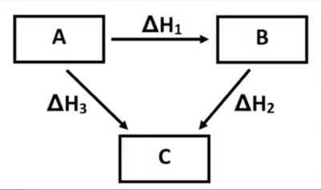
- Hess’s Law states that regardless of the multiple stages or steps of a reaction, the total enthalpy change for the reaction is the sum of all changes
- This means the enthalpy change going from A to B is the same whether the reaction proceeds directly to A or whether it goes via A to C then B
- This is known as an energy diagram and can be written as two reactions that when combined produce the overall equation: ∆H₃ = ∆H₁ + ∆H₂
Question
Using the equation below:
$$C+O_{2}→CO_{2} ∆H=-390 kJ {mol}^{-1}$$
$$Mn+O_{2}→MnO_{2} ∆H=-520 kJ {mol}^{-1}$$
Which is the enthalpy change for the following reaction?
$$MnO_{2}+C→Mn+CO_{2} ∆H=-390 kJ {mol}^{-1}$$
As you can see, if we reverse the second reaction (and change the sign of the enthalpy), it cancels to give the above reaction, therefore the enthalpy change is -390 + 520 = 130 kJ mol⁻¹

5.3 | Bond enthalpies
5.3.1 | Bond-forming releases energy and bond-breaking requires energy
5.3.2 | Average bond enthalpy is the energy needed to break one mol of a bond in a gaseous molecule averaged over similar compounds
5.3.3 | Calculations of the enthalpy changes from known bond enthalpy values and comparison of these to experimentally measured values
5.3.4 | Sketching and evaluation of potential energy profiles in determining whether reactants or products are more stable and if the reaction is exothermic or endothermic
5.3.5 | Discussion of the bond strength in ozone relative to oxygen in its importance to the atmosphere
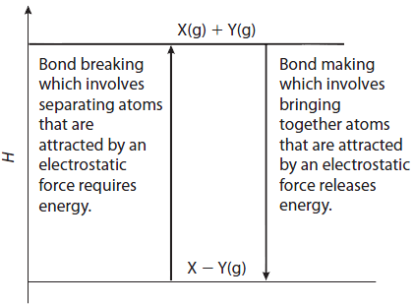
Bond enthalpy
- Average bond enthalpy: The energy required to break one mole of the same type of bond in the gaseous state averaged over a variety of similar compounds
- Energy is released through the formation of chemical bonds
  - Bond forming: Removing heat brings atoms closer together, forming bonds
  - Releases energy, $∆H$ negative therefore exothermic
- Energy is required when breaking chemical bonds
  - Bond breaking: Adding heat separates atoms, breaks bonds (See 5.3)
  - Requires energy, $∆H$ positive therefore endothermic

- The enthalpy of reaction ($∆H^{θ}$) can be calculated using bond enthalpies
- Since there are average bond enthalpies, the calculation gives only an approximate result. To calculate:
$$∆H^{θ}=ΣE\left(bonds broken\right)- ΣE(bonds formed)$$
- $E$ represents the bond energy per mol of bonds (see data booklet)
- When $ΣE\left(bonds broken\right)>ΣE\left(bonds formed\right)$ the reaction is endothermic
- When $ΣE\left(bonds formed\right)>ΣE\left(bonds broken\right)$ the reaction is exothermic
Question
Calculate the enthalpy of reaction of methane: $CH_{4}+2O_{2}→CO_{2}+3H_{2}O$
$$Enthalpy of reaction=ΣE\left(bonds broken\right)- ΣE\left(bonds formed\right)$$
$$Enthalpy of reaction=\left(4\left(C-H\right)+2\left(O=O\right)\right)-\left(2\left(C=O\right)+6\left(H=O\right)\right)$$
$$Enthalpy of reaction=\left(4×414×+2×498\right)-(2×804+6×463)$$
$$Enthalpy of reaction=-1734 kJ {mol}^{-1}$$
- However, bond enthalpies can only be used by themselves if all the reactants and products are in the gaseous state
Ozone depletion
- Oxygen is present in the atmosphere in two forms:
  - Normal oxygen: O₂
  - Ozone: O₃
- Much of the harmful UV radiation is absorbed by the ozone layer
- The ozone layer forms a protective screen which absorbed the UV light to ensure that the radiation that reaches the surface of the Earth is different from the emitted by the Sun
  - Without the ozone layer the UV radiation would have caused damage to living tissue
- The bond in oxygen and ozone are both broken when they absorb UV radiation of sufficient energy
- However, both oxygen and ozone are broken by UV light of different wavelengths
- This is because the bonds in oxygen, O₂, are stronger than those in ozone, O₃
- The stronger double bond in O₂ requires higher energy UV radiation (Shorter wavelength) to break
- The wavelengths of light needed to break the bonds in ozone are calculated using a modified Planck’s equation:
$$E_{photon}=\frac{h×c}{λ}$$
Ozone depletion question:
The bond energy in ozone is $363 kJ {mol}^{-1}$. Calculate the wavelength of UV radiation needed to break the bond
One mole of photons are needed to break one mole of bonds. The energy of a mole of photos is the energy of one photon multiplied by Avogadro’s number ($L$)
$$L×E_{photon}=363 000 J$$
$$E_{photon}=\frac{363 000}{6.02×{10}^{23}}$$
We want to find wavelength, $λ$, so by rearranging Planck’s equation:
$$λ=\frac{h×c}{E_{photon}}$$
$$λ=330nm$$
Any radiation in the UV region with a wavelength smaller than 330nm breaks the bond in ozone
- The bonds in O₃ are broken by UV radiation with a wavelength of <330nm
- The bond in O₂ is broken by UV radiation with a wavelength of <242nm
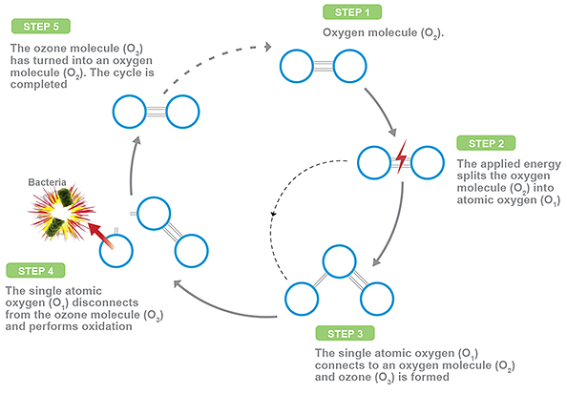
The Ozone-Oxygen Cycle
- The ozone–oxygen cycle is the process by which ozone is continually regenerated in Earth's stratosphere
- It describes how ozone is both formed and depleted by natural processes in the atmosphere (diagram on right)
- In the atmosphere, high-energy UV breaks the strong bonds in O₂ so that O3 can be formed. Lower-energy UV breaks the weaker bonds in O₃
- This cycle of reactions is significant because dangerous ultraviolet light has been absorbed and the stratosphere has become warmer
15.1 | Enthalpy cycles
15.1.1 | Representative equations can be used for enthalpy/energy of hydration, ionization, atomization, electron affinity, lattice, covalent bond and solution
15.1.2 | Enthalpy of solution, hydration enthalpy and lattice enthalpy are related in an energy cycle
15.1.3 | Construction of Born-Haber cycles for group 1 and 2 oxides and chlorides
15.1.4 | Construction of energy cycles from Born-Haber or dissolution energy cycles
15.1.5 | Relate size and charge of ions to lattice and hydration enthalpies
15.1.6 | Perform lab experiments which could include single replacement reactions in aqueous solutions
Born-Haber Cycle
- Born-Haber cycles are energy cycles describing the formation of ionic compounds
- Lattice enthalpy cannot be measured because gaseous ions do not combine directly to form a compound
- The Born-Haber cycle allows the experimental lattice enthalpy to be calculated from other enthalpy changes
  - Hess’s law can be used to find any missing value from a Born Haber cycle, not just a lattice enthalpy
- Remember the following:
Energy cycle | Definition | Equation
Ionization enthalpy $∆H_{i}^{θ}$  First ionization energy | The energy required to remove 1 mole of an electron from 1 mole of an atom in gaseous state*  Since ionization always requires energy, it is always endothermic | $$X\left(g\right)→X^{+}\left(g\right)+e^{-}$$
Second ionization energy | The energy required to remove 1 mole of an electron from 1 mole of an ion in its gaseous state* | $$X^{+}\left(g\right)→X^{2+}\left(g\right)+e^{-}$$
Electron affinity enthalpy $∆H_{e}^{θ}$  First electron affinity | The energy change when 1 mole of an electron is added to 1 mole of an atom in its gaseous state* | $$X\left(g\right)+e^{-}→X^{-}\left(g\right)$$
Lattice Enthalpy $∆H_{lat}^{θ}$ | The energy required when 1 mole of an ionic compound is formed from its gaseous ions* | $$X^{+}\left(g\right)+Y^{-}\left(g\right)→XY\left(s\right)$$
Atomization Enthalpy $∆H_{atom}^{θ}$ | The energy change to make 1 mole of gaseous atoms from its elements* | $$X\left(s\right)→X\left(g\right)$$
* “under standard conditions” with regarding enthalpy
- The Born-Haber cycle will contain all enthalpy cycles listed above
- By rearranging this formula, we can solve for lattice energy (Hess’s Law)
Energy Cycle: Enthalpy of solution, hydration and lattice enthalpy
- Other energy cycles include the one between enthalpy of solution, hydrate and lattice enthalpy
  - Enthalpy of solution ($∆H_{sol}^{θ}$): The enthalpy change when one mole of an ionic compound is dissolved in water to infinite dilution
  - Enthalpy of Hydration ($∆H_{hyd}^{θ}$): The enthalpy change when one mole of gaseous ions dissolve to give an infinitely dilute solution
- The enthalpy of solution is found by (Hess’s Law):
$$∆H_{sol}^{θ}=∆H_{lat}^{θ}+∆H_{hyd}^{θ}$$
- First the solid ionic compound is broken down into its gaseous ions ($∆H_{lat}^{θ}$)
- Then the gaseous ions are then hydrated by water molecules ($∆H_{hyd}^{θ}$)
15.2 | Entropy and spontaneity
15.2.1 | Entropy (S) refers to the distribution of available energy among the particles. The more ways the energy can be distributed the higher the entropy
15.2.2 | Gibbs free energy (G) relates the energy that can be obtained from a chemical reaction to the change in enthalpy ($∆H$), change in entropy ($∆S$), and absolute temperature (T)
15.2.3 | Entropy of gas > liquid > solid under same conditions
15.2.4 | Prediction of weather a change will result in an increase or decrease in entropy by considering the states of the reactants and products
15.2.5 | Calculations of entropy changes ($∆S$) from given standard entropy values ($S^{o})$
15.2.6 | Application of $∆G°=∆H°-T∆S°$ in predicting spontaneity and calculation of various conditions of enthalpy and temperature that will affect this
16.2.7 | Relation of $∆G$ to position of equilibrium
Entropy
- Entropy (S) refers to the distribution of available energy among the particles in a system
  - The more ways the energy can be distributed the higher the energy
- Entropy is sometimes referred to as a measure of disorder of a system
- The change in the disorder of a system is known as the entropy change, $∆S$
- The more disordered a system becomes the more positive the value of $∆S$ becomes
- Systems which become more ordered will have decreasing $∆S$ values
- Standard entropy: The entropy content of one mole of substance under a standard state
- Factors that increase the entropy of a system include:
- Changes of state, gas has the most entropy, solids have the least (account for coefficients)
  - Solids have low entropy values
  - Gas molecules have a high entropy value
- Increased number of particles (Example, increasing concentration)
- Increased temperature (which increases movement of particles)
- More complicated structure (or more atoms attached)
- Dissolution (dissolving) of an ionic compound
- Unlike enthalpy, absolute values of entropy can be measured
- The standard entropy change for a reaction can be determined by (account for coefficients):
$$∆S^{θ}={S^{θ}}_{products}-{S^{θ}}_{reactants}$$

Entropy question:
Calculate the standard entropy for the formation of ammonia:
$$3H_{2}+N_{2}⇌2{NH}_{3}$$
Step 1: Calculate the standard entropies of each molecule/compound (account for coefficients)
The standard entropies of hydrogen, nitrogen and ammonia are 131, 192 and 192 kJ mol⁻¹ respectively
$$∴∆S^{θ}={S^{θ}}_{products}-{S^{θ}}_{reactants}=2×192-\left[\left(3×131\right)+192\right]=-201 {kJ}^{-1}$$
- $∆S$ can also be calculated in a reversible process by: $∆S=\frac{q}{T}$
- The second law of thermodynamics states that the entropy of a spontaneous reaction (when not in equilibrium) will increase over time. When the system is at equilibrium will have 0 entropy
Spontaneity
- A reaction is said to be spontaneous if the system moves from a less stable to a more stable state
- Spontaneity depends both upon the enthalpy change and the entropy change
- These two factors are combined and expressed as the Gibbs energy change $∆G$, often called “free energy change”
- The standard free energy change $∆G^{θ}$ is defined as:
$$∆G^{θ}=∆H^{θ}-T∆S^{θ}$$
- A spontaneous reaction is one that releases free energy, so $∆G$ must be negative if the reaction is spontaneous
  - If $∆G^{θ}<0$ the reaction is spontaneous
  - If $∆G^{θ}=0$ the reaction is at equilibrium
  - If $∆G^{θ}>0$ the reaction is not spontaneous
- Some reactions will always be spontaneous depending on $∆H^{θ}$, $T$ and $∆S^{θ}$
- $∆H$and $∆S$ can be either positive or negative, while $T$ can either be a low or high value. The spontaneity can then be:
$$∆H$$ | $$∆S$$ | $$-T$$ | $$∆G$$ | Spontaneity
+ | + | Low | + | Not Spontaneous
 |  | High | - | Spontaneous
+ | - | Low/High | + | Not spontaneous
- | + | Low/high | - | Spontaneous
- | - | Low | - | Spontaneous
 |  | High | + | Non spontaneous

- Spontaneity can also be found by substituting values into: $∆G^{θ}=∆H^{θ}-T∆S^{θ}$
- Substitute 100 for $∆H$ and $∆S$
- Substitute 0.1 for a low temperature, and 10 for a high temperature
- If $∆G$ is negative the reaction is spontaneous. If $∆G$ is positive, the reaction is not spontaneous

