Topic 11: Measurement and data processing
11.1 | Uncertainties and errors in measurements and results
10.1.1 | Qualitative data includes all non-numerical information obtained from observations not from measurements
10.1.2 | Qualitative data are obtained from measurements, and are always associated with random errors/uncertainties, determined by the apparatus, and by human limitations such as reaction times
10.1.3 | Propagation of random errors in data processing shows the impact of the uncertainties on the final result
10.1.4 | Experimental design and procedure usually lead to systematic errors in measurement, which cause a deviation in a particular direction
10.1.5 | Repeat trials and measurements will reduce random errors but not systematic errors
10.1.6 | Distinction between random errors and systematic errors
10.1.7 | Record uncertainties in all measurements as a range (±) to an appropriate precision
10.1.8 | Discussion of ways to reduce uncertainties in an experiment
10.1.9 | Propagation of uncertainties in processed data, including the use of percentage uncertainties
10.1.10 | Discussion of systematic errors in all experimental work, their impact on the results and how they can be reduced
10.1.11 | Estimation of whether a particular source of error is likely to have a major or minor effect on the final result
10.1.12 | Calculations of percentage error when the experimental result can be compared with a theoretical or accepted results
10.1.13 | Distinction between accuracy and precision in evaluating results
Quantitative and Qualitative Data
- Quantitative data is data taken from measurements made in the laboratory and is associated with random errors
- Qualitative data includes non-numerical data obtained from observations, not from measurements
- A results table should include quantitative data with units and uncertainties
- Quantitative data should be recorded to the appropriate precision
- Qualitative data should also be recorded
Absolute and Percentage uncertainties
- The absolute uncertainty of digital apparatus is ± the smallest scale division
$$Percentage Uncertainty=\frac{Absolute uncertainty}{Measurement}×100\%$$
- Absolute uncertainty of mass balance is ±0.01g
- Absolute uncertainty of analog apparatus is ± half the smallest scale division
  - Absolute uncertainty of measuring cylinder is ±0.5cm³
- Absolute uncertainty of burette is ±0.05cm³
Random Errors
- Random errors are caused by unpredictable changes in the experiment (in the conditions or apparatus)
- With random errors, there is an equal probability of the measured value being too high or too low
- Examples of random error:
  - Changes in the environment during the experiment (such as a change in the room temperature)
  - Observer misinterpreting the reading
  - Insufficient data (not conducting repeat trials)
- Random errors cannot be eliminated but can be reduced by conducting repeat trials
- They can also be reduced by using precise apparatus (such as a volumetric pipette rather than a beaker to measure volume)
Systematic Errors
- Systematic errors occur as a result of a flaw in the experimental design of apparatus
- Systematic errors cause the measured value to be consistently higher or lower than the actual value
- They cannot be reduced by conducting repeat trials
- Examples of systematic error:
  - Heat loss in an experiment to measure enthal py change
  - Losing a product (such as a gas) in a reaction
  - Overshooting the endpoint in a titration
  - Reading from the top of the meniscus when measuring volume
  - Forgetting to zero a mass balance
Percentage error
- Percentage error is a measure of how close the experimental value is to the theoretical or accepted value
$$Percentage Error=\frac{Experimental value-Theoretical value}{Thoretical value}×100\%$$
- If the experimental value is less than the theoretical value, the percentage error will be negative
11.3 | Spectroscopic identification of organic compounds
10.1.1 | The degree of unsaturation or index hydrogen deficiency (IHD) can be used to determine from a molecular formula the number of rings or multiple bonds in a molecule
10.1.2 | Mass spectrometry (MS), proton nuclear magnetic resonance spectroscopy (¹H NMR) and infrared spectroscopy (IR) are techniques that can be used to help identify compounds and to determine their structure
10.1.3 | Determination of the IHD from a molecular formula
10.1.4 | Deduction of information about the structural features of a compound from percentage composition data, MS, ¹H NMR or IR
Index of Hydrogen Deficiency (IHD)
- The index of hydrogen deficiency (IHD) is a count of how many molecules of H₂ need to be added to convert the molecule to the corresponding, saturated, non-cyclic molecule. In other words a degree of unsaturation
- The IHD for a hydrocarbon with $x$ carbon atoms and $y$ hydrogen atoms:
$$IHD=\frac{(2x+2-y)}{2}×100\%$$
- Note:
  - Sulfur and oxygen do not affect IHD
  - Halogens (F, Cl, Br and I) are treated like H atoms
  - For each nitrogen atom, add one to the number of carbon and hydrogen atoms
- By calculating the IHD, we can tell from the molecular formula how many multiple bonds and rings are present in the molecule. For compounds that contain other atoms other than hydrogen:
IHD | Multiple bonds/rings present in molecule
0 | Single bonds
1 | Double bond/Ring structure
2 | Triple bond

Infrared Spectroscopy
- When molecules absorb energy in the IR region of the electromagnetic spectrum, it causes the bonds between the atoms to vibrate (the bonds stretch and bend)
- The frequency of IR radiation that is absorbed is measured as the number of waves per centimeter
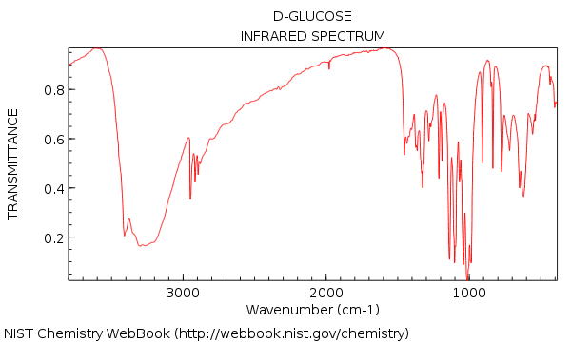
- The fingerprint region can be used to identity an unknown compound by comparing with the IR spectra of known compounds
- However a bond will only interact with IR radiation if it is a polar covalent bond (non-polar bonds do not absorb IR radiation)
- The intensity depends on the dipole moment of the bond:
  - Strongly polar bonds produce strong bands
  - Bonds with medium polarity produce medium bands
- Note IR is not generally used to determine the whole structure of an unknown molecule
- In order to analyze IR graph we need to look for:
  - Tongue: A broad, rounded peak in the region
  - Swords: These peaks are almost always the strongest peaks in the entire spectrum and are relatively narrow, giving them a somewhat “sword-like” appearance
- Once we have identified our “tongue” and our “swords” compare the wavelength value to the value in Table 26
- Note that the graph can be divided up into a functional group region, and the fingerprint region. The fingerprint region is located on the right while the functional group region is located on the left and involves the tongue
Mass Spectrometry
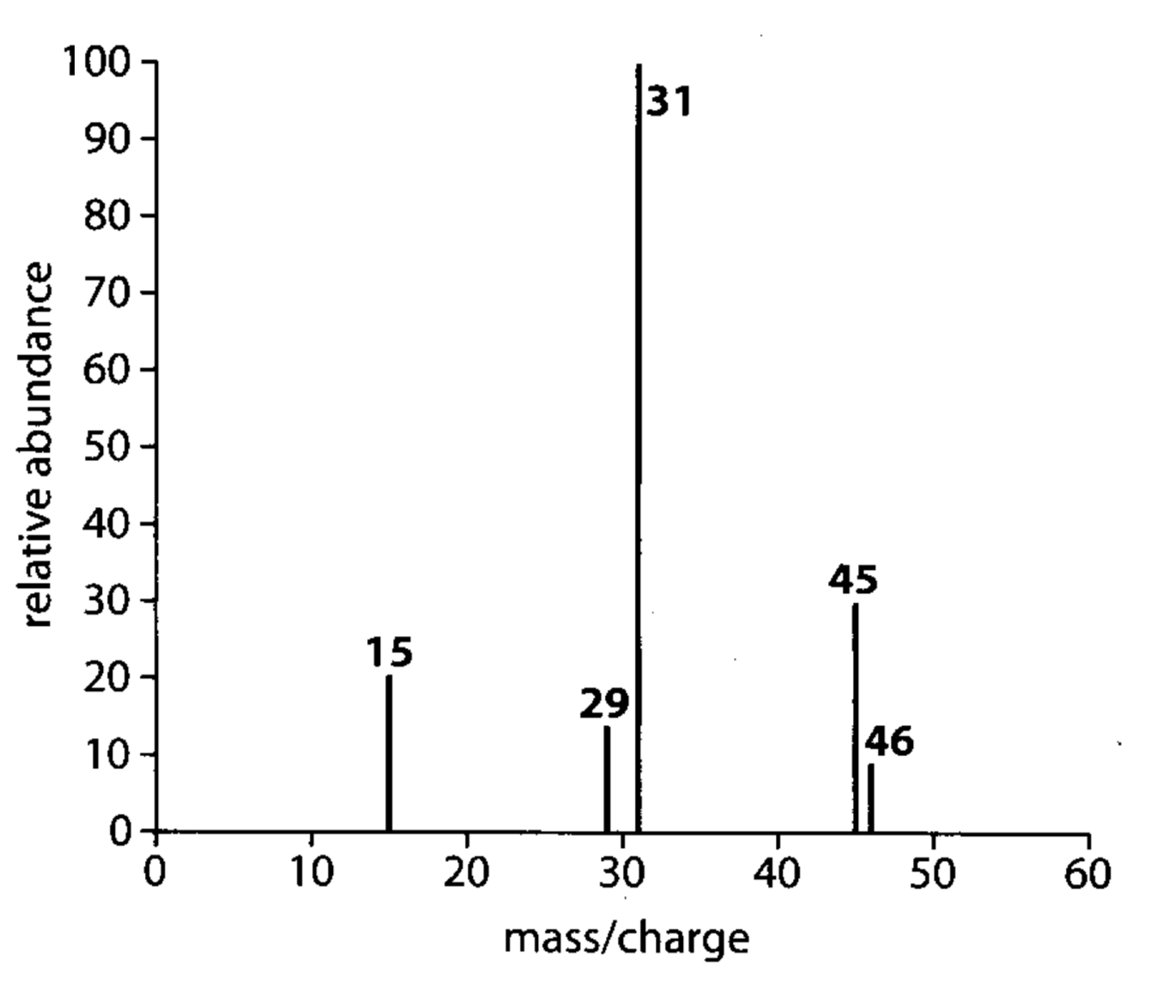
- While mass spectrometry is used to determine the relative atomic mass (A_{r}) of an element it can also be used to determine the structure of a compound
- Inside the mass spectrometer, some of the molecular ions break down to produce fragments
- A fragmentation pattern is produced which gives useful information about the structure of the compound
- When determining the structure of a compound don’t use the mass/charge (m/z) value
- Instead take the largest value and subtract every other value from it
¹H NMR: Proton nuclear magnetic resonance spectroscopy
- NMR or nuclear magnetic resonance spectroscopy is a technique used to determine a compound’s unique structure
- The position of the NMR signal is measured relative to the signal produced by TMS tetramethylsilane
- The chemical shift is measured relative to the point 0
- If there are two of the same group (two CH₃ groups), look at the groups of atoms that those groups are bonded to, if they are the same then the protons are in the same chemical environment, if not they are in different chemical environments
- First look at:
  - Number of hydrogen types
  - Peaks
  - Neighbors
  - Cause of shift

