Topic 10: Organic Chemistry
10.1 | Fundamentals of organic chemistry
10.1.1 | A homologous series is a series of compounds of the same general formula, which differ from each other by a common structural unit
10.1.2 | Structural formulas can be represented in full and condensed format
10.1.3 | Structural isomers are compounds with the same molecular formula but different arrangements of atoms
10.1.4 | Functional groups are the reactive parts of molecules
10.1.5 | Saturated compounds contain single bonds only and unsaturated compounds contain double or triple bonds
10.1.6 | Benzene is an aromatic, unsaturated hydrocarbon
10.1.7 | Explanation of the trends in boiling points of members of a homologous series
10.1.8 | Distinction between empirical, molecular and structural formulas
10.1.9 | Identification of different classes: alkanes, alkenes, alkynes, halogenoalkanes, alcohols, ethers, aldehydes, ketones, esters, carboxylic acids, amines, amides, nitriles and arenes
10.1.10 | Identification of typical functional groups in molecules eg phenyl, hydroxyl, carbonyl, carboxyl, carboxamide, aldehyde, ester, ether, amine, nitrile, alkyl, alkenyl and alkynyl
10.1.11 | Construction of 3D models (real or virtual) or organic molecules
10.1.12 | Application of IUPAC rules in the nomenclature of straight-chain and branched chain isomers
10.1.13 | Identification of primary, secondary and tertiary carbon atoms I halogenoalkanes and alcohols and primary, secondary and tertiary nitrogen atoms in amines
10.1.14 | Discussion of the structure of benzene using physical and chemical evidence
# C atoms | Prefix
1 | meth-
2 | eth-
3 | prop-
4 | but-
5 | pent-
6 | hex-
Homologous series
- Homologous series: A series of compounds of the same family, with the same general formula, which differ from each other by a common structural unit
- The main features of a homologous series are:
  - Members of a homologous series show a gradation in their physical properties due to the gradual increase of sizes and weight (example: boiling points increase)
  - Members of a homologous series show similar chemical properties as all compounds in the series have the same functional group (functional groups are the reactive part)
  - Successive members of a homologous series differ by a –CH₂— group
- Members of a homologous series are represented by same formula. They are named by:
  - Prefix: # Of carbon atoms in the longest chain
  - Suffix: Homologous series to which the compound belongs
Homologous Series | Description | Formula | Suffix
Alkanes | Saturated hydrocarbons containing carbon-carbon single bonds | $$C_{n}H_{2n+2}$$ | -ane
Alkenes | Unsaturated hydrocarbons containing carbon-carbon double bonds | $$C_{n}H_{2n}$$ | -ene
Alkynes | Unsaturated hydrocarbons containing carbon-carbon triple bonds | $$C_{n}H_{2n-2}$$ | -yne
Organic compound classes
- Each class name contains a specific functional group which is a chemical group (small molecule) that determines the specific chemical properties of a compound, which in turn determines the type of chemical reactions it undergoes
- This means that different compounds/classes in organic chemistry undergo characteristic reactions depending on the functional groups they contain
  - Functional groups are specific groups of atoms or bonds within molecules that are responsible for the characteristic chemical reaction of those molecules
  - A functional group is either named as a prefix or a suffix
- Example classes and functional groups include:
Class: | Alkane |  |  | Alkenes |  |  | Alkynes
Functional Group: | $$-C-C-$$ |  |  | $$-C=C-$$ |  |  | $$-C≡C-$$
Suffix | - ane |  |  | - ene |  |  | - yne
Class: | Alcohols |  |  |  |  | Aldehyde
Functional Group: | $$-OH$$
Name/Suffix | Hydroxyl |  | - ol |  |  | Aldehyde |  | - al
Class: | Amine |  |  |  |  | Amide
Functional Group: | 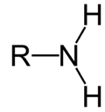 |  |  |  |  | 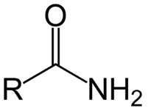
Name | Amines |  |  |  |  | Carboxyamide
Class: | Ether |  |  |  | Ester |  | Nitrile
Functional Group: | $$-O-C$$ |  |  |  | 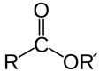 |  | $$-C≡N$$
Name | Ether |  |  |  | Ester |  | Nitrile
Class | Ketones |  |  |  | Carboxylic Acid |  | Arenes
Functional Group: | 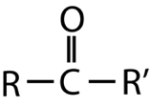 |  |  |  | 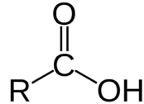 |  | 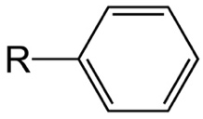
Name/Suffix | Carbonyl | - one |  |  | Carboxyl |  | Phenyl
Class | Halogenoalkanes
Functional Group: | $$-F$$ |  |  |  | $$-Cl$$ |  | $$-Br$$
Prefix | Fluoro- |  |  |  | Chloro- |  | Bromo-

Structural Formulas of Organic Compounds
- Structural formulas can be represented in full and condensed format
  - Full structural formula shows the molecular geometry of the molecule. All bonds must be shown
  - Condense structural formula (aka semi-structural) omits all bonds and groups together
- Skeletal formula (stereochemical formula) shows carbon-to-carbon backbone without any hydrogen atoms, however will show functional groups like Br₂
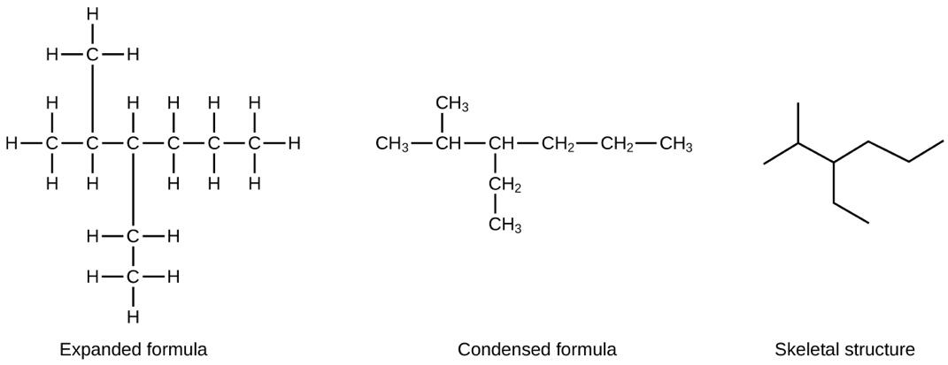

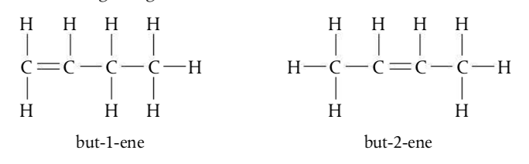
Structural Isomers
- Structural Isomers: Compounds with the same molecular formula but different arrangement of atoms
- Each isomer is a distinct compound having unique physical and chemical properties
Primary, Secondary and tertiary carbon atoms
- A primary carbon atom is bonded to zero or one other carbon atom
- A secondary carbon atom is bonded to two other carbon atoms
- A tertiary carbon is bonded to three other carbon atoms
Primary | Secondary | Tertiary
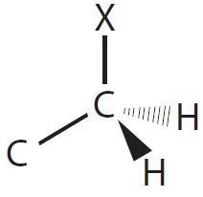 | 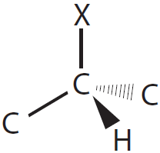 | 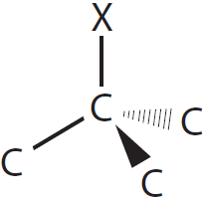  -

- Alcohols also follow the primary/secondary/tertiary nomenclature except instead of a hydroxyl group there will be a halogen
- Amines are named according to the number of carbons attached to nitrogen
  - Primary secondary, and tertiary amines are nitrogen bound to one, two and three carbons, respectively

Nomenclature for organic compounds: IUPAC system
- Organic compounds are named according to the nomenclature of IUPAC
- Find the longest continuous chain of carbon atoms to find the stem of the name:
  - 1C: Meth
  - 2C: Eth
  - 3C: Prop
  - 4C: But
  - 5C: Pent
  - 6C: Hex
- Check for single, double, or triple bonds in the chain
  - Single bonds: an
  - Double bonds: en
  - Triple bonds: yn
- Check for function groups and add their prefix or suffix to the name
  - Alkenes: ene/Alkyne: yne/Alcohol: ol/Ether: oxyalkane/Aldehyde: al/Ketone: one
  - Carboxylic acid: oic acid/ Ester: oate/Amide: amide/Amine: amine/Nitrile: enetrile/Arene: Benzene
- Add a number in fron tof the suffix or predix to indicate the position of the functional group
- If more than one of the SAME functional group is present, use:
  - Di for 2
  - Tri for 3
  - Tetra for 4
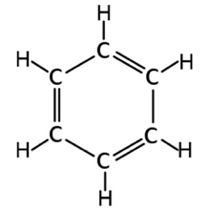
Benzene
- Benzene is an aromatic, unsaturated hydrocarbon with the molecular formula C₆H₆
  - As it only contains carbon and hydrogen atoms, benzene is classed as a hydrocarbon
- The six carbon atoms are joined in a ring with one hydrogen atom attached to each
- Benzene derived products are known to be pleasantly fragrant
- So organic compounds containing benzene rings were classified as being “aromatic” and are called arenes
- The benzene functional group is described as a phenyl group and has the formula C₆H₅
- The 1:1 ratio of hydrogen to carbon in benzene indicates a high degree of unsaturation, greater than alkenes or alkynes
- Benzene has no isomers and is reluctant to undergo addition reactions

10.2 | Functional group chemistry
10.2.1 | Alkanes have low reactivity and undergo free-radical substitution reactions
10.2.2 | Alkenes are more reactive than alkanes and undergo addition reactions
10.2.3 | Bromine water can be used to distinguish between alkenes and alkanes
10.2.4 | Alcohols undergo nucleophilic substitution reactions with acids (also called esterification or condensation) and undergo oxidation reactions
10.2.5 | Halogenoalkanes are more reactive than alkanes. They can undergo (nucleophilic) substitution reactions. A nucleophils is an electron- rich species containing a lone pair that it donates to a electron –deficient carbon
10.2.6 | Addition polymers consist of a wide range of monomers and form the basis of the plastics industry
10.2.7 | Benzene does not readily undergo addition reactions but does undergo electrophilic substitution reactions
10.2.8 | Writing equations for the complete and incomplete combustion of hydrocarbons
10.2.9 | Explanation of the reaction of methane and ethane with halogens in terms of a free-radical substitution mechanism involving photochemical hemolytic fission
10.2.10 | Writing equations for the reactions of alkenes with hydrogen and halogens and of symmetrical alkenes with hydrogen halides and water
10.2.11 | Outline of the addition polymerization of alkenes
10.2.12 | Relationship between the structure of the monomer to the polymer and repeating unit
10.2.13 | Writing equations for the complete combustion of alcohols
10.2.14 | Writing equations for the oxidation reactions of primary and secondary alcohols (using acidified potassium dichromate (VI) or potassium manganite (VII) as oxidizing agents). Explanation of distillation and in the isolation of the aldehyde and carboxylic acid products
10.2.15 | Writing the equation for the condensation reaction of an alcohol with a carboxylic acid, in the presence of a catalyst (eg concentrated sulfuric acid) to form an ester
10.2.16 | Writing the equation for the substitution reactions of halogenoalkanes with aqueous sodium hydroxide
Homolytic and Heterolytic bond fission
- In homolytic bond fission, a covalent bond between two atoms in a molecule breaks with each atom taking one electron from the bond
- Homolytic bond fission results in the formation of free radicals which are highly reactive species with unpaired electrons
- In heterolytic bond fission, a covalent bond between two atoms in a molecule breaks with one atom taking both bonding electrons
- Heterolytic bond fission results in the formation of ions (cation and anion). The more electronegative atom usually takes both bonding electrons
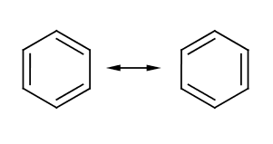
Benzene reactions
- The Kekulé structure of benzene consists of alternating carbon to carbon single and double bonds
- The actual structure of benzene is a resonance hybrid structure with equal bonds that are intermediate in length and strength between a single and a double bond
- Benezene undergoes electrophilic substitution reactions in which a hydrogen atom is replaced by another group
  - An electrophile is a species which is electron deficient (either a positive ion or has a positive charge)
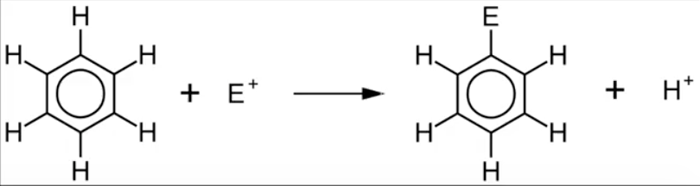

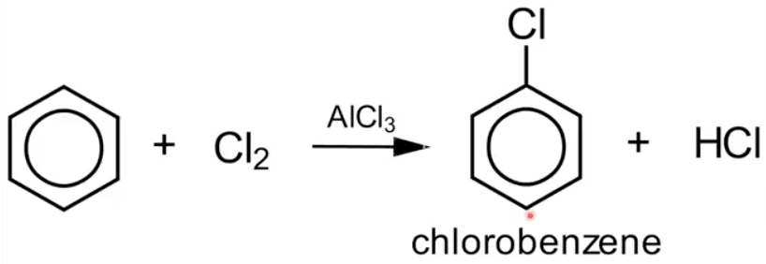
- For instance benzene reacts with chlorine to form chlorobenzene (to the right)
Alkanes Reactions
- Alkanes undergo very few reactions as they are relatively unreactive
- This is because the C-H bond is a non-polar bond and the C-C and C-H are relatively strong
- The two types of reactions that alkanes undergo are combustion reactions and free radical substitution reactions
Combustion
- Complete combustion (in excess oxygen) of any hydrocarbon produces carbon dioxide and water
- Provided the combustion is complete, all hydrocarbons will burn with a blue flame
- However, the bigger the hydrocarbon, the more likely it will burn with a yellow, smoky flame (as it is more difficult to completely combust)
- An incomplete combustion (lack of oxygen) can lead to the formation of carbon or carbon monoxide. I.e. the hydrogen in the hydrocarbon reacts with the oxygen first, then the carbon gets to react with the rest
- Incomplete combustion produces carbon monoxide and water
  - Carbon monoxide is produced as a colorless poisonous gas
  - Carbon monoxide binds irreversibly (or very strongly) making a particular molecule of hemoglobin useless for carrying oxygen
  - If you breath in enough carbon monoxide you will die from a sort of internal suffocation
- The chemical equation for the complete combustion of alkanes is:
$$C_{x}H_{y}+O_{2}→CO_{2}+H_{2}O$$
- The chemical equation for incomplete combustion of alkanes is:
$$C_{x}H_{y}+O_{2}→CO+H_{2}O$$
- A good technique to balancing these types of equations are to use CHOD (Carbon, Hydrogen, Oxygen, Double)
Example: Propane Combustion
With propane (C₃H₈), you can balance the carbons and hydrogens as you write the equation down. Balance alkanes, carbon dioxide and water first. Then balance the oxygens:
$$C_{3}H_{3}+{5O}_{2}→3{CO}_{2}+4H_{2}O$$
- Hydrocarbons become harder to ignite as the molecules get bigger. This is because bigger molecules don’t vaporize so easily. Furthermore, bigger molecules have greater Van der Waals attractions which makes it more difficult for them to break away from their neighbors and turn to gas
Free radical substitution
- Alkanes undergo free radical substitution reactions
- In a substitution reaction, an atom or group of atoms is replaced by another atom or group
- The most common type of substitution reactions of alkanes involve halogenation
- Substitution reactions happen in which hydrogen atoms are replaced one by one by a halogen
- Unlike the complex transformations of combustion, the halogenation of an alkane appears to be a simple substitution reaction in which a C-H bond is broken and a new C-X bond is formed
- Replacing hydrogen atoms in an alkane molecule with chlorine or bromine is called chlorination or bromination
- This type of reaction requires a catalyst to active the reaction usually in the form of UV light
- Free radicals are species with unpaired electrons which are represented by a dot
- We describe the substitution of a halogen by a sequence of steps known as a reaction mechanism. The three stages of the mechanism are called initiation (known as photochemical homolytic fusion), propagation and termination

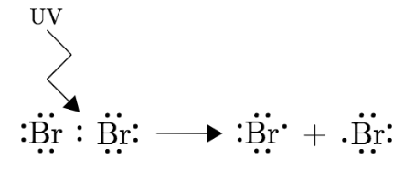
Initiation:
- Initiation occurs in the presence of UV light
- Photochemical homolytic fission then occurs where the bond between the halogen (in this case Bromine) is broken by UV light which produces two halogen radicals (two bromine radicals)
- In initiation steps the number of free radicals increases
Propagation:
- In propagation these reactions keep the chain reaction going
  - First the bromine free radical will then react with methane to produce a methyl radical and hydrogen bromide (the hydrogen will bond with the bromine radical)
  - Then the methyl radical (produced in the first propagation step) will react with a bromine molecule to produce bromomethane and a bromine radical
  - CH₃Br can continue to react through similar propagation steps to form CH₂Br₂, CHBr₃ and eventually CBr₄
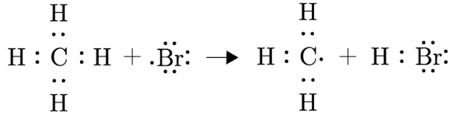
- In propagation the number of free radicals stays the same

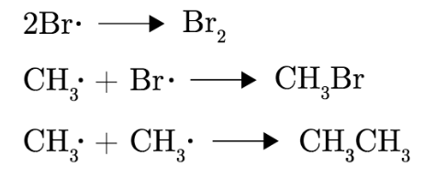
Termination:
- Free radicals react with each other to form molecules. Since the radicals are much more reactive than the molecules, the reaction stops when there are no more radicals
- In termination steps the number of free radicals decreases
Tests for unsaturation
- Bromine water can be used to distinguish between an alkane and an alkene
  - Bromine water has a distinctive brown color
- Alkenes are more reactive than alkanes due to their double carbon bond
- Alkenes react spontaneously with bromine water due to their unsaturated nature
  - When alkenes come into contact with bromine water, they cause it to decolorize
  - An addition reaction will take place and results with an alkane with two bromine functional groups
- Alkanes do not react with spontaneously bromine water due to their saturated nature
  - When alkanes come into contact with bromine water, there is no color change
Alkene reactions
- Alkenes undergo electrophilic addition reactions in which two molecules combine to produce a larger molecule (which also breaks the double bond). The types of reactions include:
Hydrogenation
- An alkene reacts with hydrogen to form an alkane
- The double C=C bond is broken and converted to a C-C single bond. The H₂ then breaks open and attaches itself as two individual H atoms to the carbon in the question
- Catalyst used in this reaction: Finely divided nickel
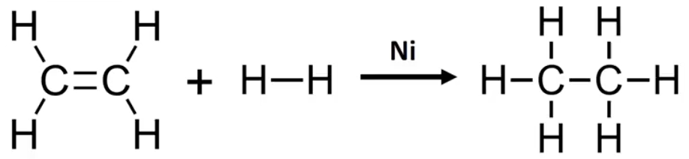

Hydration
- An alkene reacts with steam to form an alcohol
- The double C=C bond is broken and is converted into a C-C single bond
- H₂O then breaks open and attaches itself as H and OH to the carbon atoms that are now open
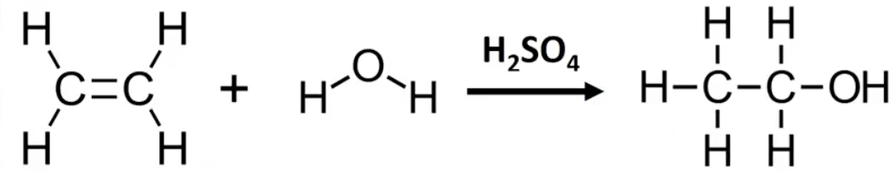

- Catalyst used in this reaction: H₂SO₄
Halogenation
- Alkenes react with halogens to produce dihalogen compounds
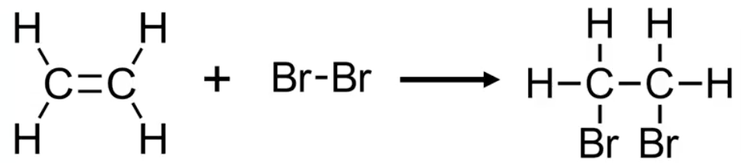

Addition Polymerization:
- Addition polymers are formed when smaller unsaturated molecules (monomers) react together
  - PVC or poly (vinyl chloride) is a polymer made from the monomer unit chloromethane (vinyl chloride)
  - Poly (propene) is an additional polymers made from the monomer unit propene
  - The polymerization of 2-methylpropene forms the polymer poly (2-methylpropene) or butyl rubber
- In addition polymerization, small monomers that contain a C=C double bond link together to form a longer polymer
- During the process the double bonds in the monomers are converted into single bonds in the polymer
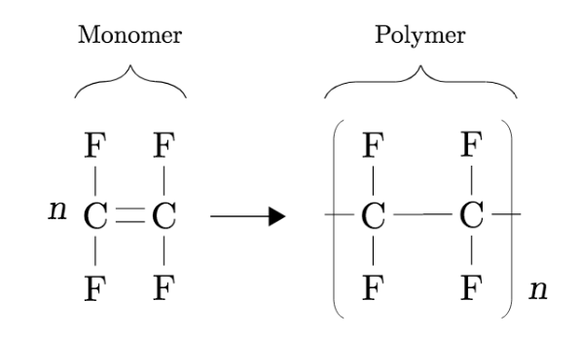

Alcohol Reactions
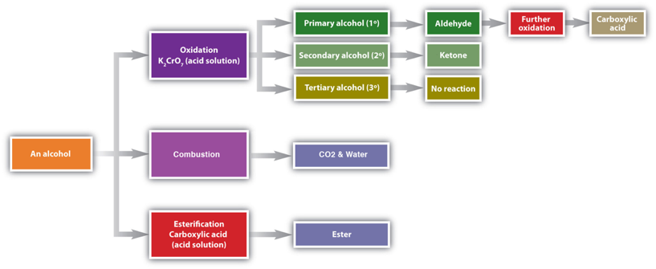
- Alcohols are molecules containing the hydroxyl functional group (-OH) that is bonded to the carbon
- The hydroxyl functional group strongly contributes to the physical properties of alcohols. The hydroxyl group is polar so increases the solubility of alcohol in water
- Chemical reactions in alcohols occur mainly at the functional group, but some involve hydrogen atoms attached to the OH-
- Alcohols undergo three major kinds of alcohol reactions:
Oxidation
- Because a variety of oxidizing agents can bring about oxidation, the symbol $[O]$ above the arrow indicates an oxidizing agent without specifying a particular one
- Oxidation reactions with alcohols are used to make aldehydes, ketones and carboxylic acids
- They can also be a way to distinguish between primary, secondary and tertiary alcohols
  - Primary alcohols are oxidized to form aldehydes and can be oxidized again to form carboxylic acid
  - Secondary alcohols are oxidized to form ketones
  - Tertiary alcohols are not readily oxidized
- The oxidizing agent used in these creations are normally a solution of potassium (VI) dichromate (K₂Cr₂O₇)
Primary Alcohols:
- The oxidation of any primary alcohol is a two-step process that first produces an aldehyde which is then further oxidized to a carboxylic acid
- The alcohol is heated under reflux with an excess of the oxidizing (put heat under arrow in equation) and using K₂Cr₂O₇
- When the reaction is complete, the carboxylic acid is distilled off
- The full equation for the oxidation of a primary alcohols is (put heat under arrow in equation):
$$Primary alcohol\underset{→}{[O]}Alehyde\underset{→}{[O]}Carboxylic Acid$$
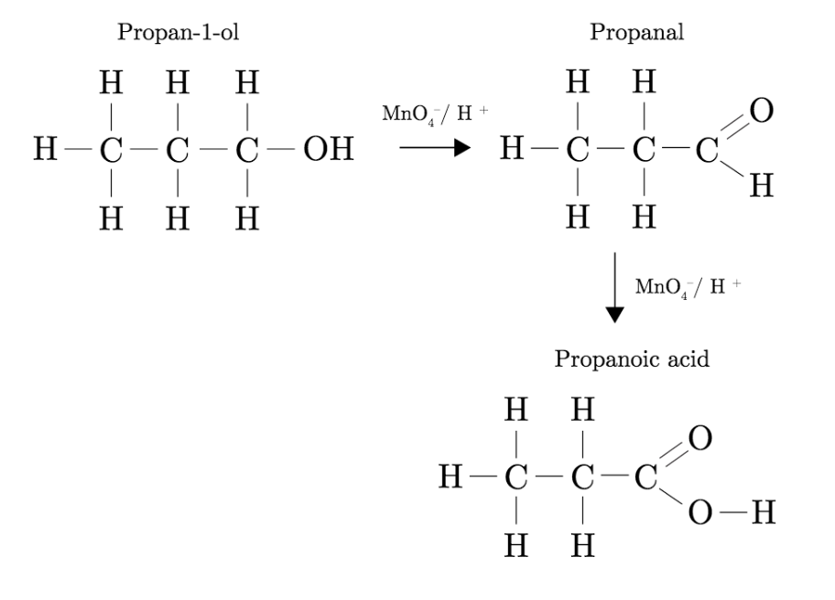

Secondary Alcohols:
- The oxidation of any secondary alcohol is a one-step process that produces a ketone. After ketone is produced, no further oxidation is possible as the carbon atom of the ketone has no more hydrogen attached to it
- The equation for the oxidation of secondary alcohols is:
$$Secondary alcohol\underset{→}{[O]}Ketone$$
- During the second stage of the primary alcohol reaction, the oxygen was “slotted in” between the carbon and the hydrogen in the aldehyde group to produce the carboxylic acid. In this case, there is no such hydrogen so the reaction has nowhere further to go:
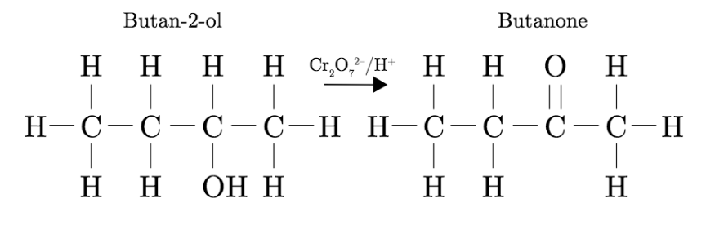

Tertiary Alcohols:
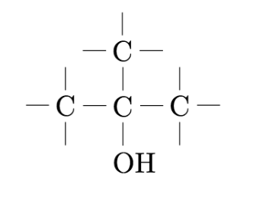
- Tertiary alcohols can't be oxidized since the carbon atom that holds the alcohol group has zero hydrogens attached to it

Example: Write the equation for the formation of ethanoic acid from ethanol
$$CH_{3}CH_{2}OH\begin{matrix}\underset{→}{H^{+}{{/Cr}_{2}O_{7}}^{2-}} \\ heat\end{matrix}{CH}_{3}CHO\begin{matrix}\underset{→}{H^{+}{{/Cr}_{2}O_{7}}^{2-}} \\ reflux\end{matrix}{CH}_{3}COOH$$

Combustion
- Alcohols are flammable. They burn in air because of the presence of a hydrocarbon chain
- They burn to produce carbon dioxide and water. This property allows alcohols to be used as a fuel
- The chemical equation for combustion of alcohols is:
$$C_{x}H_{y}OH+O_{2}→CO_{2}+H_{2}O$$
- A good technique to balancing these types of equations are to use CHOD (Carbon, Hydrogen, Oxygen, Double)
Example: Write an equation for the combustion of ethanol
$$C_{2}H_{5}OH+{3O}_{2}→{2CO}_{2}+{3H}_{2}O$$
Esterfication
- Esters are formed when carboxylic acids react with alcohols in the presence of sulfuric acid as a catalyst
- The name of esters is key to finding which specific alcohol and acid it has been made from:
  - The alcohol is always named as an alkyl group
  - The acid is always named as an alkanoate group
- For instance ethyl propanoate is made from an ethanol group and propaoic acid
Halogenalkane Reactions
- Halogenoalkanes contain an atom of fluorine, chlorine, bromine or iodine
- Halogenoalkanes are more reactive than alkanes and can undergo nucleophilic substitution reactions
- Halogenoalkanes undergo either substitution or elimination reactions depending on the type of halogenoalkane:
  - Primary: Mainly substitution reactions
  - Secondary: Both substitution and elimination
  - Tertiary: Mainly elimination
Substitution nucleophilic reactions
Definitions
Substitution – Swapping a halogen atom for another atom or group of atoms
Nucleophile: An electron rich species that can donate a pair of electrons to form a covalent bond

- In a substitution reaction, the halogen atom is replaced by an –OH group to give an alcohol
- The halogenoalkane is heated under reflux with a solution of sodium or potassium hydroxide
  - Heating under reflux means heating with a condenser placed vertically in the flask to prevent loss of volatile substances from the mixture
- Halogenoalkanes undergo substitution nucleophilic reactions (the replacement of one atom by another atom or group)
  - The halogen is more electronegative than the carbon atoms forming a polar bond
  - The halogen has a partial negative charge and the carbon has a partial negative charge and the carbon has a partial positive charge (electron deficient)
- Nucleophiles are electron rich species that contain a lone pair of electrons that is donates to an electron deficient carbon
- Halogenoalkanes react with alkalis such as NaOH to form alcohols
- The hydroxide ion behaves as a nucleophile
Elimination reactions
- Halogenoalkanes also undergo elimination reactions in the presence of sodium or potassium hydroxide
  - Elimination: removal of small molecule (often water) from the organic molecule

20.1 | Types of organic reactions
 | Nucleophilic Substitution Reactions:
20.1.1 | S_{N}1 represents a nucleophilic unimolecular substitution reaction and S_{N}2 represents a nucleophilic bimolecular substitution reaction
20.1.2 | For tertiary halogenoalkanes the predominant mechanism is S_{N}1 and for primary halogenoalkanes it is S_{N}2. Both mechanisms occur for secondary halogenoalkanes
20.1.3 | The rate determining step (slow step) in an S_{N}1 reaction depends only on the concentration of the halogenoalkane, $rate=k[halogenoalkane]$ For S_{N}2, $rate=k\left[halogenoalkane\right][nucleophile]$. S_{N}2 is stereospecific with an inversion of configuration at the carbon
20.1.4 | S_{N}2 reactions are best conducted using aprotic, non-polar solvents and 2_{N}1 reactions are best conducted using protic, polar solvents
 | Electrophilic Addition Reactions:
20.1.5 | An electrophile is an electron-deficient species that can accept electron pairs from a nucleophile. Electrophiles are Lewis acids
20.1.6 | Markovnikov’s rule can be applied to predict the major product in electrophilic addition reactions of unsymmetrical alkenes with hydrogen halides and interhalogens. The formation of major product can be explained in terms of the relative stability of possible carbon cations in the reaction mechanism
 | Electrophilic Substitution Reactions:
20.1.7 | Benzene is the simplest aromatic hydrocarbon compound (or arene) and has a delocalized structure of $π$ bonds around its ring. Each carbon to carbon bond has a bond order of 1.5. Benzene is susceptible to attack by electrophiles
 | Reduction Reactions:
20.1.8 | Carboxylic acids can be reduced to primary alcohols (via the aldehyde). Ketones can be reduced to secondary alcohols. Typical reducing agents are lithium aluminum hydride (used to reduce carboxylic acids) and sodium borohydride
 | Nucleophilic Substitution Reactions
20.1.9 | Explanation of why hydroxide is a better nucleophile than water
20.1.10 | Deduction of the mechanism of the nucleophile substitution reactions of halogenoalkanes with aqueous sodium hydroxide in terms of S_{N}1 and S_{N}2 mechanisms. Explanation of how the rate depends on the identity of the halogen (ie the leaving group), whether the halogenoalkane is primary, secondary or tertiary and the choice of solvent
20.1.11 | Outline the difference between protic and aprotic solvents
 | Electrophilic Addition Reactions
20.1.12 | Deduction of the mechanism of the electrophilic addition reactions of alkenes with halogens/interhalogens and hydrogen halides
 | Electrophilic Substitution Reactions:
20.1.13 | Deduction of the mechanism of the nitration (electrophilic substitution) reaction of benzene (using a mixture of concentrated nitric acid and sulfuric acid)
 | Reduction Reactions:
20.1.14 | Writing reduction reactions of carbonyl containing compounds: aldehydes and ketones to primary and secondary alcohols and carboxylic acids to aldehydes, using suitable reducing agents.
20.1.15 | Conversion of nitrobenzene to phenylamine via a two-stage reaction.

Definitions
Nucleophile: An electron rich species that can donate a pair of electrons to form a covalent bond (Acts like a Lewis base). i.e. they are strongly attracted to a region of positive charge. OH⁻ is a better nucleophile than H₂O because it has a negative charge whilst the water molecular only has a dipole. Therefore it is more attracted
Leaving group – A substituent which easily withdraws its bonding electrons to form a separate, stable species

Nucleophilic Substitution Reactions
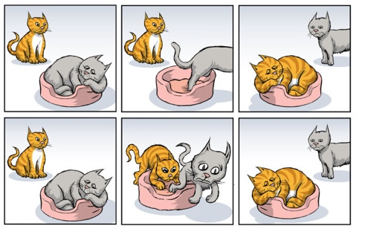
- There are two major classes of nucleophilic substitution reactions: S_{N}1 and S_{N}2

- This can be thought of like cats. Cat #1 finds Cat #2 on his comfy chair and wants to sit. He has two option:
  - He can wait for Cat #2 to leave, and then sit in the comfy chair
  - Or he can be a bitch and kick Cat #2 out of the comfy chair
- Situation 1 resembles S_{N}1 reactions, and Situation 2 represents S_{N}2 reactions. The chair is the solvent, Cat #1 is nucleophile
- In the substitution reaction where the halogen is substituted, the halogen is referred to as the leaving group (Cat #2)
- Halogenoalkanes undergo nucleophilic substitution reactions as the bond between the carbon atoms and the halogen is polar as the halogen is highly electronegative giving the carbon atoms a partial positive charge
S_{N}1: Nucleophilic unimolecular substitution reaction
- S_{N}1 is a two step reaction that involves the formation of a carbocation intermediate
- As S_{N}1 reaction initiates, the leaving group will depart from the substrate, and in doing so creates a stable intermediate
- However, soon after the nucleophile will attack and bond to the intermediate which results in the final product
- Note there is a complete loss of stereochemistry as the nucleophile can bond anywhere
- The reaction is unimolecular. The rate determining step depends on the concentration of the leaving group only
- Tertiary halogenoalkanes undergo S_{N}1 reactions (so replace leaving group with the halogen name when explaining)
- Some factors favoring S_{N}1 reactions include:
  - Weak nucleophiles
  - More substitute substrates
  - Better leading groups
  - Solvent charge
S_{N}2: Nucleophilic biomolecular substitution reaction
- S_{N}2 is a one step reaction that involves the formation of an unstable transition state
- The nucleophile will first attack the opposite side of the leaving group, despite the leaving group haven’t not departed yet
- An unstable transition state is then formed in which the carbon is weakly bonded to the leaving group and the nucleophile
- The carbon to the leaving group breaks heterolytically and the leaving group departs
- The backside attack causes an inversion of stereochemistry
- The rate is bimolecular. The rate determining step (slow step) depends on both the concentration of the leaving group and the nucleophile
- Primary halogenoalkanes undergo S_{N}2 reactions (so replace leaving group with the halogen name when explaining)
- Some factors favoring S_{N}2 reactions:
  - Good nucleophiles
  - Less substituted substrates
  - Poor leaving groups
 | S_{N}1 | S_{N}2
Mechanism | Two step mechanism | Single connected step
Kinetics | First order kinetics  $$rate=k\left[leaving group\right]$$ | Second order kinetics:  $$rate=k\left[leaving group\right][nucleophile]$$
Stereochemistry | Loss of stereochemistry | Sterochemical inversion
Nucleophile* | Weak | Strong
Substrate* | Highly substituted | Less substituted
Leaving group* | Good | Poor
*Favorable conditions
Choice of solvent
- A protic solvent is one in which there is a hydrogen atom attached to an oxygen or nitrogen atom and that is capable of being donated
- Polar, protic solvents are preferred for S_{N}1 reactions
- Examples of commonly used protic solvents include: water, methanol, ethanol, methanoic acid and ethanoic acid
- An aprotic solvent is one which does not possess a hydrogen atom that is capable of being donated. Aprotic solvents can be polar or non-polar. Common examples include: propanone and ethyl ethanoate (both polar) as well as hexane and benzene (non-polar) Polar, protic solvents are preferred for S_{N}1 reactions
- Non-polar, aprotic solvents are preferred for S_{N}2 reactions
Electrophilic addition reactions
Definitions
Electrophile: An electron deficient species that can accept an electron pair to form a new covalent bond (Acts like a Lewis Acid)

- An addition reaction is a reaction in which two molecules join together to make a bigger one
- Nothing is lost in the process and all the atoms in the original molecules are found in the bigger one
- An electrophilic addition reaction is an addition reaction where a molecule with a region of high electron density is attacked by something carrying some degree of positive charge
- Electrophilic addition reactions involves any alkane with molecules such as halogens or hydrogen halides
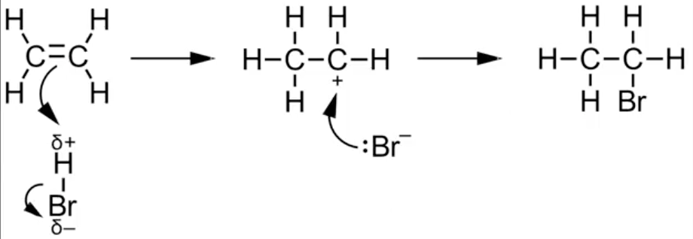

- The δ+ hydrogen atom of H-Br is attracted towards the C=C in ethene. The two electrons from the π -bond in the C=C attack the hydrogen atom and, at the same time, the H−Br bond breaks to form a bromide ion
- A lone pair of electrons on the bromide ion attacks the positively-charged carbon atom on the carbocation intermediate forming a coordinate bond
- The correct drawing for the mechanism includes curly arrows and lone pairs of electrons
Markovnikov’s Rule
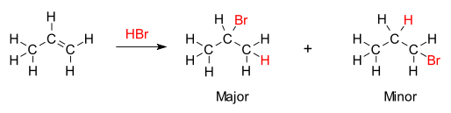
- Markovnikov’s rule helps to determine which atoms in an electrophile join to which of the two carbon atoms in a C=C﻿﻿

- As you can see the hydrogen and bromine can be bonded to two different spots (as shown by major and minor)
- To decide which one bonds where remember “the hydrogen rich get richer”
- In other words the carbon with the more hydrogen will gain more hydrogen
- Major is used to describe the more likely structure
- Markovnikov’s rule only applies to asymmetrical alkenes where two products are possible (does not apply to ethene)
Nitration of benzene
- Benzene reacts with a mixture of concentrated nitric acid (HNO₃) and concentrated sulfuric acid (H₂SO₄) to form nitrobenzene (C₆H₅NO₂) and water
$$C_{6}H_{6}+HNO_{3}→C_{6}H_{5}NO_{2}+H_{2}O$$
- This reaction requires a H₂SO₄ catalyst, and roughly 55°C
- The nitration of benzene involves the electrophilic substitution mechanism:
  - A pair of electrons from the π -system attacks the NO₂⁺ electrophile forming a coordinate bond and destroying the delocalization
  - The HSO₄⁻ ion acts as a base, pulling off a hydrogen atom and reforming sulfuric acid
  - The C−H bond breaks and the two electrons reform the delocalized π -system
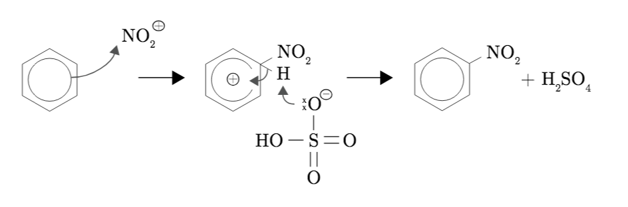

  - The C−H bond breaks and the two electrons reform the delocalized π -system.
Reduction of carbonyl compounds
- The carbon to oxygen bond is a polar bond because of the difference in electronegativity between carbon and oxygen
- Primary and secondary alcohols can be oxidized to aldehydes, ketones, or carboxylic acids depending on the conditions
- These oxidation reactions can be reversed by using a suitable reducing agent
  - Sodium borohydride (NaBH₄) in aqueous or alcoholic solution (protic solvents)
  - Lithium aluminum hydride (LiAlH₄) in anhydrous conditions such as dry ether (aprotic solvent). The reaction is then acidified to obtain the product
  - Both these reagents produce the hydride ion (H⁻) which acts as a reducing agent undergoing a nucleophilic addition reaction with the electron deficient carbon atom of the carbonyl group
Reduction reactions
- Nitrobenzene can be reduced to phenylamine in a two stage reaction
  - Nitrobenzene is reacted with Sn and concentrated HCl (heat under reflux in a boiling water bath). The product is the phenylammonium ion
  - The C₆H₅NH₃⁺ is reacted with NaOH to remove the hydrogen ion (H⁺) and produce phenylamine

20.2 | Synthetic routes
20.2.1 | The synthesis of an organic compound stems from a readily available starting material via a series of discrete steps. Functional group interconversions are the basis of such synthetic routes
20.2.2 | Retro-synthesis of organic compounds
20.2.3 | Deduction of multi=step synthetic routes given starting reagents and the products (s)
Reaction pathways
- Read up: https://prezi.com/gxhp4xojcjci/ib-chemistry-organic-reaction-pathways/
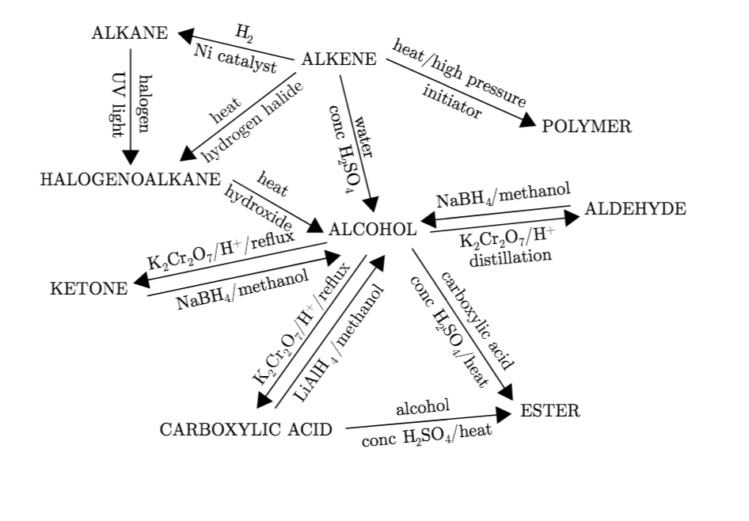

Retro-Synthesis
- Retro-synthesis involves planning a synthesis backwards, by starting at the product, and taking it back one step at a time to simple, available starting materials
20.3 | Stereoisomerism
10.2.1 | Stereoisomers are subdivided into two classes – conformational isomers, which interconvert by rotation about a $σ$ bond and configurational isomers that interconvert only by breaking and reforming a bond  Configurational isomers are further subdivided into cis=trans and E/Z isomers and optical isomers
10.2.2 | Cis-trans isomers can occur in alkenes or cycloalkanes (or heteroanalogues) and differ in the position of atoms (or groups) relative to a reference plane. According to IUPAC, E/Z isomers refer to alkenes of the form $R1R2C=CR3R4$ ($R1≠R3, R3≠R4$ where neither R1 nor R2 need be different from R3 or R4
10.2.3 | A chiral carbon is a carbon joined to four different atoms or groups
10.2.4 | An optically active compound can rotate the plane of polarized light as it passes through a solution of the compound. Optical isomers are enantiomers. Enantiomers are non-superimposeable mirror images of each other. Diastereomers are not mirror images of each other.
10.2.5 | A racemic mixture (or racemate) is a mixture of two enantiomers in equal amounts and is optically inactive
10.2.6 | Construction of 3-D models of a wide range of stereoisomers
10.2.7 | Explanation of stereoisomerism in non-cyclic alkenes and C3 and C4 cycloalkanes
10.2.8 | Comparison between the physical and chemical properties of enantiomers
10.2.9 | Description and chemical properties of enantiomers
10.2.10 | Distinction between optical isomers using a polarimeter

Isomerism
- An isomer of a molecular is a molecule with the same molecular formula but a different structural or spatial arrangement of atoms. This variation can lead to difference in physical or chemical properties
- Isomers can be split into two broad groups: structural isomers, and stereoisomers
Structural Isomerism
- Structural isomers have their atoms and functional groups attached in different ways
- Structural isomers can be split again into three main subgroups:
Chain isomers
- Chain isomers are molecules with the same molecular formula, but different arrangements of the carbon “skeleton”
- Organic molecules are based on chains or carbon atoms, and for many molecules this chain can be arranged differently: either as one continuous chain, or a chain with multiple side groups of carbons branching off
- The name of the molecules can be changed to reflect this
Position isomers
- Position isomers are based on the movement of a “functional group” in the molecule
- Remember a functional group is the part of a molecule that gives it its reactivity
- Nothing else about the molecule changes, simply where the functional group in it is, and the name
Functional Isomers
- Also referred to as functional group isomers, these are isomers where the molecular formula remains the same, but the type of functional group in the atom is changed. This is possible by rearranging the atoms within the molecule so that they’re bonded together in different ways
Stereoisomerism
- Stereoisomerism have different spatial arrangement of atoms
- There are two types of stereoisomerism: Geometric isomerism, and optical isomerism
Geometric isomerism
Conformational isomerism: Interconvert by rotation around the sigma bond
- This type of isomerism most frequently involves carbon double bonds
- This means that the rotation of these bonds is restricted, compared to single bonds, which can rotate freely
- In other words if there are two different atoms, or groups of atoms, they can be arranged in different ways to give different molecules
Configurational isomerism: Interconvert only by breaking a bond
- Optical isomers are so named due to their effect on plane-polarized light and come in pairs
- They usually (although not always) contain a chiral center, which is a carbon atom, with four different atoms attached to it
- These atoms or groups can be arranged differently around the central carbon in such as a way that the molecule can’t be rotated to make the two arrangements align. This is referred to as “non-superimposable mirror images” where one of the isomers is the mirror image of the other
Cis-trans isomerism:
- Cis-trans isomerism occurs when there is restricted rotation around a bond either because of a double bond or as a result of the ring structure in a cyclic molecule
- Cycloalkanes contain a ring structure that restricts rotation. When the molecule contains two or more different groups attached to the ring, two different isomers are formed
  - Cis isomers have the same groups on the same side of the double bond/ring
  - Trans isomers have the same groups on opposite sides of the double bonds/ring
E/Z/ Isomerism
- A chiral carbon is a carbon atom bonded to four different atoms or groups
Optical isomerism
- A chiral carbon is a carbon atom bonded to four different atoms or groups
- Mirror images are non-superimposable and are known as enantiomers
- Diastereomers are stereoisomers that are non-superimposable but not mirror images
- Ordinary light consists of waves that vibrate in all planes perpendicular to its direction of travel
- Plane-polarized light consists of waves vibrating in one plane only

