Topic 1: Quantitative Chemistry
1.1 | Introduction to the particulate nature of matter and chemical change
1.1.1 | Atoms of different elements combine in fixed ratios to form compounds, which have different properties from their component elements
1.1.2 | Mixtures contain more than one element and/or compound that are not chemically bonded together and so retain their individual properties
1.1.3 | Mixtures are either homogeneous or heterogeneous
1.1.4 | Deduction of chemical equations when reactants and products are specified
1.1.5 | Application of the state symbols (s), (l), (g), and (aq) in equations
1.1.6 | Explanation of observable changes in physical properties and temperatures during changes of state
Particle Nature of Matter
- Matter is anything that takes up space
- Matter can either refers to the particles (pure substances) or combination of a substances (mixtures):
Pure Substances
- A pure substance has definite and constant composition
- For a pure substance, from a particle perspective all particles will look and remain the same
Definitions
Element – Atoms all having the same number of protons
Molecule – Two or more elements chemically join together
Compounds – Two or more different elements chemically joined together in a fixed ratio

- From their definitions: All compounds are molecules, but not all molecules are compounds
- When the elements are joined, the atoms lose their individual properties and have different properties from the elements they are composed of
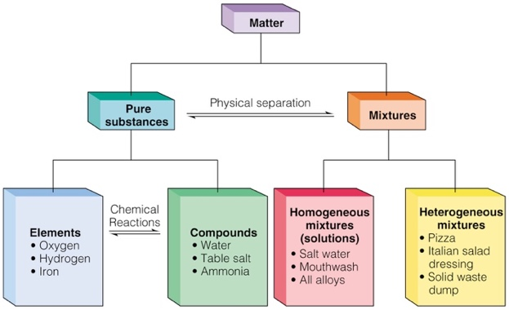
Mixtures
- Mixture: A combination of pure substances
- Mixtures contain more than one element and/or compound that are not chemically bonded together, so retain their individual properties
- Mixtures are either homogeneous or heterogeneous:
- Homogeneous mixtures are the same mixture throughout
  - They will have a uniform composition
- Heterogeneous mixtures have a different mixture throughout
  - They will have visibly different substances or phases throughout, a non-uniform composition
Chemical Equation
- Chemical Equation: Describes what happens during a chemical reaction
- A chemical reaction will always have reactants and products as well as some special reaction conditions if required
- Reactants are always on the left, and products are always on the right: $Reatants→Products$
- Chemical equations usually use state symbols to identify the state of the products and reactants
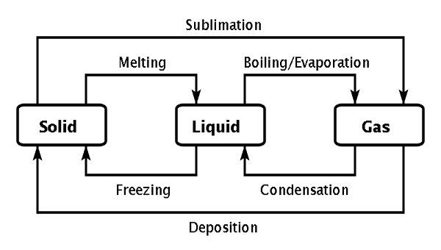
State Symbols
- Reactants and products can be in one of four states
  - (s): solid
  - (l): liquid
  - (g): gas
  - (aq): aqueous solution (dissolved in a solvent)
- The changes of state are to the left:
- A heating curve is a graph showing the temperature of a substance plotted against the amount of energy it has absorbed
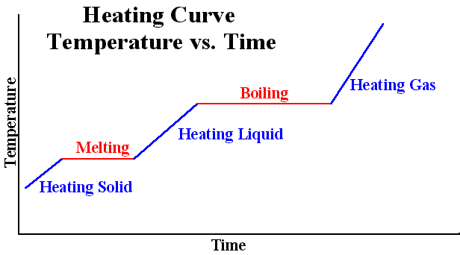

- Note, during a state change there will be no increase or decrease in temperature
- Adding temperature only increases the kinetic energy of the molecules, which will eventually break the bonds, then the molecules will change state
- It also takes a higher temperature to turn a solid to a liquid, and an even greater temperature to turn a liquid to a gas
Physical and Chemical Changes
- In a physical change, no new substances are produced
  - Example: The melting of ice is a physical change. It is being changed physically
- In a chemical change, new chemical substances are formed
  - The atoms in the reactants are rearranged to form new products. It is being changed chemically
1.2 | The mole concept and Avogadro’s Constant
1.2.1 | The mole is a fixed number of particles and refers to the amount, n, of substance
1.2.2 | Masses of atoms are compared on a scale relative to ¹²C and are expressed as relative atomic mass (A_{r}) and relative formula/molecular mass (M_{r})
1.2.3 | Molar mass (M) has the units g mol⁻¹
1.2.4 | Calculation of the molar masses of atoms, ions, molecules and formula units
1.2.5 | Solution of problems involving the relationships between the number of particles, the amount of substance in moles and the mass in grams
1.2.6 | Interconversion of the percentage composition by mass and the empirical formula and molar mass
1.2.7 | Determination of the molecule formula of a compound from its empirical formula and molar mass
1.2.8 | Obtaining and using experimental data for deriving empirical formulas from reactions involving mass changes

The Mole
Definitions
Mole – The amount of substance that contains the same number of specified particles as there are atoms in 12g of Carbon-12

- When dealing with particles of the size of atoms and molecules, it becomes very difficult to do the calculations as they are present in very large numbers. So to make these calculations simpler, answers are expressed in mol
- The mole is given by the symbol $n$
- The mole makes it possible to correlate the number of particles with the mass that can be measured
- The number of particles in 1 mole is given by Avogadro’s constant
  - Avogadro’s constant (L): 1 mol = 6.02 x 10²³ particles (atoms, molecules, ions)
- In order to calculate number of particles: $N=n ×L$
  - $N$: number of particles (atoms, molecules, ions)
    - Atoms are simple elements, ions are elements with a charge, and molecules are more than one atom
  - $n$: number of moles
  - $L$: Avogadro’s number
- We can also rearrange this formula if we want to find number of mols: $n=\frac{N}{L}$
Mole question:
Calculate the number of O₂ molecules in 1.5 mol of oxygen (O₂)
$$n\left(O_{2}\right)= 1.5mol$$
$$L=6.02×10^{23}$$
Therefore: $N= n × L$ => $N= 1.5 × 6.02 × {10}^{23}=9.0 × {10}^{23}$
Mole relationships
- A chemical formula shows the mole relationship between the individual atoms that make up that molecule. Example:
  - Methane gas is produced from the combination of 1 mol of carbon atoms and 4 mol of atoms
  - 1 mol of C + 4 mol of H → 1 mol of CH₄
- To find the number of mol of an element in a molecule multiply the number of that element in the molecule by the amount of mol of that molecule:
$$n\left(X\right)=\# × amount of mols$$
- To find the number of atoms of an element in a molecule multiply the above equation by $L$
- To find the total number of atoms of a molecule multiply the amount in mol by the number of atoms in the molecule
Mole relationship question:
- Calculate the number of mol of oxygen in 0.05 mol of O₂ molecules
$N\left(O\right)=2×n(O_{2})$ note that there is a two because in one molecule of O₂ there are two oxygen atoms ratio ∴ is 2:1
$$N\left(O\right)=2×0.05$$
$$N\left(O\right)=0.1mol$$
- Calculate the number of mol of SO₄²⁻ ions in a 2.39x10⁻³ mol sample of PbSO₄
$$n\left(PbSO_{4}\right)=2.39×10^{-3}$$
$n\left({SO_{4}}^{2-}\right)=n\left(PbSO_{4}\right)$ It is equal because the ratios are equal
$$n\left({SO_{4}}^{2-}\right)=2.39×10^{-3}$$
The Mole Concept
- Masses of atoms are compared on a scale relative to ¹²C and are expressed as relative atomic and molecular mass
Definitions
Relative atomic mass (A_{r}) – The average mass of all isotopes of an element compared to $\frac{1}{12}$ the mass of C₁₂ atom
Relative molecular/formula mass (M_{r}) – The mass of a molecule compared to $\frac{1}{12}$ the mass of C₁₂ atom

- The relative molecular mass (M_{r}) also called the molar mass can be calculated from its chemical formula using the relative atomic masses (A_{r}) of the elements from the periodic table
- Some elements will have a greater atomic mass than others despite their atomic number because they will either have a greater proportion of heavier isotopes or they will have a greater number of neutrons
- Relative atomic and molecular mass are relative therefore it has no units
- Molar mass (M) has the units g mol⁻¹
Relative molecular mass question:
Calculate the relative formula mass (molar mass) of Vitamin C: C₆H₈O₆
$M_{r}\left(Vitamin C\right)=\left[6×A_{r}\left(C\right)\right]+\left[8×A_{r}\left(H\right)\right]+[6×A_{r}\left(O\right)]$ Note the multiples because there is a # of atoms
$$M_{r}\left(Vitamin C\right)=\left(6×12\right)+\left(8×1\right)+\left(6×16\right)$$
$$M_{r}\left(Vitamin C\right)=176$$
Therefore $M_{r}\left(Vitamin C\right)=176gmol^{-1}$
Amount of moles
- In order to calculate number of moles: $n=\frac{m}{M}$ where
  - $n$: moles
  - $m$: mass
  - $M$: molar mass
Number of moles question:
Calculate the amount in mol of 1.2g of Nitric Oxide (NO)
$m=1.2$ $M=14+16=30$
Therefore, since $n=\frac{m}{M}→n=\frac{1.2}{30}=0.04 mol$
Percentage Composition
- The values of molar masses of elements in compounds can be used to calculate the % compositions of a compound once its formula is known
- This is given by the following equation:
$$\% composition by mass of element= \frac{molar mass of x}{molar mass of the compound}$$
Question: Determine the % composition by mass of each element in potassium nitrate (KNO₃)
$\%K=\frac{39.10}{101.11}×100$= 38.67% $\%O=\frac{3 × 16.00}{101.11}×100=47.47\%$
$$\%N=100-38.67-47.47=13.86\%$$
Empirical formula
- Empirical formula: The formula of a compound that shows the lowest whole number ratio of each type of atom
- To calculate the empirical formula of compounds we:
- Write the elements present in the compound
- Write each elements % composition or mass
- Divide the % or mass by the relative atomic mass and calculate the ratio
- Divide each ratio by the smallest ratio above to get a whole number ratio
- Express as an empirical formula
Question: A compound consists of carbon 75% and hydrogen 25% by mass. Determine empirical formula
$$C:H$$
$$\frac{75}{12.01}:\frac{25}{1.01}$$
$$\frac{6.24}{6.24} :\frac{24.8}{6.24}$$
$$1:4$$
Molecular formula
- Molecular formula: The formula of a compound that shows the actual number of each type of atom in the molecule
- A molecular formula gives the actual number of different atoms covalently bonded in one molecule
- The molecular formula is always a whole multiple of the empirical formula
- A molecular formula can be found is the molar mass is known
Question: Work out the molecular formula of CH₂ (M_{r} = 70)
$$Empirical Formula:A_{r}\left(C\right)+A_{r}\left(H_{2}\right)=12+2=14$$
$$70÷14=5$$
$$CH_{2}×5=C_{5}H_{10}$$
Atom Economy
- The atom economy of a chemical reaction is a measure of the amount of starting materials that become useful products
- A high atom economy means that less waste is created and the reaction has a higher efficiency
- To calculate:
$$Atom economy=\frac{total mass of desired products}{total mass of all products/reactants}×100$$
1.3 | Reacting masses and volumes
1.3.1 | Reactants can either be limiting or excess
1.3.2 | The experimental yield can be different from the theoretical yield
1.3.3 | Avogadro’s law enables the mole ratio of reacting gases to be determined from volumes of the gases
1.3.4 | The molar volume of an ideal gas is a constant at specified temperature and pressure
1.3.5 | The molar concentration of a solution is determined by the amount of solute and the volume of solution
1.3.6 | A standard solution is one of known concentration
1.3.7 | Solution of problems relating to reacting quantities, limiting and excess reactants, theoretical, experimental and percentage yield
1.3.8 | Calculation of reacting volumes of gases using Avogadro’s law
1.3.9 | Solution of problems and analysis of graphs involving the relationship between temperature, pressure and volume for a fixed mass of an ideal gas
1.3.10 | Solution of problems relating to the ideal gas equation
1.3.11 | Explanation of the deviation of real gases from ideal behavior at low temperatures and high pressure
1.3.12 | Obtaining and using experimental values to calculate the molar mass of a gas from the ideal gas equation
1.3.13 | Solution of problems involving molar concentration, amount of solute and volume of solution
1.3.14 | Use of the experimental method of titration to calculate the concentration of a solution by reference to a standard solution
Limiting/Excess reactants
- Reactants can either be in limiting or excess:
  - The limiting reactant is the reactant that will be used up first in a chemical reaction
  - The excess reactant is the reactant that will be left over after the limiting reactant is used all up
- In order to determine limiting reactant, divide the moles by the leading coefficient
- The reactant with the lower number of moles is the limiting reactant
Question:
Sulfur hexafluoride (SF6) is a colorless, odorless, and extremely stable compound. It is formed by burning sulfur in the atmosphere of fluorine. Suppose that 4 moles of S are added to 20 moles of F₂. Which will be the limiting reagent?
S + 3F₂ $→$ SF₆
$n\left(s\right)÷1=4 mol ÷1=4$ Divided by 1 because coefficient is one
$n\left(F_{2}\right)÷3=20 mol ÷3=6.67$ Divided by 3 because coefficient is three
Therefore, S is limiting and F₂ is in excess
Percentage yield
- Experimental yield can be different from theoretical yield. The yield of a reaction is the actual mass of product obtained:
  - Some of the reactants may remain unreacted when the reaction is complete
  - Some of the product may be lost when liquids or solids are transferred from one container to another
  - Some of the reactants may form other products
- A percentage yield is the amount of product produced experimentally compared to the theoretical amount
- In order to calculate percentage yield:
$$Percentage yield \left(\%\right)= \frac{actual yield}{theoretical yield}×100$$
Question:
10.00g of ethane (C₂H₄) will react with exactly 56.95g of bromine. The theoretical yield for this reaction is 66.95. The experimental yield of C₂H₄Br₂ prepared in an experiment was 50.00g. Calculate the percentage yield.
$$Percentage yield \left(\%\right)= \frac{actual yield}{theoretical yield}×100$$
$$\frac{50}{66.95}×100=74.68\%$$
Therefore, percentage yield if 74.68%

Theory of an ideal gas
- The kinetic molecular theory is a model used to explain the behavior of gases. The essential ideas are:
  - Gaseous particles are in continuous random motion, in straight lines not curved
  - Perfect elastic collision
  - Average kinetic energy is directly proportional to temperature
  - Volume of gas is negligible
  - No intermolecular forces (no attraction between particles)
- Note that no gas is perfectly ideal
Ideal Gas Equation
- Ideal gas equation: $PV=nRT$ where:
  - P: Pressure in kilopascals (kPa) In IB convert to Pa
  - V: Volume decimeters cubed (dm³) In IB convert to m³
  - n: Number of moles
  - T: Temperature in kelvin
  - R: 8.31 (Universal gas constant)
Question:
0.25 mol of nitrogen is placed in a flask of volume 5.0dm³ at a temperature of 5°C. What is the pressure?
$P=x, V=5.0 dm^{3}, n=0.25 mol, T=278K, R=8.31$
Therefore: $P\left(N_{2}\right)=\frac{nRT}{V}=\frac{0.25 × 8.31 × 278}{5.0}=116kPa$
Combined Gas Equation
- The three gas laws applied to a fixed mass of gas can be summarized:
  - $P∝ \frac{1}{V}$ at constant temperature
  - $V∝ T$ at constant pressure
  - $P∝ T$ at constant volume
- These three laws can combine to form the combined gas law: $\frac{P_{1}V_{1}}{T_{1}}=\frac{P_{2}V_{2}}{T_{2}}$
Law | Result | Formula
Combined gas law | $$\frac{PV}{T}=k$$ | $$\frac{P_{1}V_{1}}{T_{1}}=\frac{P_{2}V_{2}}{T_{2}}$$
Gay-Lussacs’ law | $$\frac{P}{T}=k$$ | $$\frac{P_{1}}{T_{1}}=\frac{P_{2}}{T_{2}}$$
Boyles’ law | $$PV=k$$ | $$P_{1}V_{1}=P_{2}V_{2}$$
Charles’s law | $$\frac{V}{T}=k$$ | $$\frac{V_{1}}{T_{1}}=\frac{V_{2}}{T_{2}}$$
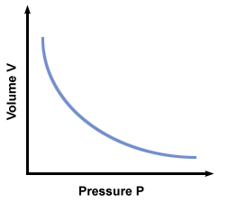
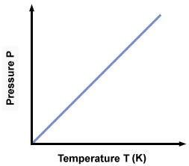
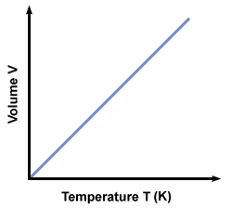

- An ideal gas will have the greatest volume at a high temperature and low pressure
Question:
A balloon has a volume of 150L at a pressure of 101kPa and a temperature of 27°C. It rises to an altitude of 15km where the temperature is -30°C and the pressure 12kPa.
What is the volume of the balloon at this altitude
$V_{1}=150L$ $V_{2}=x$
$P_{1}=101kPa$ $P_{2}=12kPa$
$T_{1}=27+273K$ $T_{2}=-30+273K$
Therefore: $V_{2}=\frac{P_{1}V_{1}T_{2}}{T_{1}P_{2}}= \frac{101×150×(273+27)}{(273-30)×12}=1559L$
Real vs Ideal Gases:
- A gas behaves more like an ideal gas at a high temperature and lower pressure:
  - High temperature: The potential energy due to intermolecular forces becomes less significant compared with the particles kinetic energy
  - Low pressure: The size of the molecules becomes less significant compared to the empty space between them
Real Gases | Ideal Gases
Gas particles have volume | Gas particles do not have volume
Particles have attractive forces | No attractive forces between particles
Molar Volume
- The molar volume of an ideal gas is a constant at specified temperature and pressure
  - Molar volume (V_{m}): The volume occupied by one mole of a substance (chemical element or chemical compound) at a given temperature and pressure
- Avogadro’s law states 1 mol of any gas at STP will occupy 22.7dm³
  - Standard temperature and pressure (STP) conditions are at 273K and 100kPa
- Avogadro’s law enables the mole ratio of reacting gases to be determined from volumes of the gases
$$n=\frac{V_{m}}{V}$$
- In order to calculate the volume of a gas at STP: $V=n ×V_{m}$
  - Where n: moles, V: volume of gas, V_{m}: molar volume of gas at STP
Question:
Determine the volume occupied by 16.g of oxygen gas (O₂ at STP)
$$n=\frac{m}{Mr}=\frac{16}{32}=0.55$$
$$V\left(O_{2}\right)=n×V_{m}=0.500×22.7=11.4$$

Molar Concentrations
Definitions
Solute – The smallest component in a solution (what is being dissolved)
Solvent – The largest component of a solution (what is it being dissolved in) (Remember VENT)
Solution – The solute and solvent combined (A homologous mixture)
Concentration – A measure of solute (mol) per solution (dm⁻³)

- Concentration can be calculated by: $concentration=\frac{mole of solute}{volume of solution}=\frac{n}{V}$
Question:
What is the concentration of sodium chloride in a saline solution if 200cm³ of the solution contains 0.010mol NaCL
$c=\frac{n}{v}=\frac{0.010}{200/1000}=0.050M({mol dm}^{-3})$ Volume is divided because dm³ is needed
Addition of solutions
- Calculate the new amount of mols by adding the number of moles from each individual solution, then find the new volume
Question:
Calculate the final concentration of mol dm⁻³ of CaCl₂ when 25cm³ of 0.40M CaCl₂ added to 50cm³ of 1.2M CaCl₂
$n\left(CaCl_{2}\right)=c×v$ $n\left(CaCl_{2}\right)=c×v$
$n\left(CaCl_{2}\right)=0.40 × 0.025$ $n\left(CaCl_{2}\right)=0.40 × 0.050$
$n\left(CaCl_{2}\right)=0.010mol$ $n\left(CaCl_{2}\right)=0.060mol$
Therefore, by adding both mols together we get 0.070mol. Now we need to calculate concentration:
$$\left[CaCl_{2}\right]=\frac{n}{v}=\frac{0.070}{0.075}=0.93M$$
Dilution
- Dilution: The process of adding more solvent to a solution
- When a solution is diluted, the solute particles are more widely spread. There is a direct relationship between volume and concentration
- The dilution formula is then: $C_{1}V_{1}=C_{2}V_{2}$
Question:
Calculate the molarity of CalCl₂ in 200cm³ of 0.40M CaCl₂ diluted to 400cm³ of water
$C_{1}=0.40M$ $C_{2}=x$ $V_{1}=200cm^{3}$ $V_{2}=400cm^{3}$
Therefore: $C_{2}=\frac{C_{1}V_{1}}{V_{2}}=\frac{0.40×0.200}{0.40}=0.20M$

