

RISK MANAGEMENT PLAN & PROCEDURE

## INTRODUCTION

In order to ensure DSST Public Schools can successfully operate its school programs and fulfill its responsibility to students, parents and the larger community as a whole, it’s imperative that DSST sufficiently evaluates, plans and prepares for the risks that could cause physical harm, disrupt operations, create unexpected financial burden and/or damage DSST’s reputation.

This document outlines the structures, procedures and mitigation strategies DSST utilizes to manage the risk of operating public schools in Colorado.

## GUIDING PRINCIPLES

1. The safety of DSST’s students, staff, families and extended communities is of paramount importance, as is the security of DSST’s resources
2. All DSST team members have responsibility to protect the safety and security of DSST’s communities
3. DSST uses as primary DPS’s Risk Management practices and requirements (*i.e*., Emergency Response & Crisis Management Plans, Contractual Insurance Requirements, Facility Standards)
4. DSST supplements DPS’s risk and emergency protocols where needed to optimize the safety and well-being of our learning communities

## STRUCTURES

**Risk Management Team:**

The following team is responsible for developing and implementing **proactive** risk management strategies, plans and protocols that prevent and minimize events that could cause physical harm, financial damage, operational disruption and/or damage to reputation.

|  |  |
| --- | --- |
| Role | Responsibilities |
| CEO | * Ultimately accountable for strategy, process, decisions and response to manage risks, crises and emergencies |
| Director of Operations | * Accountable for the creation and ongoing management of DSST Risk Management Plan * Accountable for ensuring that annual risk management assessment & prevention cycle occurs as it should * Accountable for ensuring the DSST network is in compliance with DPS’s Emergency Response and Crisis Management requirements * Responsible for ensuring facilities are safe |
| Director of Human Capital | * Accountable for having Employee Assistance Programs to support staff * Accountable for ensuring all staff get CBI background checks * Accountable for ensuring staff get required trainings: mandated reporter, harassment, *etc*. |
| Chief of Staff | * Accountable for creating proactive strategic communication plans – internal and external – in the event of an incident, crisis or emergency |
| Chief of Schools | * Responsible for ensuring School Leaders implement and lead risk management procedures at their schools |
| Director of Finance | * Responsible for ensuring DSST has required and necessary insurance coverage * Responsible for ensuring DSST has a financially sustainable long-term budget forecast |
| School Leaders | * Accountable for ensuring staff are trained and school is in compliance with DPS’s Emergency Response & Crisis Management (ERCM) requirements (drills, *etc.*) |
| School Attorney | * Responsible for legal compliance of Risk Management Plan and accompanying procedures |

**Incident Response Team:**

The following team is responsible for **executing response** once an incident, crisis or emergency happens to mitigate or minimize physical harm, financial damage, operational disruption and/or damage to reputation.

|  |  |
| --- | --- |
| Role | Responsibilities |
| CEO | * Ultimately accountable for decision-making in a crisis or emergency |
| School Leaders | * Accountable for executing emergency response as Incident Commanders at their schools (following baseline DPS ERCM protocols & supplemental DSST protocols) |
| Director of Operations | * Responsible for convening the Incident Response Team in the event of an incident, crisis or emergency via DSST’s emergency conference line (**303-200-1222 x9999**) * Responsible for on-the-ground updates from law enforcement to the Incident Response Team * Responsible for engaging DPS’s District Crisis Recovery Team as needed * Responsible for finding physical space to support incident response (*i.e.*, conference room) |
| Director of Human Capital | * Accountable for activating Employee Assistance Programs, grief counseling, *etc.* to support staff |
| Chief of Staff | * Accountable for leading strategic communications response – internal and external * Accountable for content of all publicly released messages or statements * Accountable for managing press |
| Chief of Schools | * Responsible for “on-the-ground” support of School Leaders in an incident, emergency or crisis * Responsible for decisions about education programming based on the nature / impact of an incident, crisis or emergency |

**Risk Mitigation Components in Place:**

The following mitigation components are in place at all DSST school sites.

|  |  |
| --- | --- |
| Area | Mitigation |
| Safety of People | * Secured access-controlled, video-monitored doors * Annual Emergency Response & Crisis Management plans & team training * Security Cameras * Monthly evacuation drills * 2 lockdown drills per year * 2 shelter-in-place drills per year * Evacuation Maps * Classroom 1-page emergency protocols * Annual Home Office emergency audit * Fire sprinklers & pull stations * Staff IDs, Visitor IDs & Check-in Process * First aid kit and/or emergency response backpack * CPR-trained staff * Annual Denver Fire Department Inspection * Employee Assistance Program for individuals’ needs or crisis counseling * Access to DPS Crisis Response Team for student crisis counseling * Mandated reporter status and training for potential neglect/abuse * All staff, coaches, *etc.* complete CBI background check * Small, school communities built on strong relationships supporting prevention * Policies outlined in annual staff and student handbooks |
| Safety of Facility | * New or renovated facilities, current to building codes * Fire sprinklers & pull stations * Gas, water, electrical shut-off controls * Security Alarms & Security Cameras * Facility Use Agreements with DPS, where DPS is responsible for preventative maintenance and repair * Annual Denver Fire Department Inspection |
| Security Against Financial Damage | * Insurance Policy with following Limits, as required by DPS:   + Comprehensive general liability: $2,000,000 aggregate   + Officers, directors and employees errors and omissions: $1,000,000 aggregate   + Motor vehicle liability (if appropriate): $1,000,000   + Bonding (if appropriate) Minimum amounts: $25,000   + Bonding (if appropriate) Maximum amounts: $100,000   + Workers’ compensation as the state law requires * Long-term budget forecast * Reserve funds * Governmental Immunity Act |
| Information & Data Security | * <<AWAITING SHAUN’S INPUT>> |
| Business Continuity | * CEO Secession Plan |

## PROCEDURES:

**Annual Risk Management Assessment & Prevention Cycle:**

Each year, DSST’s Risk Management Team will implement the following continuous improvement cycle to assess our risks, and develop and execute mitigation strategies and improvements.

(Continued on next page)

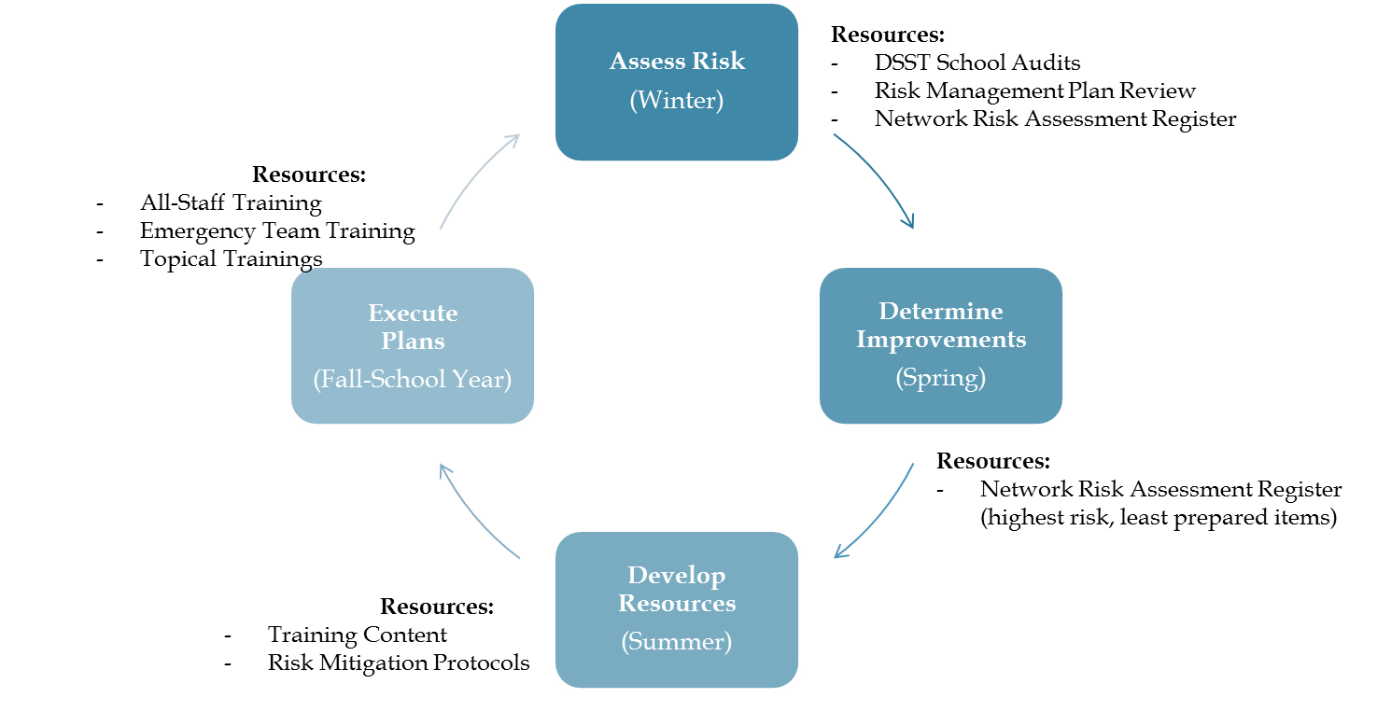

**Annual Risk Assessment Methodology**

DSST will conduct an annual risk assessment to evaluate areas of risk, level of risk, mitigation practices in place and actions required to ensure DSST is effectively managing its risk. Level of risk will be determined based upon the following Likelihood | Consequence matrix.



**Response Planning & Action:**

* Foundational – Compliance with DPS ERCM & Compliance Protocols
  + DPS has invested in practices in this area and DSST will remain in compliance
    - Sept: Annual ERCM Plan updated for each school
    - Oct: Emergency team members complete online training
    - Nov: Staff complete Mandated Reporter training
    - Monthly: Fire Evacuation Drills
    - 2x per year: Lockdown Drills
    - 2x per year: Shelter-in-Place Drills
* Supplementary DSST Protocols
  + DSST Home Office operations will complete an annual internal emergency audit of each campus’s emergency preparedness
  + DSST has created supplementary response protocols for various emergency scenarios

X:\Operations\Public - All Home Office\Risk Management Plans