Participants Guide
Write your “I Remember Poem” below

When deciding on where to live (region, state, city, etc.), what is important to you?
Which city would you move to?

Making Your Claim
Write or type your assertion in the space below. Use the ACES rubric to assist you.

Cite Evidence
Select your two strongest pieces of evidence that helped you form your assertion. (The chart is on the next page, if needed.)
If needed, use these sentence starters:
- For Example,
In addition,
- First,
Second,
- According to…

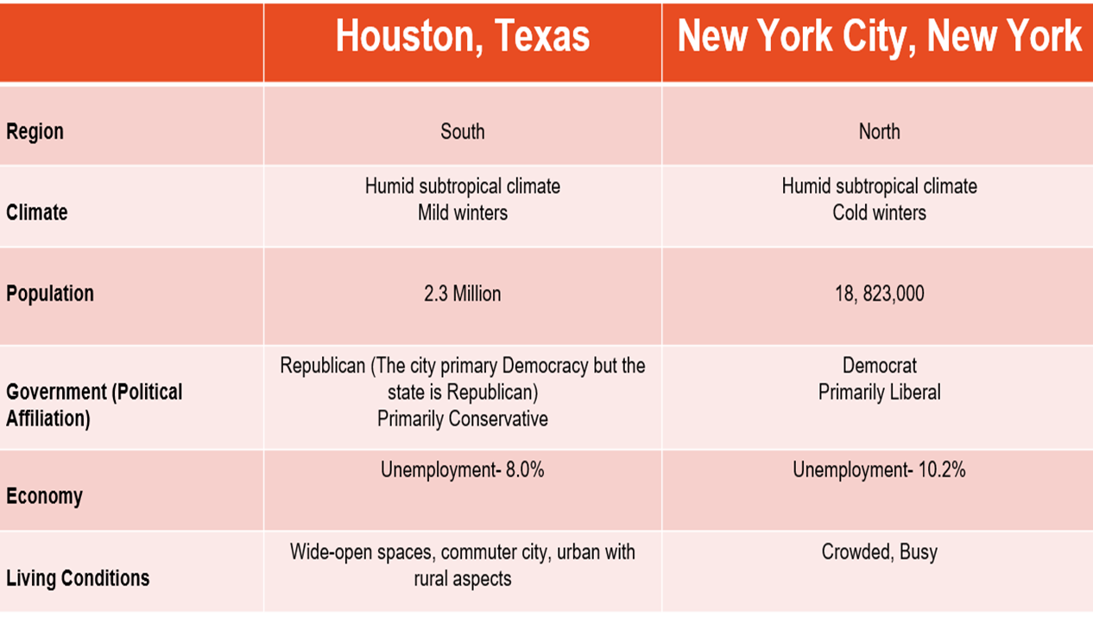
From Evidence to Analysis
Explain your reasoning – why did you select the evidence and how does it prove the assertion to be true?
If needed, use this sentence starter:
- This proves…

Task #5 – Summary Sentence
If needed, use this sentence starter:
- As a result, …

ACES Writing Student Must Haves
Assertion  (Thesis) | My Assertion or Thesis:  - Answers the question or prompt.  - Has a subject and an opinion about the question or prompt (such as “Reading is a great hobby.”)  - Gives the reader a preview of how I will defend my opinion.  Example: Reading is a great hobby because you learn new information and it improves reading skills.
Cite Evidence | My Evidence:  - Supports the thesis statement with specific information. Examples include: people, places, dates, events, social studies terms, and data from maps, charts, graphs, and tables.  - Supports the thesis statement with information that is related to my opinion.  - Supports the thesis statement with information that is accurate.  - Cites more than one piece of accurate, specific, and relevant evidence.  Example: Reading is a great hobby because you learn new information and it improves reading skills. For example, while reading Harry Potter and the Sorcerer’s Stone, I learned that the climate of England is cold and rainy. In addition, I learned a new word “ravine” from reading the text.
Explain Reasoning (Rationale) | My Reasoning:  - Is my own opinion.  - Explains how my evidence is connected to my thesis.  Example: Reading is a great hobby because you learn new information and it improves reading skills. For example, while reading Harry Potter and the Sorcerer’s Stone, I learned that the climate of England is cold and rainy. In addition, I learned a new term “ravine” from reading the text. This proves that reading is a great hobby because I used the new facts and words I learned from the book to help me have a conversation with others in my Geography class when studying England.
Summary Statement | My Summary Statement:  - Restates the assertion using different words and language than my assertion or thesis.  Example: Reading is a great hobby because you learn new information and it improves reading skills. For example, while reading Harry Potter and the Sorcerer’s Stone, I learned that the climate of England is cold and rainy. In addition, I learned a new term “ravine” from reading the text. This proves that reading is a great hobby because I used the new facts and words I learned from the book to help me have a conversation with others in my Geography class when studying England. As a result, reading is the best hobby a person can have.
Mechanics, Structure and Organization | My ACES Writing:  - Has few to no spelling and grammatical errors.

 | Not Yet | Emerging | Proficient | Advanced
Assertion  (Thesis) | - There is no thesis present.  - The thesis is attempted but does not contain BOTH a subject and opinion.  - The thesis does not answer the question or address the prompt.  - The thesis doesn’t contain analysis of the prompt. | - Thesis is present but it is confusing.  - Thesis contains a subject and an opinion but does not address the prompt.  - Thesis does not contain analysis of the prompt. | - Thesis is present but only restates the prompt.  - Thesis contains both subject and opinion but no analysis of the prompt.  - Thesis may contain grammatical errors that do not significantly detract from the assertion. | - Thesis statement addresses the question.  - Thesis statement contains both the subject and an opinion about the subject.  - Thesis is well-developed and includes an analysis of the prompt.  - Thesis statement is well written and does not contain major grammatical errors.
Cite Evidence | - Evidence contains major historical errors (not accurate.)  - Evidence does not support the thesis.  - Evidence is not specific. | - Cites only one relevant, accurate, specific piece of evidence  - One or more piece of evidence is inaccurate  - One or more piece of evidence is irrelevant  - One or more piece of evidence is not specific | - Cites more than one piece of evidence.  - Most evidence is accurate, relevant, and specific | - Evidence supports the thesis statement with specific information.  - Evidence supports the thesis statement with relevant information.  - Evidence supports the thesis statement with accurate information.  - Cites more than one piece of accurate, specific, and relevant evidence.
Explain Reasoning (Rationale) | - There is no rationale given as to why or how the evidence supports the thesis. | - There is a rationale but it is confusing and/or not well-developed | - There is a rationale as to why or how the evidence given proves the thesis but it is too general or simply restates the evidence itself. | - There is a rationale as to why or how the evidence given proves the thesis (assertion.)
Summary Statement | - There is not a summary statement | - There is a summary statement but it does not restate assertion  - There is a summary statement but it does not give the reader a sense of closure (i.e. provides new information not addressed in the writing) | - There is a summary statement but it uses the exact same language as the assertion | - There is a summary statement that restates the assertion using different language than the assertion
Mechanics, Structure and Organization | - Major problems in writing and organization such that the meaning of the essay is lost. | - Problems in writing and organization that detract from the quality and meaning of the essay.  - Contains major historical errors | - Acceptable writing and organization.  - May contain some errors that do not seriously detract from the quality of the essay. | - May contain minor errors that do not detract from the overall quality of the essay.

Notes Page: You may use this page to jot down ideas etc.

