Add, Edit, or Remove Certifications on Your Profile
Certifications are a great way to showcase your knowledge and professional achievements on your LinkedIn profile.

Managing certifications
To add a certification:

- Click the Me icon at the top of your LinkedIn homepage.

- Click View profile.

- If you've previously added a certificate, scroll down to the Licenses and Certifications section and click Add.

  - If you've never added a certification, you'll first want to add a Licenses and Certifications section. On your profile page click Add new profile section in your introduction card. Under the Background dropdown, click the Add icon next to Licenses and Certifications.

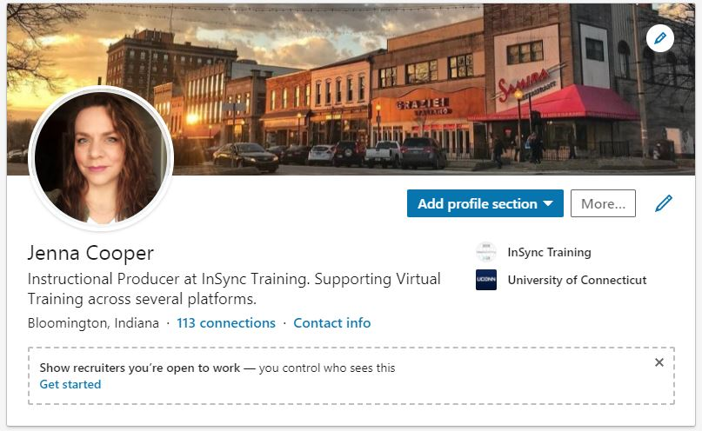

- In the new dialogue window type in your certification information.
- Your badge does not expire so please check the box.
- Credential ID is the name of the Badge again
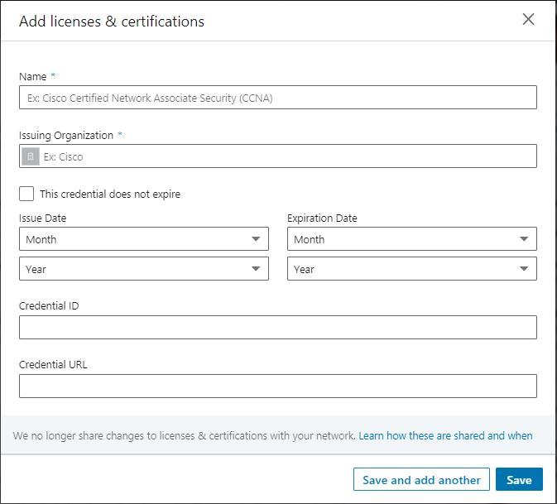

- A menu displaying companies will appear as you type in the Issuing Organization field. Be sure to select the correct authority from the menu so their logo appears next to the certification on your profile.

- Click Save.

Your Badge will show as below and anyone who clicks the “See Credential” will be redirected to the InSync Training Digital Badge Page.

