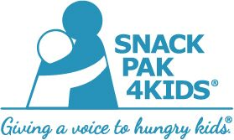

Contents of Snack Pak 2020-2021

- 1 Gatorade G-Zero
- 1 shelf-stable chocolate Fairlife milk
- 2 pouches of Kellogg’s cereal
- 1 Austin peanut butter cracker pack
- 1 Cheez-It package
- 2 SP4K Beef Stiks
- 1 JIF-to-GO peanut butter
AND
- 1 Kraft macaroni and cheese
- OR 1 Musselman apple/strawberry sauce squeeze pouch and
- 1 Rice Krispie cereal bar

We will be delivering each Wednesday morning with the exception of holidays.

