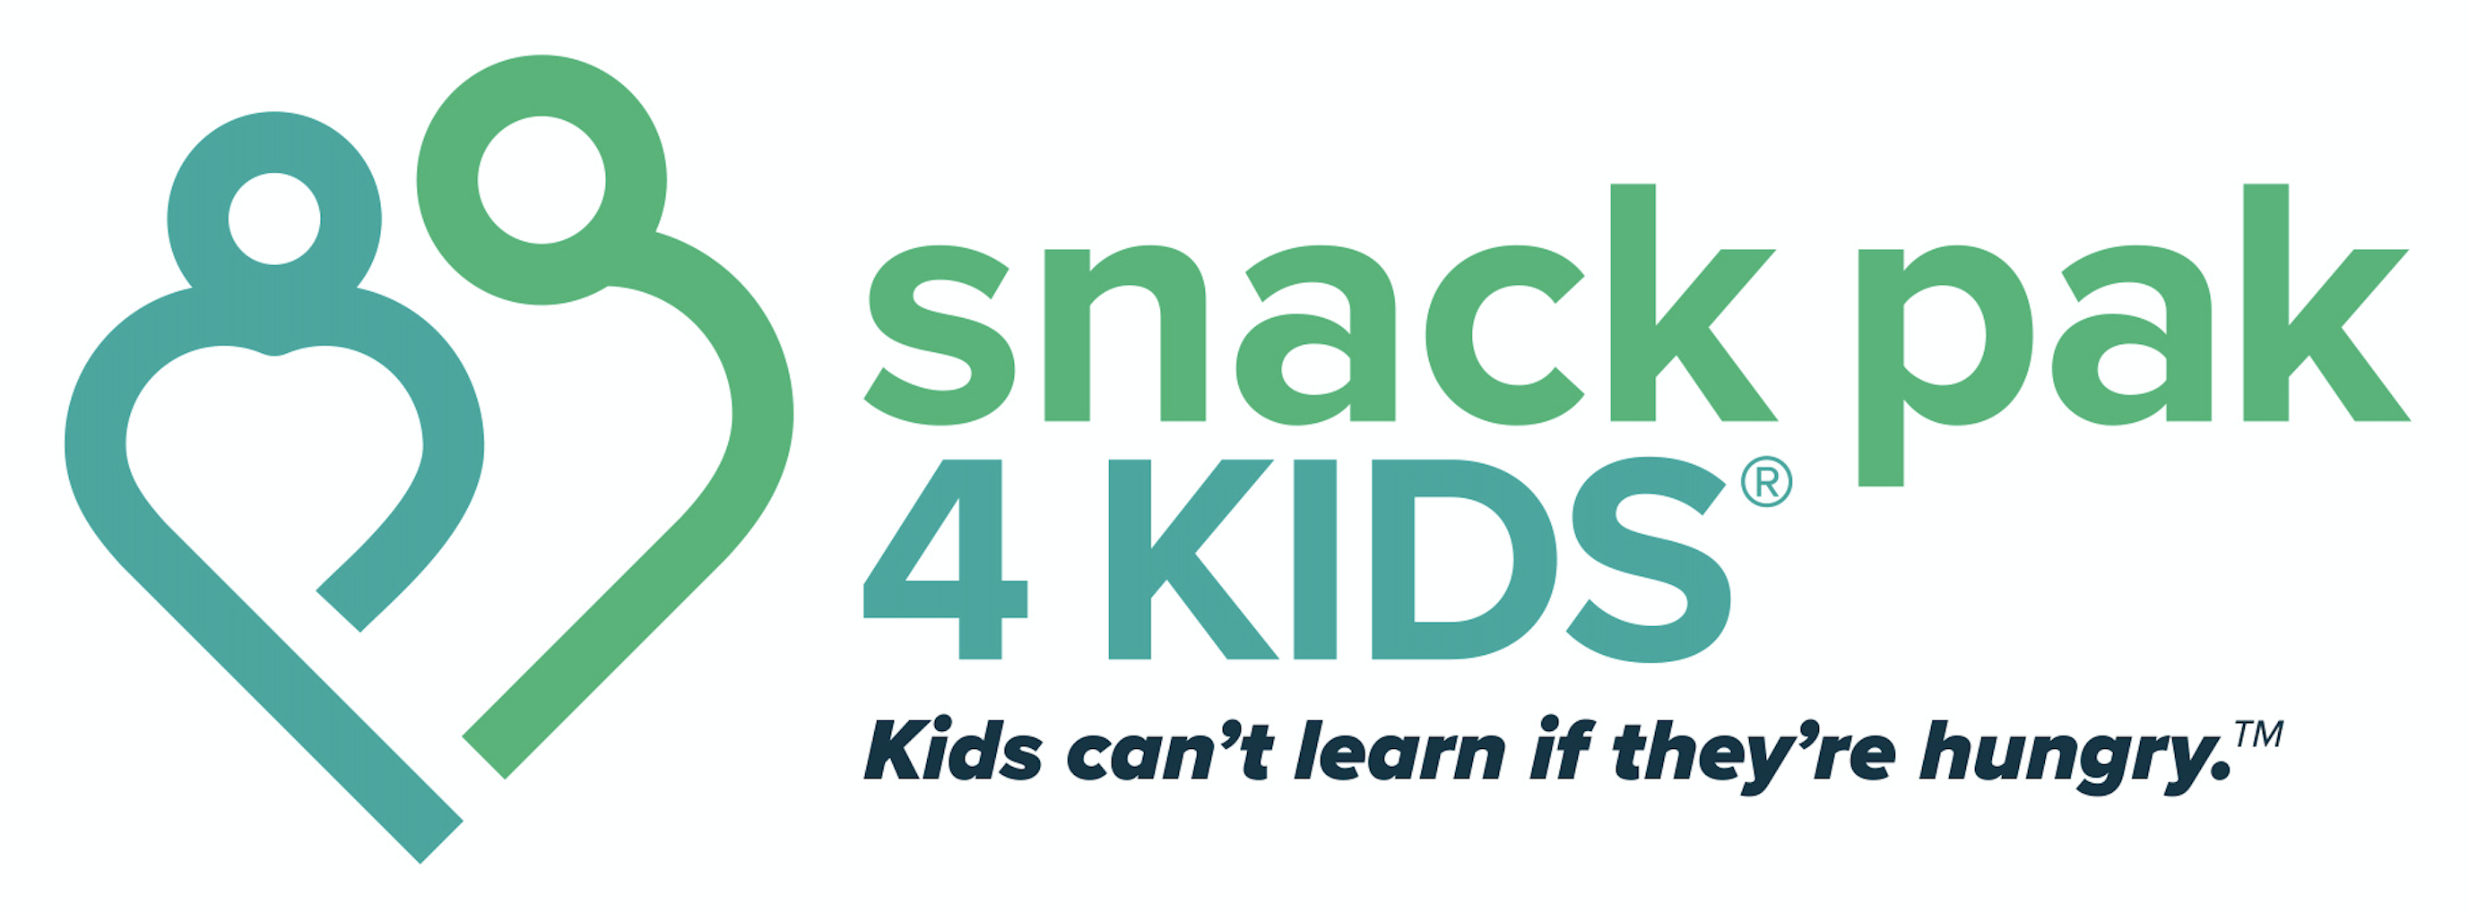

School Coordinator Tasks and Responsibilities

- Identify operation procedures for your specific site
  - Where will you store the food?
  - How will the students receive their Snack Paks in a discrete manner? Placing them in backpacks or lockers is preferred.
  - Who will distribute should you be absent on a Friday? What is your backup plan for bad weather?

- Coordinate annual survey efforts with students in May and ensure they are returned to SP4K
  - This is crucial. It helps us to know if we’re on the right track with the snacks we’re offering and the process in which we deliver them. It also helps to make sure we’re serving the right kids.

- Present Snack Pak 4 Kids® to all faculty and staff at your site
  - Explain chronic hunger signs/symptoms and referral process. We suggest you have a meeting with the entire staff at the beginning of each school year, and reference the documents regarding chronic hunger (lounge flyer and Identifying Hungry Children).
  - All school forms can be found via our website at http://snackpak4kids.org/school-forms
  - If you need assistance with presenting this to your staff, contact Becky at becky@sp4k.org or 806-626-9012.
  - Let your faculty/staff members know that identification of students in need of Snack Pak is a team effort. They can add/remove a student at any time. The relationship between the student and the teacher is the best way to identify a need.

- Place blank Child Referral forms in a convenient location for faculty/staff

- Begin receiving child referrals from faculty/staff
  - Place completed and approved referrals in a binder. *Ask the nurse or child about any food allergies.

- Send home notification letters/parent permission forms to parents of referred children
  - Snack Pak 4 Kids® requires permission from parents, but make sure to follow your school procedures and policies. All permission forms remain in the possession of the school district.

- Meet with referred children individually to explain Snack Pak 4 Kids®
  - “Backpack Buddies” or another creative name can be used when talking to the referred children about the program.

- Email your SP4K contact weekly with the number of bags you will need
  - Becky Stogner – becky@sp4k.org
  - Numbers need to be emailed each week no later than Monday afternoon so we can ensure no kids are missed. If there is no change, the same amount will be sent as the previous week.
  - Empty totes will be picked up by the Snack Pak volunteers on every other Friday or Monday, or on Wednesdays when new totes are delivered. Please have them available in an accessible location.

- Prepare Distribution Record with names of children referred into the program

- Distribute bags to children on Friday and record numbers on Distribution Record

