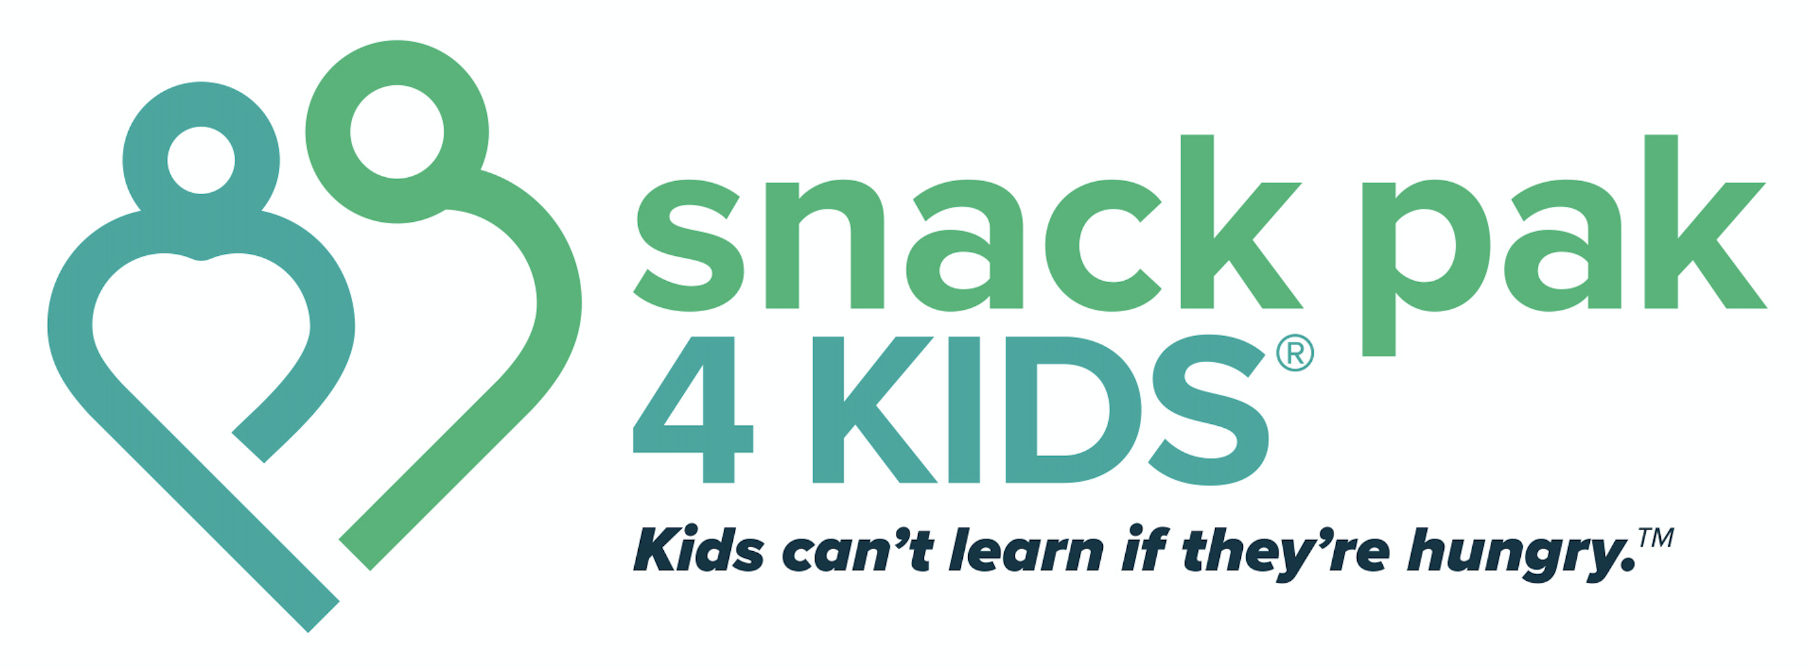

2021-2022 Menu

Priority Items
1 - fairlife milk
1 - Gatorade Zero*
1 - Cheez-It *
2 - Beef Stick *
1 - Kraft mac ‘n’ cheese cup *
1 - Rice Krispie treat* / Pop tart
1 – General Mills cereal bowl
1 – Kellogg’s cereal pouch

Options (choose two each week to mix & match)
Some weeks offer 2 Gatorade, no milk
Jif to Go peanut butter
Peanut Butter Crackers
Dick & Jane snack *
Honey Graham snacks * (tested well, though this wasn’t reflected in the survey)
GoGo Squeez Applesauce
* Student Favorites

Sample Menus

1 - Gatorade Zero 2 - Gatorade Zero 1 - Gatorade Zero 1 - Gatorade Zero
1 - Milk 1 - Applesauce 1 - Milk 1 - Milk
1 - Jif to Go peanut butter 1 - Jif to Go peanut butter 1 - Applesauce 1 - Rice Krispie treat
1 - Honey Graham snack 1 - Dick & Jane snack 1 - Honey Graham 1 - Dick & Jane
1 - Cheez-It 1 - Cheez-It 1 - Cheez-It 1 - Cheez-It
1 - Cereal bowl 1 - Cereal bowl 1 - Cereal bowl 1 - Cereal bowl
1 - Cereal pouch 1 - Cereal pouch 1 - Cereal pouch 1 - Cereal pouch
2 - Beef Stick 2 - Beef Stick 2 - Beef Stick 2 - Beef Stick
1 - Rice Krispie treat 1 - Mac ‘n’ Cheese cup 1 - PB cracker 1 - Mac ‘n’ Cheese
1 - Peanut butter cracker

