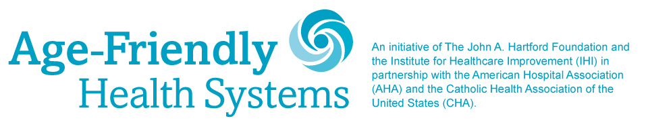

MILESTONE CELEBRATION PROMOTION ACTIVITIES, CONTENT & INSTRUCTIONS
For
Week of March 29, 2021

Hello! Our joint celebration campaign for the Age-Friendly Health Systems movement is gaining momentum. We couldn’t have done this without your participation. Thank you for joining us in spreading the word about the movement.
We are celebrating success and spreading the movement so it grows further and achieves its important aims of improving health care for older adults across the US. Organizations like yours, who led the way in adopting age-friendly care, can be a role model and inspire others to join by sharing your story.
For the week of March 29, please help us by sharing why you joined the Age-Friendly Health Systems movement and the value your participation has brought to your organization and your surrounding community.

Week of March 29, 2021:
Post the following message on Facebook along with the “We joined the Age-Friendly Health Systems movement” visual. Please use the file “Age-Friendly_Social-Media_Participants-We-Joined-Facebook.jpg”

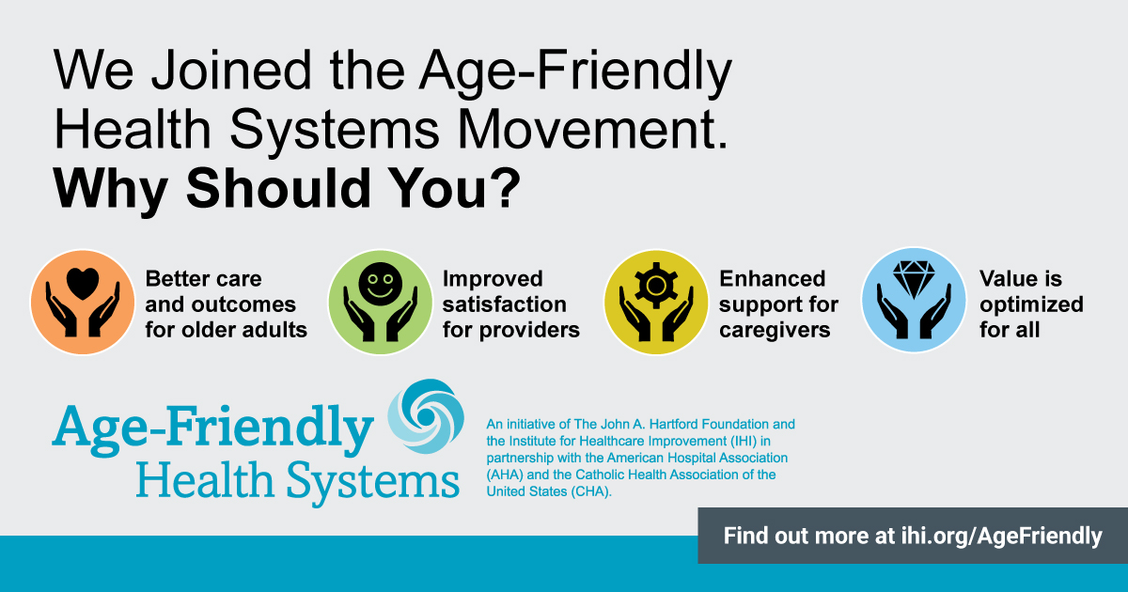
Adults 65 and older are a rapidly growing segment of our patient community. We have committed to providing them #agefriendly care by joining the #AgeFriendlyHealthSystems movement and adopting the 4Ms framework. Here’s why every #healthcare provider should join this movement.
@TheIHI @johnahartford @ahahospitals @catholichealthassociation

Week of March 29, 2021:
Post the following message to Twitter along with the “We joined the Age-Friendly Health Systems movement” visual. Please use the file “Age-Friendly_Social-Media_Participants-We-Joined-Twitter.jpg”

We joined the #AgeFriendlyHealthSystems movement. Why should you?
#healthcare #agefriendly @TheIHI @ahahospitals @johnahartford @TheCHAUSA
