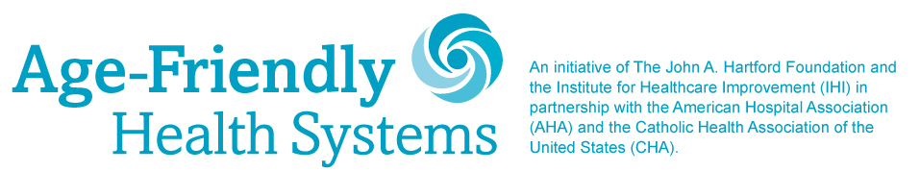

**MILESTONE CELEBRATION PROMOTION ACTIVITIES, CONTENT & INSTRUCTIONS**

**For**

**Week of March 22, 2021**

We enjoyed kicking off the Age-Friendly Health Systems celebration on March 18 and hope your communications also received a good response! We are ready with our outreach for the week of March 22. On the following pages, we suggest activities and content for you so we can coordinate our efforts to get the word out about this important movement.

Again, we realize you are busy. Please share as many messages as you can anytime during the celebration.

**Week of March 22, 2021:**

On March 22, IHI will post a video message from their President and CEO Kedar Mate, MD, about participating organizations’ significant role in making the Age-Friendly Health Systems initiative a success.

Please share and retweet IHI’s post through your Facebook and Twitter channels using the sample messages below or feel free to adapt to your own voice.

We will also alert you when the video message is posted.

**Facebook**

Thank you @TheIHI for recognizing our commitment and leadership in delivering #agefriendly care to #olderadults. #AgeFriendlyHealthSystems

@johnahartford @ahahospitals @catholichealthassociation

**Retweet of IHI Video**

Thank you @KedarMate @TheIHI for recognizing our commitment and leadership in delivering #agefriendly care to #olderadults. #AgeFriendlyHealthSystems

@ahahospitals @johnahartford @TheCHAUSA

**Week of March 22, 2021:**

Download the “We are Age-Friendly” milestone celebration sign, print it on 11x17 paper and take a picture with your Age-Friendly team holding the sign.

Please use the file “[We-Are-Age-Friendly-Sign-11x17.pdf”](https://f.hubspotusercontent30.net/hubfs/241684/Age-Friendly-Milestone/Sign/We-Are-Age-Friendly-Sign-11x17.pdf)

**](https://f.hubspotusercontent30.net/hubfs/241684/Age-Friendly-Milestone/Sign/We-Are-Age-Friendly-Sign-11x17.pdf)**

**Post the following message on Facebook** along with the picture of your team holding the   
[“We are Age-Friendly”](https://f.hubspotusercontent30.net/hubfs/241684/Age-Friendly-Milestone/Sign/We-Are-Age-Friendly-Sign-11x17.pdf) sign.

**](https://f.hubspotusercontent30.net/hubfs/241684/Age-Friendly-Milestone/Sign/We-Are-Age-Friendly-Sign-11x17.pdf)**

The #AgeFriendlyHealthSystems movement, through recognizing older adults’ unique #healthcare needs, is benefitting #olderadults and their care providers. (*Name of Participating Health Care Organization*) is proud to be one of the earliest organizations to have joined this movement, to adopt its 4Ms framework, and to be driving it forward by delivering Age-Friendly care.

@johnahartford @ahahospitals @TheIHI @catholichealthassociation

**Post the following message on Twitter** along with the picture of your team holding the   
[“We are Age-Friendly”](https://f.hubspotusercontent30.net/hubfs/241684/Age-Friendly-Milestone/Sign/We-Are-Age-Friendly-Sign-11x17.pdf) sign.

(*Name of Participating Health Care Organization*) is one of the earliest organizations to join the #AgeFriendlyHealthSystems movement and adopt its 4Ms framework to directly address older adults’ unique health care needs. Proudly delivering #agefriendly care.

@TheIHI @johnahartford @ahahospitals @TheCHAUSA

**](https://f.hubspotusercontent30.net/hubfs/241684/Age-Friendly-Milestone/Sign/We-Are-Age-Friendly-Sign-11x17.pdf)**

**Important Instructions:**

* Print sign file named [“We-Are-Age-Friendly-Sign-11x17.pdf”](https://f.hubspotusercontent30.net/hubfs/241684/Age-Friendly-Milestone/Sign/We-Are-Age-Friendly-Sign-11x17.pdf) and take a picture of your   
  Age-Friendly team members holding the poster prominently
* Please make sure your team members follow your organization’s COVID-19 guidelines while taking the picture (for example – wear masks and maintain appropriate distance)
* Share photo with above messages