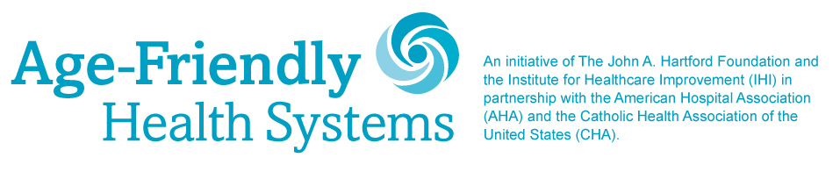

**MILESTONE CELEBRATION PROMOTION ACTIVITIES, CONTENT & INSTRUCTIONS**

**For**

**Week of April 5, 2021**

For the week of April 5, we are encouraging you to talk about the 4Ms framework, share improvements you have achieved as a result of implementing it, and showcase the impact that it has helped you make in your local community. Every organization has its own story and results. The copy below provides a sample for you to follow.

**Week of April 5, 2021:**

**Post the following message on Facebook** along with the 4Ms framework visual.   
Please use the file [“Age-Friendly_Social-Media_4Ms-Facebook.jpg”](https://f.hubspotusercontent30.net/hubfs/241684/Age-Friendly-Milestone/Social-Media-Assets/Age-Friendly_Social-Media_4Ms-Facebook.jpg)

](https://f.hubspotusercontent30.net/hubfs/241684/Age-Friendly-Milestone/Social-Media-Assets/Age-Friendly_Social-Media_4Ms-Facebook.jpg)

The #AgeFriendlyHealthSystems 4Ms framework allowed us to address the key drivers of improving care for #olderadults. (*Name of Participating Health Care Organization)* is proud to be leading the way in adopting and implementing the 4Ms framework.

#agefriendly @TheIHI @johnahartford @ahahospitals @catholichealthassociation

**Week of April 5, 2021:**

**Post the following message on Twitter** along with the 4Ms framework visual.   
Please use file [“Age-Friendly_Social-Media_4Ms-Twitter.jpg”](https://f.hubspotusercontent30.net/hubfs/241684/Age-Friendly-Milestone/Social-Media-Assets/Age-Friendly_Social-Media_4Ms-Twitter.jpg)

The #AgeFriendlyHealth Systems 4Ms framework is helping us improve care for #olderadults. We are proud to lead the way in adopting and implementing the 4Ms. #healthcare

@TheIHI @johnahartford @ahahospitals @TheCHAUSA

](https://f.hubspotusercontent30.net/hubfs/241684/Age-Friendly-Milestone/Social-Media-Assets/Age-Friendly_Social-Media_4Ms-Twitter.jpg)

**Week of April 5, 2021:**

**Post below message on Facebook**

By adopting #agefriendly care approaches, *(Name of participating organization)* has been able to positively impact the lives of (insert number) #olderadults in our community. We are proud to be one of the earliest organizations to join the #AgeFriendlyHealthSystems movement and adopt its 4Ms framework. Learn more at [ihi.org/AgeFriendly](http://ihi.org/AgeFriendly)

@TheIHI @johnahartford @ahahospitals *@catholichealthassociation*

**Or**

Implementing the #AgeFriendlyHealthSystems 4Ms framework in our care of #olderadults led to (Insert result. For example: decrease in delirium incidence from X% to Y% over one year or reduced administration of high-risk medications by X %). Learn how you can achieve these results: [ihi.org/AgeFriendly](http://ihi.org/AgeFriendly)

#healthcare @TheIHI @johnahartford @ahahospitals *@catholichealthassociation*

**Post below message on Twitter**

Adopting the 4Ms has allowed us to positively impact the lives of (insert number) #olderadults in our community. Proud to be one of the earliest organizations to join the #AgeFriendlyHealthSystems movement. #healthcare

@TheIHI @ahahospitals @johnahartford @TheCHAUSA