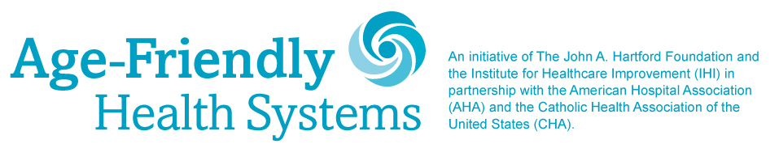

MILESTONE CELEBRATION PROMOTION ACTIVITIES, CONTENT & INSTRUCTIONS
For
Week of April 12, 2021

For the week of April 12, we are asking that you share any additional improved outcomes related to your participation in the Age-Friendly Health Systems movement and implementation of the 4Ms framework. Every organization has its own results and stories to tell. Below are samples to inspire you. If you don’t want to post results, you can also post a general message about the movement. A sample is provided.

Week of April 12, 2021:
Add or adapt below message based on your organization’s improved outcomes and post on Facebook along with the “Focusing on what matters …” visual. Please use file “Age-Friendly_Social-Media_What-Matters-Facebook”

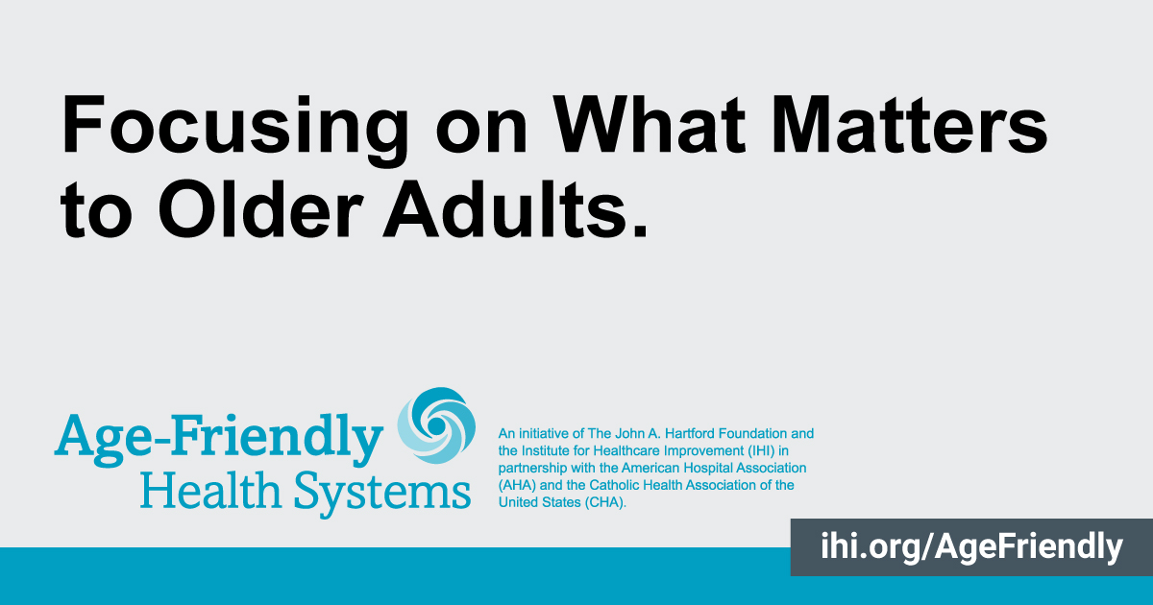
(Name of Participating Health Care Organization), focused on what matters to older adults and (Insert result. For example, reduced average length of stay or readmissions by XX percent over previous year). Learn more at ihi.org/AgeFriendly
#AgeFriendlyHealthSystems #agefriendly @TheIHI @johnahartford @ahahospitals
@catholichealthassociation

Alternative: (Name of Participating Health Care Organization) is focusing on what matters to #olderadults to provide them better care. We are committed to being an #AgeFriendlyHealthSystem and implementing the 4Ms framework: What Matters, Medication, Mentation, Mobility.
#healthcare @TheIHI @johnahartford @ahahospitals @catholichealthassociation

Week of April 12, 2021:
Add or adapt below message based on your organization’s improved outcomes and post on Twitter along with the “Focusing on what matters …” visual. Please use file “Age-Friendly_Social-Media_What-Matters-Twitter”

By focusing on what matters to #olderadults, we were able to (Insert result. For example, reduced average length of stay or readmissions by XX percent over previous year). Learn more at ihi.org/AgeFriendly #AgeFriendlyHealthSystems #agefriendly
@TheIHI @johnahartford @ahahospitals @TheCHAUSA
