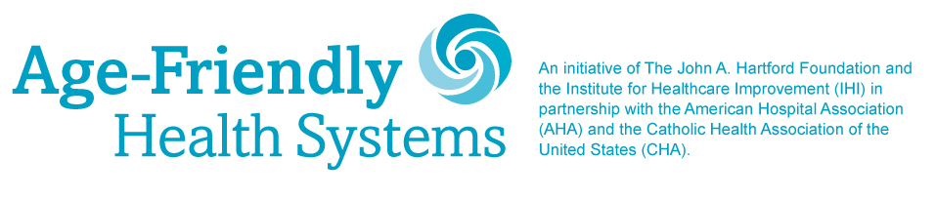

MILESTONE CELEBRATION PROMOTION ACTIVITIES, CONTENT & INSTRUCTIONS
For
March 18, 2021

We are very excited to celebrate your organization’s contribution to improving care for older adults through your participation in the Age-Friendly Health Systems movement.

Beginning March 18, IHI and its partners are coming together in a campaign to applaud Participants and celebrate the movement’s momentum.

We’d like to make sure that all of your organization’s friends, partners, and stakeholders are also aware of your work. To make it easy for you to participate in the celebration campaign, we have provided suggested content and activities for you to share through your channels.

Please note that these are suggestions. We realize you are busy. You can share these messages and content anytime during the celebration.

See the content for March 18 on the following pages.

March 18, 2021:
Distribute a press release announcing your participation in the Age-Friendly Health Systems movement to media in your local market

[INSERT LOGO HERE] 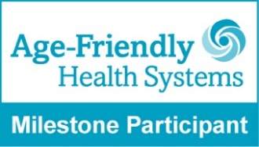

FOR IMMEDIATE RELEASE Contact: XXXX

(Name of Participating Health Care Organization) drives forward national movement to improve care for (optional: name of city/county/service area) older adults

City, State — March 18, 2021

(Name of Participating Health Care Organization) was one of the earliest health care organizations to join the Age-Friendly Health Systems movement and is pleased to announce that its commitment to this national movement is not only improving care for older adults in its own community but has contributed to the national movement surpassing its 2020 milestone.
The Institute for Healthcare Improvement (IHI) has announced that the Age-Friendly Health Systems movement has beaten its participation goal by nearly 50 percent with the help of 1,956 sites of care like (Name of Participating Health Care Organization) who joined the movement by the end of 2020. The Age-Friendly Health Systems movement underscores (Name of Participating Health Care Organization)’s active commitment to improving care for older adults.
Health care organizations who join the Age-Friendly Health Systems movement adopt and demonstrate progress toward implementation of the 4Ms framework, four evidence-based practices, that lay the groundwork for optimizing care and outcomes for older adults, improving provider experience, supporting caregivers, and pursuing value-based methods of care. The 4M’s include: What Matters to older adults, their Medication, their Mentation, and their Mobility.
IHI reports that participation in the Age-Friendly Health Systems movement surged by 85 percent during the COVID-19 pandemic, when 1,671 care sites joined between March and December 2020, highlighting the impact of the older adult population’s size and distinct medical needs on US health care delivery. Adults 65 and older are a rapidly growing segment of the US population and health care consumers. Their numbers are expected to increase from 49 million today to 98 million by 2060.
Sample quote from Participating health care organization: (Name of Participating Health Care Organization) is deeply committed to the Age-Friendly Health Systems movement because of the benefits that it can deliver to older adults, their families, and our providers, says (name, title).
Insert Participating Health Care Organization’s Age-Friendly results or outcomes if available.
The founders and partners of Age-Friendly Health Systems recognize the far-reaching impact of improving care for older adults as a way to build greater resilience into individual health care organizations and to strengthen US health care overall.
The Age-Friendly Health Systems movement is an initiative of The John A. Hartford Foundation and IHI in partnership with the American Hospital Association (AHA) and the Catholic Health Association of the United States (CHA). Together, they applaud and celebrate the visionary health care organizations who signed on to improve their care of older adults and have led the way in recognizing and addressing a critical need that will strengthen health care delivery today and in the future.

For more information or to join, visit ihi.org/AgeFriendly.

Insert Boilerplate for Participating Health Care Organization

About the Institute for Healthcare Improvement (IHI)
The Institute for Healthcare Improvement (IHI) is an independent not-for-profit organization based in Boston, Massachusetts, USA. For more than 25 years, IHI has used improvement science to advance and sustain better outcomes in health and health systems across the world. IHI brings awareness of safety and quality to millions, catalyzes learning and the systematic improvement of care, develops solutions to previously intractable challenges, and mobilizes health systems, communities, regions, and nations to reduce harm and deaths. IHI collaborates with a growing community to spark bold, inventive ways to improve the health of individuals and populations. IHI generates optimism, harvests fresh ideas, and supports anyone, anywhere who wants to profoundly change health and health care for the better. Learn more at ihi.org.

Important Instructions:
- Please add your organization’s logo, Age-Friendly Health Systems Milestone Participant badge, spokesperson’s quotes, and available participation details to the release

March 18, 2021:
Distribute email to your organization’s key stakeholders

Dear XX,
As one of the earliest health care organizations to join the Age-Friendly Health Systems movement, we are pleased to announce that our commitment to this national movement is not only improving care for older adults in our community but has contributed to the national movement surpassing its 2020 milestone.
The Institute for Healthcare Improvement (IHI) has announced that the Age-Friendly Health Systems movement has beaten its goal for participation by nearly 50 percent with the help of 1,956 care locations like (Name of Participating Health Care Organization) who joined the movement by the end of 2020.
These results signify the health care community’s urgent interest and need for evidence-based approaches to better care for older adults. They also highlight the value of this movement and its 4Ms framework. Participating organizations, like ours, adopt and demonstrate progress toward implementation of the 4Ms that lay the groundwork for optimizing care and outcomes for older adults, improving provider experience, supporting caregivers and pursuing value-based methods of care.
We are proud to be leading the way in adopting and advancing the 4Ms in our community. Since we began our participation in this movement, we have (Insert Participating Organization’s Age-Friendly results or outcomes if available.)
We believe that there has never been a more critical time to prioritize adult care. People aged 65 years and older have been hit hardest by the COVID-19 pandemic, emphasizing the impact of this population’s size and distinct medical needs on the US health care delivery system.
We recognize the significant benefits that the Age-Friendly Health Systems movement offers to older adults, their families, and our providers, especially as we face this unprecedented pandemic.
We thank the founders and partners of Age-Friendly Health Systems who recognized the far-reaching impact of improving care for older adults as a way to build greater resilience into individual health care organizations and to strengthen US health care overall.
Together, with them, we stand committed to improving care for older adults.

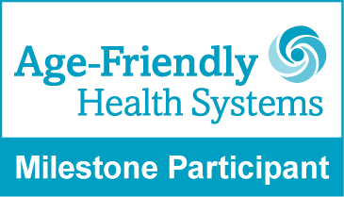

Important instructions:
You can use the above content or feel free to adapt to your voice.
Please add the Age-Friendly Health Systems Milestone Participant badge to your email signature
If you are currently using a CRM platform to distribute emails, please add the Age-Friendly Health Systems “4Ms Framework Graphic” to your HTML email

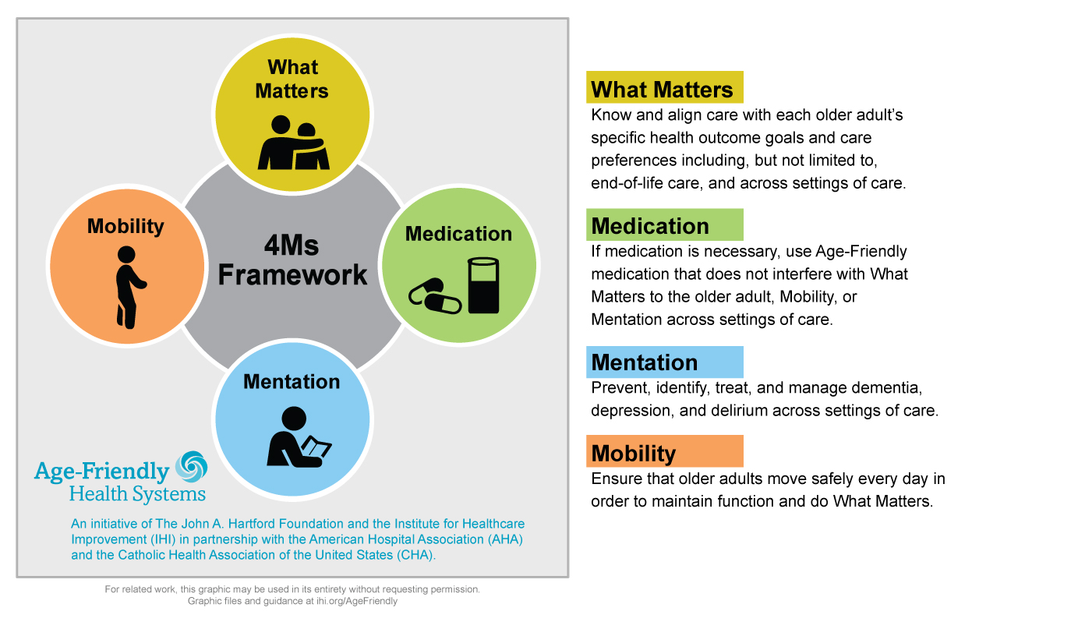

March 18, 2021:
Post the following message on Facebook along with the “We are making…” visual. Please use the file “Age-Friendly_Social-Media_Making-It-Happen-Facebook.jpg”

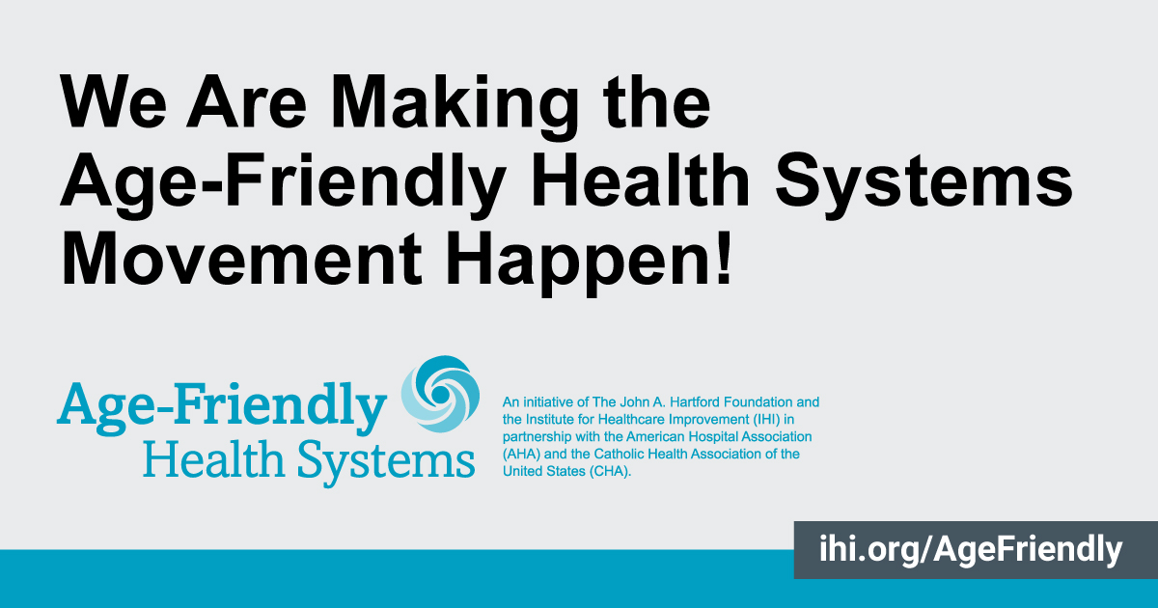
We are pleased to announce that our commitment to the #AgeFriendlyHealthSystems movement is improving care for #olderadults in our community and contributing to the national movement surpassing its 2020 milestone. The movement underscores (Name of Participating Organization’s) active commitment to improving care for this rapidly growing segment of the US population. #agefriendly
@johnahartford @ahahospitals @TheIHI @catholichealthassociation

March 18, 2021:
Post the following message to Twitter along with the “We are making…” visual.
Please use the file “Age-Friendly_Social-Media_Making-It-Happen-Twitter.jpg”

Our commitment to the #AgeFriendlyHealthSystems movement is improving care for #olderadults in our community and has contributed to the movement surpassing its 2020 milestone. We are proudly delivering #agefriendly care.
@TheIHI @ahahospitals @johnahartford @TheCHAUSA
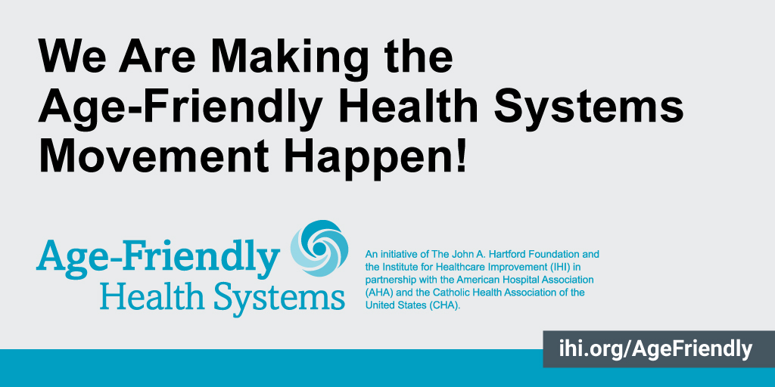

US Census Bureau

