My Favourite High Income Strategy - of all time?
Introduction
Let’s face it the Australian high income earner pay a lot of income tax with very little relief. Is it any wonder that the company or family trust with the obligatory bucket company are the preferred vehicles for small and medium businesses. But some professionals and salary and wage earners cannot position their affairs into these entities. So they are stuck with paying a lot of income taxation, month after month.
Super is a choice to reduce salary and wages but everyone will tell and scream at you that there are concessional and non-concessional contribution caps to really worry about and never go over the current $25,000 cap for concessional and $100,000 for non-concessional caps or you will pay the financial price.
But the world has changed
Importantly the penalties for excess concessional and non-concessional contributions were abolished in 2013 – six years ago. It is surprising that the contributions cap myth stills holds front and centre.
Section 291-1 of the ITAA 97 provides a summary of the concessional contribution rules:
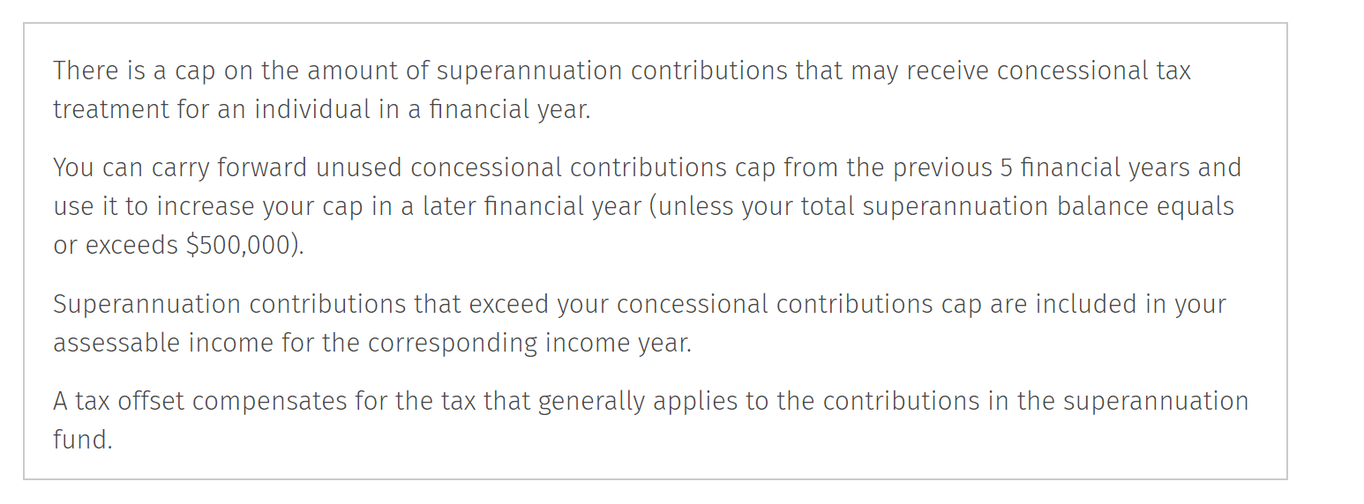
A better strategy – Super Max
A strategy I have long used is to go beyond a member’s concessional cap of $25,000. As the law states any excess over $25,000 is included in the member’s assessable income less a 15% tax offset. Importantly the excess contributor can withdraw 85% of the excess upon assessment with no preservation restrictions. It is a great strategy for high income earners and when used with all its component parts it can be a real money saver and wealth creator.
Strategy Note: This strategy applies to investment bankers, doctors, solicitors, fly in fly out workers being provided with super guarantee contributions by their employer. It also works if the taxpayer is a business owner and the employer makes a deductible contribution pursuant to section 290-60 of the ITAA 97. Again there is no limit on the amount of deduction.
A High Income Case Study
Jim Jones is 35 years old earns $400,000 per annum and is a successful computer consultant with limited ability to shift income. He is a sole trader and with his business humming along Jim’s tax liabilities are significant. On $400,000 of income the ATO’s simple tax calculator shows us that he will pay tax of $153,097.
Jim is also the sole member of the Jones SMSF with $300,000 in his superannuation benefits all sitting in cash.
Making an Excess Concessional Contribution
Jim contributing $125,000 of concessional contributions
Step One – Personal Deductible Contribution - $125,000
For the current income year 2019 – 2020 Jim makes a personal tax deductible contribution of $125,000. At the outset this would reduce Jim’s taxable income to $275,000 and his tax liabilities for the year ended 30 June 2020 to $96,847 – more than a third.

Step Two – Contributions Tax in the Fund
From the Fund’s perspective the $125,000 contributions would be assessable to the Trustee of the Jones SMSF as taxable contributions per section 295-160. Potential tax payable on these contributions (i.e contributions tax) is $125,000 x 0.15 = $18,750.
Contributions Tax Minimisation Strategy: It is important for the Trustee of the Fund to seek to reduce the contributions tax liability in the Fund and for that the Trustee could do one or more of the following:
- Borrow with any interest to cover the $125,000 of taxable contributions (assessable income) – with a 6% interest rate that would be a $2M borrowing which is unlikely in the SMSF world for a client with this profile;
- Receive franking credits – to get $18,750 of franking credits the Fund would need to receive approximately $43,000 of fully franked dividends. Which is unlikely here as the size of the share portfolio – depending on the specific share’s dividend yield would need to be in excess of $1M.
- A great alternative is if the Trustee of the Fund invests $100,000 in an Early Stage Innovation Company (see later) then the Trustee receives a tax offset of 20% of the amount invested, or $20,000. This would clear any contributions tax liability with an additional offset of $1,250 – to be used later.

Step Three – Add back Excess Concessional Contributions to Jim’s personal taxes
Jim’s personal income taxation position is as follows:
  - 2019-2020 concessional contributions threshold: $25,000
  - Personal super contributions that are excess concessional contribution: $100,000. This excess is to be added back to Jim’s assessable income.
  - Any excess concessional contribution is a non-concessional contribution using Jim’s NCC cap of $100,000 which is perfect. Of course he could take advantage of a three year bring forward of $300,000 – see later for a turbo charged version of this strategy.
  - First Personal Assessment in March 2021 based on current income of $275,000 is $96,847.
  - The trustee of the Super Fund lodges its tax return in March 2021 showing excess concessional contributions of $100,000.
  - Amended Assessment issued by the ATO to Jim personally once the Fund’s and the personal income tax returns are married up in order to tax the excess concessional contribution at Jim’s marginal tax rate – see section 291-15 of the ITAA 97. There will be an add back of the Excess Concessional Contribution of $100,000 plus an ECC Charge on any tax payable.
  - The Amended Tax Assessment for Jim is: $100,000 = $47,000 BUT section 291-15(b) provides a 15% tax offset on the $100,000 of taxable income which is $15,000.
  - So total tax payable on the $125,000 contribution is $32,000 and the ECC would be approximately $2,000 for the period to March 2021.
  - As Jim is making a concessional cap contribution of $25,000 and his income is above $250,000, he will be up for an additional 15% tax – the sustainable super contributions tax = $3,750.
  - Jim’s Total Additional Tax liability is $37,750 compared to tax on $125,000 of taxable income = $58,750. So he has saved $21,000!
Important Strategy Super Access Plan
At the time of making the amended assessment, Jim may ask the ATO to withdraw up to 85% of his excess contributions and pay his sustainable super tax from his fund. As such Jim can obtain a payment of $85,000 from the fund – which is non-taxable to pay his $37,750 tax liability (including Medicare and the ECC). The remainder can be used to pay off any mortgage, other liabilities or to add to non-super savings. Of course he can leave the money in the fund and pay the additional tax bill outside.
Going for the Max
As Jim’s excess concessional contributions are non-concessional contributions, we can look at a salary sacrifice of $325,000 which will not breach his NCC caps. The impact on this is:
  - Taxable Income of $75,000 post the deductible contribution – tax payable $15,992
  - 2019-2020 concessional contributions threshold: $25,000
  - Personal super contributions that are excess concessional contribution: $300,000. This excess is to be added back to Jim’s assessable income.
  - Any excess concessional contribution is a non-concessional contribution using Jim’s NCC cap of $100,000 which is perfect. Of course he has a three year bring forward of $300,000.
  - First Personal Assessment in March 2021 based on current income of $15,992.
  - The trustee of the Super Fund lodges its tax return in March 2021 showing excess concessional contributions of $300,000.
  - Amended Assessment issued by the ATO once the Fund’s and the personal income tax returns are married up in order to tax the excess concessional contribution at Jim’s marginal tax rate – see section 291-15 of the ITAA 97. There will be an add back of the Excess Concessional Contribution of $300,000 plus an ECC Charge on any tax payable.
  - The Amended Tax Assessment for Jim is: $300,000 = $125,925 BUT section 291-15(b) provides a 15% tax offset on the $300,000 of taxable income which is $45,000.
  - So total tax payable on the $300,000 excess concessional contribution is $80,925 and the ECC would be approximately $3,500 for the period to March 2021.
  - In addition the concessional contributions under the cap may escape the 15% excess tax as the sustainable super contributions tax excludes excess concessional contributions from reporting as taxable contributions.
Total Tax Payable under the strategy: $15,992 + $80,925 + $3,500 = $100,417
This is a personal tax saving of $52,680.
Access Amount: Jim could access 85% x $300,000 = $255,000 upon assessment to pay the tax liability of $100,417 and keep any remainder or keep it in the fund.
Of course we could keep on going for even higher income earners and go beyond the non-concessional contributions cap which can prove just as valuable. For any enquiries please contact me at grant@ilovesmsf.com

The Importance of an Early Stage Innovation Company investment for High Income Earners
An investment in an Early Stage Innovation Company provides the following:
- A 20% tax offset up to a maximum of $200,000 for a sophisticated investor such as Jim who could invest up to $1M;
- If the ESIC is sold within a ten year period there is no capital gains tax.
We saw the tax impact of contributing any excess into the Jones SMSF but let’s look at what happens if Jim invests directly in an ESIC investment.

Alternative Strategy – Straight ESIC Investment
Instead of using super contributions, Jim decides to invest $125,000 into an ESIC investment. This is simple. As noted Jim’s tax liability for 2019/2020 is $153,097. The $125,000 that Jim applies to ESIC investments would provide a rebate of $25,000 reducing his tax bill to $128,097.
If Jim invested $325,000 then his tax offset increases to $65,000 and his personal income tax is reduced to $88,097.
So which to choose?
The straight ESIC investment is by far the better choice as it is simpler and more tax effective. The SMSF option can prove useful if cash flow is an issue to get into the right ESIC investment as the Fund can invest and then the taxpayer make concessional and excess concessional contributions later in the year – closer to the time of lodging the return to get access to 85% of the excess concessional contributions.
Additionally the shares will be protected from the taxpayer’s assets in the event of bankruptcy but this must be weighed with any exit event in the ESIC shares being locked in super until retirement. For 35 year old Jim, both sides need to be explained and let him make the decision.
On ESIC Investment
Little is understood about ESIC investment but in short, the Government has provided great tax concessions for companies no more than 3 years old which have been doing a lot of R & D, have a proven business model, international opportunity and no more than $200k in revenue in the prior income year. They are risky and the limit for non-sophisticated investors is a maximum $50,000 per year or $10,000 in tax concessions. For sophisticated investors it is a maximum $1M investment or $200,000 in tax offsets.
The problem is getting a solid company issue that meets the ESIC guidelines.

The LightYear Group Capital Raising meets ESIC Guidelines
The LightYear Group is doing a small capital raising enabling you to provide or introduce your high income earning clients to the LightYear Group opportunity. We meet ESIC guidelines - have significant R & D - regular accounting, financial planning and AFSL clients and tendering for contracts overseas for our strategy automation and process automation solution. The Directors are of the opinion that the current valuation under the offer is below the company’s intrinsic value. If you would like to look into the offer this is the relevant link to obtain the full document offer: https://www.fundsition.com/investment/lightyear-group/ You will need to register with the platform provider Fundsition – a requirement by ASIC under this type of ESIC retail offer.
Please note that once the allocation is gone, it’s gone so register and if you would like to invest you can commit but do not need to pay until September 2019. Contact our CFO Michael Jeffriess to discuss – 1300 168 380.

Taxpayers earning above $180,000 pay $57,600 income tax plus 47% for every $1 of income earned beyond that. A taxpayer on $300,000 of income would pay $114,000 in tax while an individual taxpayer on $500,000 would pay $208,000.
We will use the ATO calculator and note it has its limitations – particularly as the rates are limited to those for 2018/2019 but we are demonstrating the effect in globo.
section 290-150 of the ITAA 97 provides that any personal contribution made by a taxpayer to a complying superannuation fund is tax deductible. There is no limit on the deduction and it still applies even where the taxpayer is in receipt of employer contributions.
The ECC is set at a current rate for the June quarter 2019 of 4.94% which accrues on a daily basis from the start of the income year in which the contribution is made until the assessment is made and paid.
The ECC is set at a current rate for the June quarter 2019 of 4.94% which accrues on a daily basis from the start of the income year in which the contribution is made until the assessment is made and paid.

