[District Name] Students and Guardians Get an Easier Way to Track Progress from Smartphones
[District Name] will always strive to give you new and better ways to stay informed.

This year, students and guardians can download a new mobile app for OnCourse Connect, [District Name]’s portal for retrieving student schedules, grades, teacher feedback, and attendance.

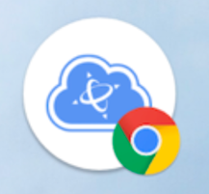
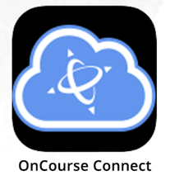
On your mobile device, you may already have an app shortcut on your smartphone (see pictures: Android on left, iPhone on right). Before getting the new app, we encourage you to delete these icons if you have them.

How to Get the New OnCourse Connect App

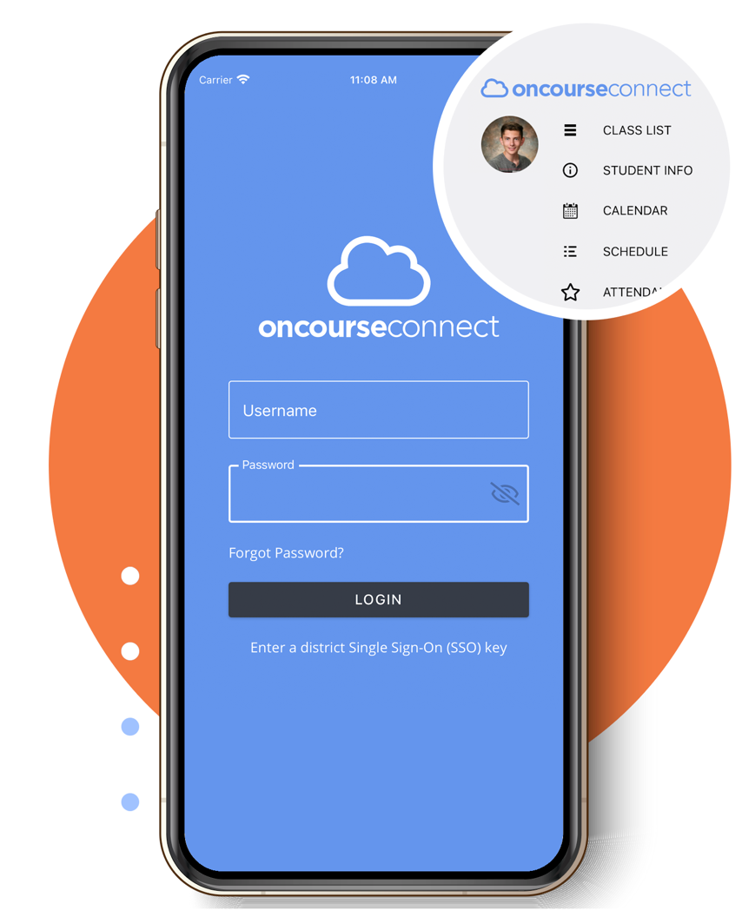
- Visit the App Store/Google Play Store from your iPhone or Android phone
- Search for “OnCourse Connect” and download the app
- Enter your district-issued username and password
Don’t remember your login? Press the Forgot Password link on the app home screen.
(District Instructions – if your school uses SSO, remove this step and provide your District Key instead)
If you need help, please contact [District Contact] at:
- [E-mail Address]
- [Phone Number]

