This is a sample form letter that has not been reviewed for legal compliance with state/federal guidance. Before using this content, it is strongly recommended that your district get approval from your district administration and/or legal department.

[Lorem School District] Goes High-Tech to Reduce COVID-19 Exposure

District to use an online health screening application to monitor individuals that are symptomatic or have been exposed to COVID-19.

[Ipsum High School] is taking many new steps to ensure a safe environment for students and staff. One of these steps is to identify symptomatic individuals before they enter a school bus or building.

To make this possible, [Ipsum High School] is activating a “Daily Health Screening” feature in the OnCourse Connect portal for parents and guardians.

<Insert Quote from District Administrator>

Each morning before school, guardians must log into OnCourse from a computer or smartphone to complete a quick health screening of their students. If they receive a green “Approved” indicator, their student may board the school bus and enter the building. If they receive a red “Not Approved” indicator, the district asks that the student not report to school and contact the office for next steps.

<Insert any Procedural Guidance that you expect students/parents to take, like showing their phone/computer or printed pass to bus driver or entryway personnel>

Teachers, administrators, and school staff members will also complete this health screening each day before entering campus buildings or transportation.

With this screening system in place, trained staff will have a fast and confidential way to monitor symptomatic/exposed households and help students protect themselves and their peers. However, for this system to be successful, every student and guardian must participate consistently and honestly.

For households without access to internet or devices, the district will provide an alternate method.

Daily Health Screening for Guardians

The Daily Health Screening application allows guardians to monitor the health symptoms of their children. This guide provides step-by-step instructions.
_____________________________________
1
Upon logging into OnCourse Connect you will automatically see the Health Screening form (shown below.) Here you have the option to complete or skip the screening form.
If you choose to complete the form, you'll need to:
- Review the Symptoms and Exposure forms with your child and check any boxes that apply.
- Check the box next to the confirmation statement (“I confirm that my...”) to activate the Submit button.
- Press the Submit button.
*If you have multiple children in the district, you will automatically be taken to a Health Screening form for the second child.
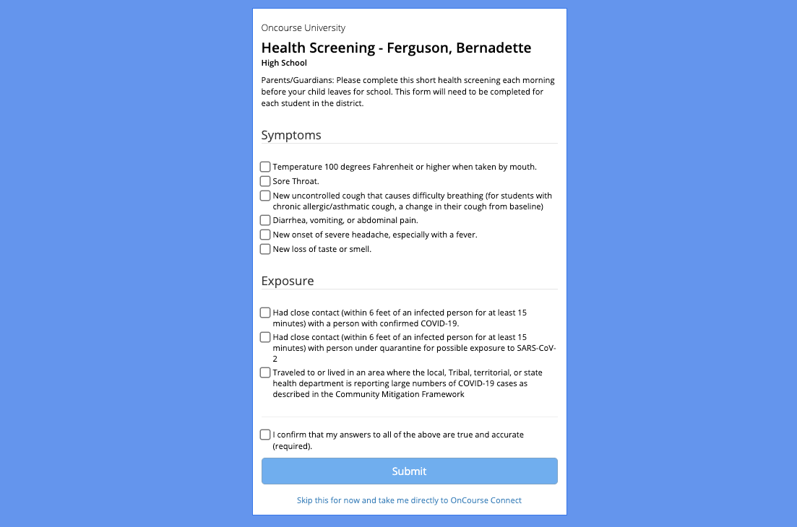
2
If your child has been approved, you will see this banner. If your district requires the use of an entry pass, click the Show Pass button.
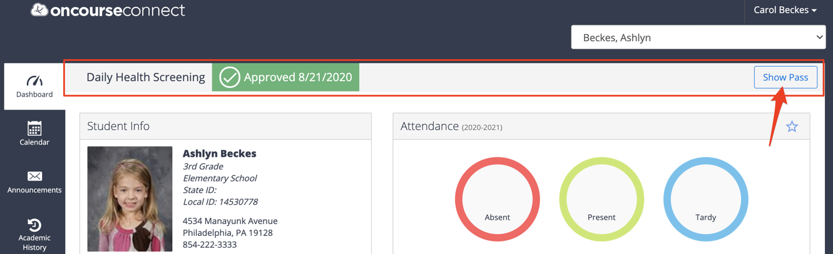

3
The entry pass will look like this. The pass can be printed, or a screenshot can be taken.
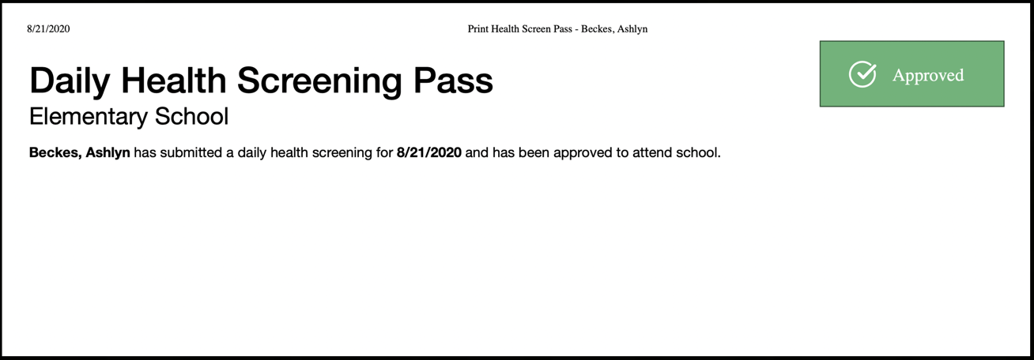

4
If your child has not been approved, you will see this banner and will be able to print an entry pass by clicking the Show Pass button.
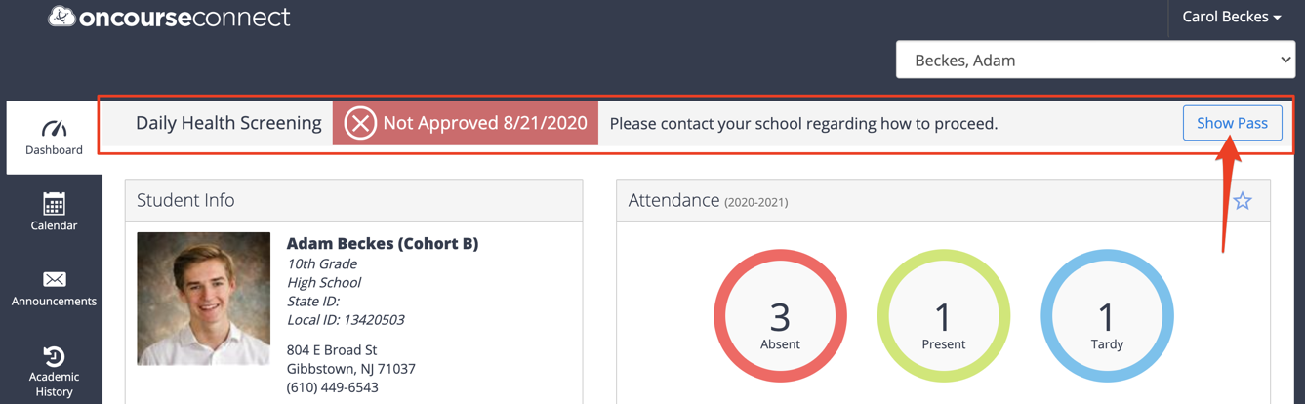
5
The entry pass will look like this. The pass can be printed, or a screenshot can be taken.
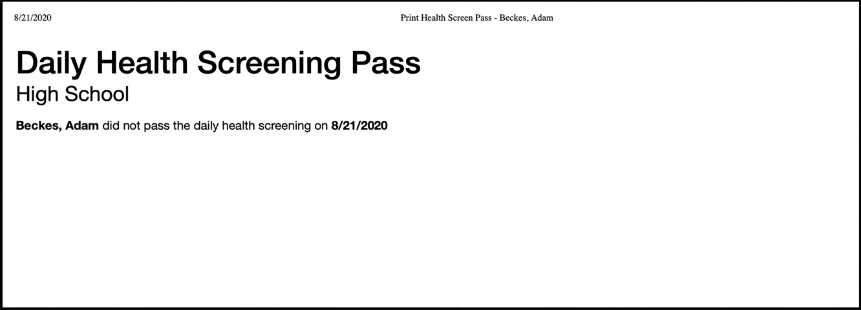
6 (Optional)
If you skipped the form in Step 1, you will be taken into your student’s OnCourse account. Here you will see the Take Daily Health Screening Survey button which can be selected to re-launch the Health Screening Survey.
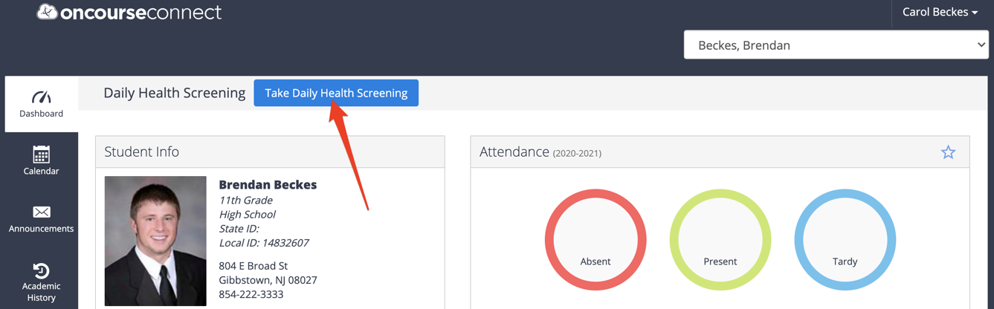

*If you need to make changes a submission, please contact your school.

